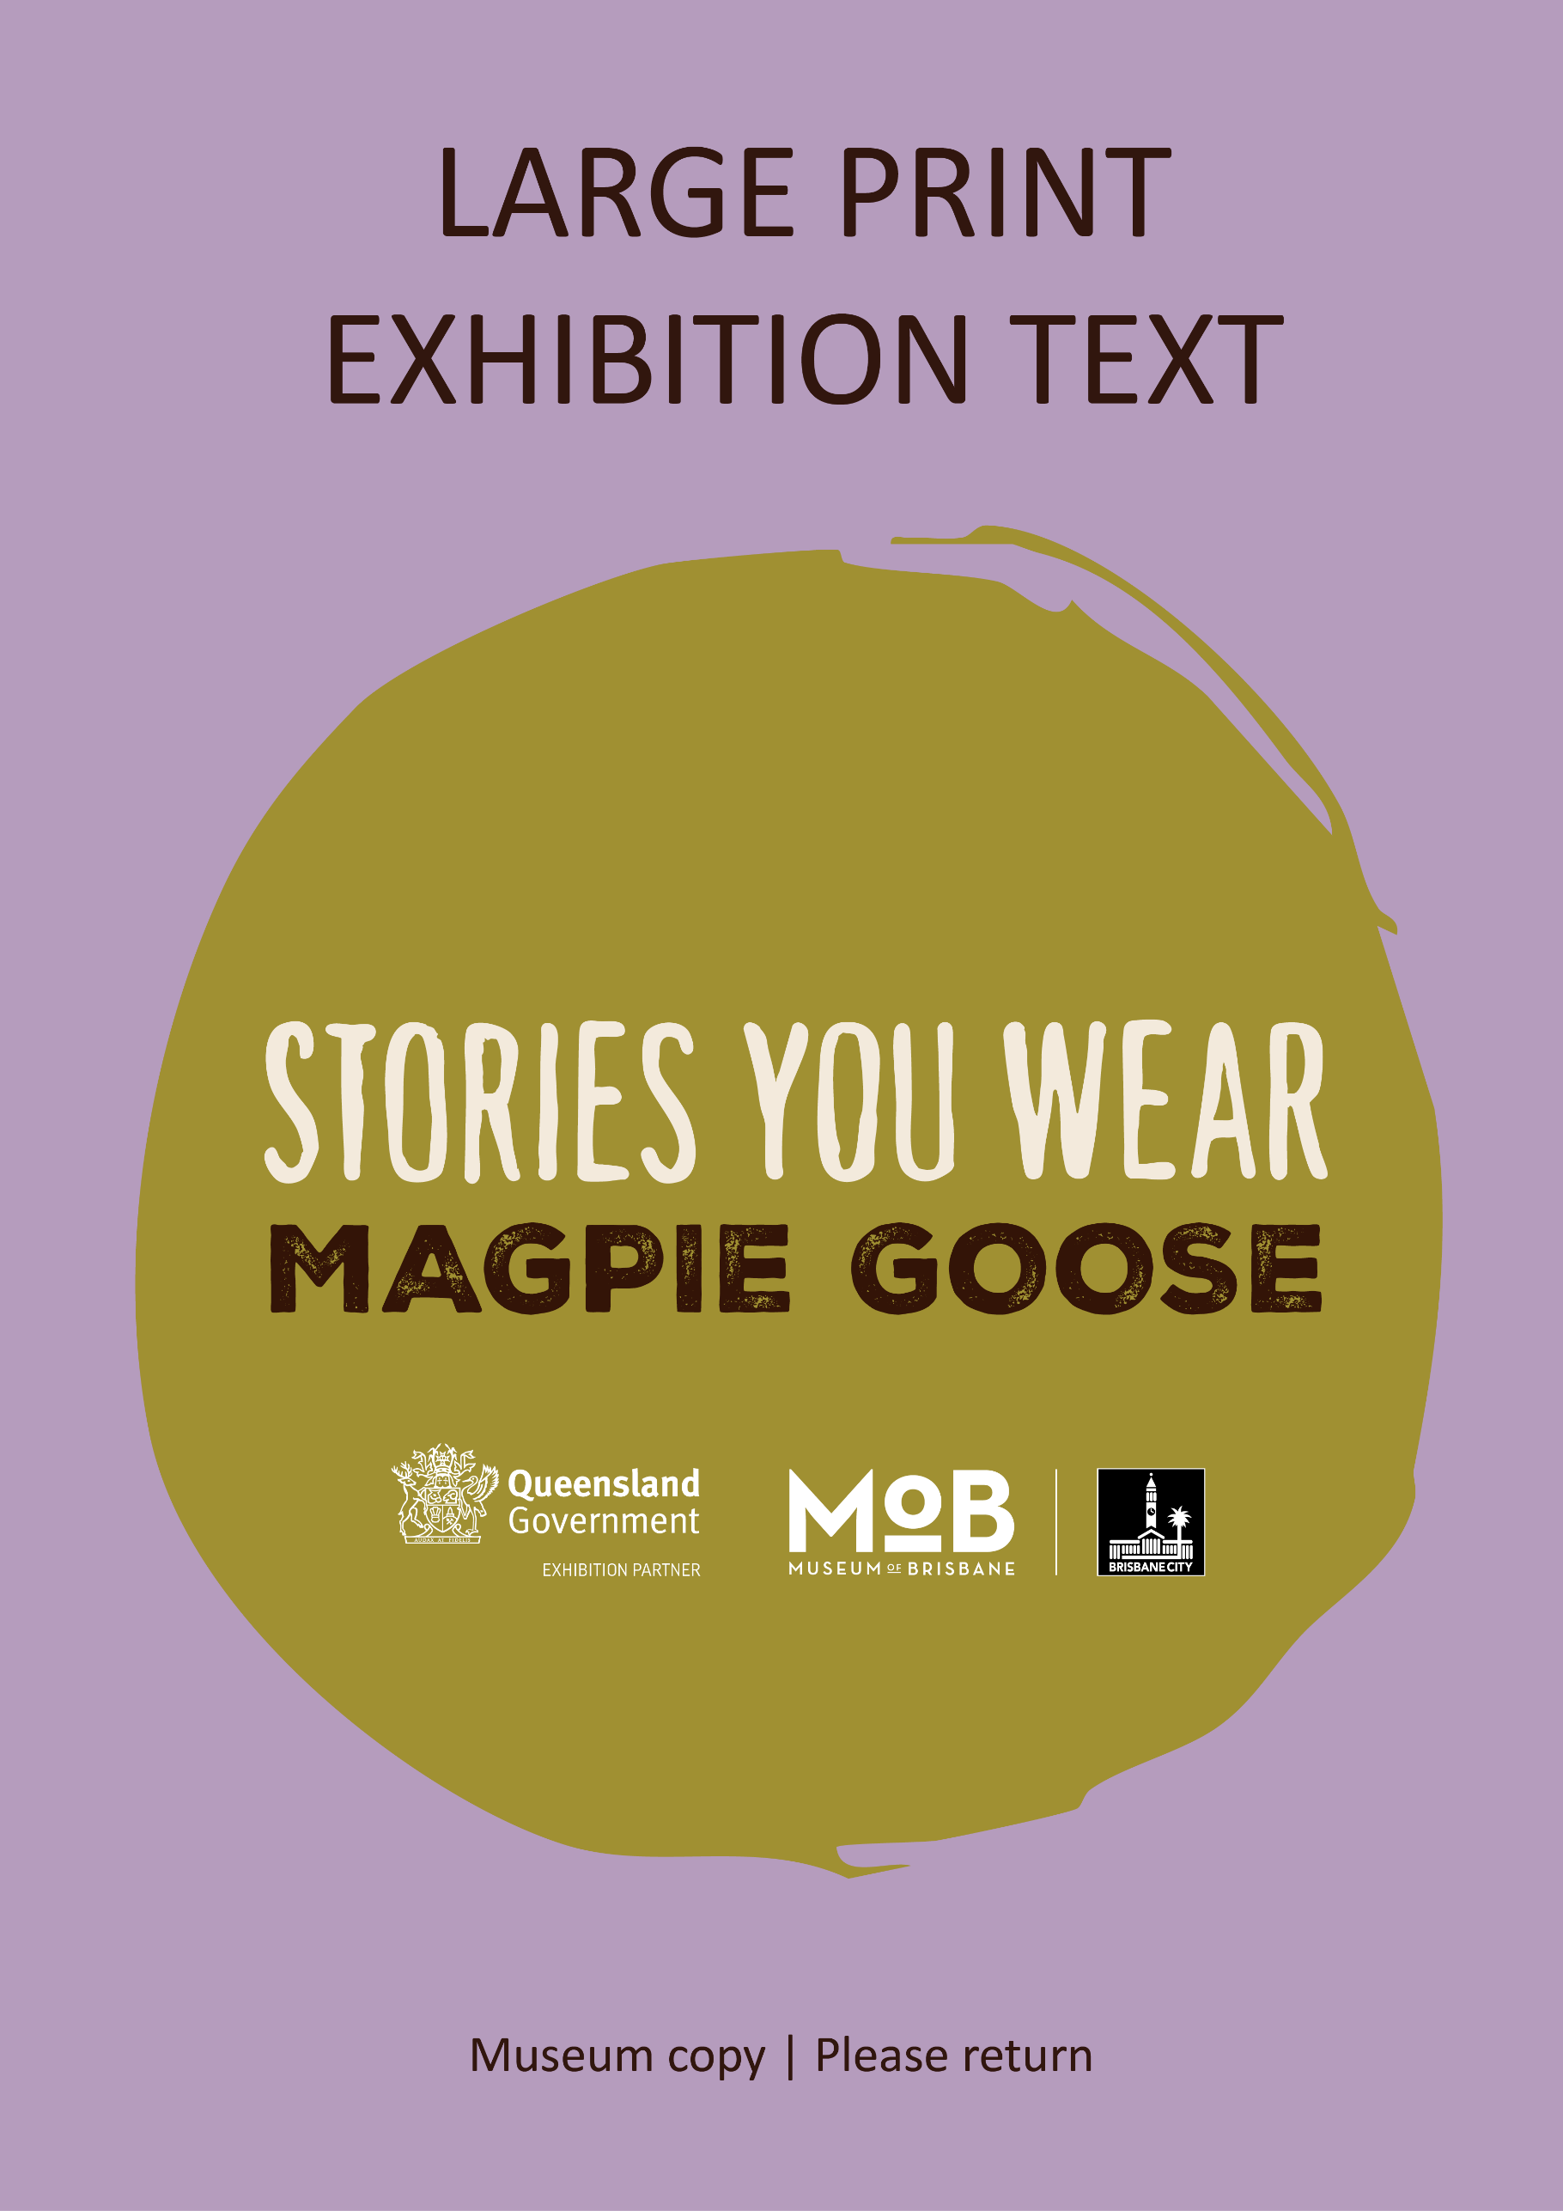

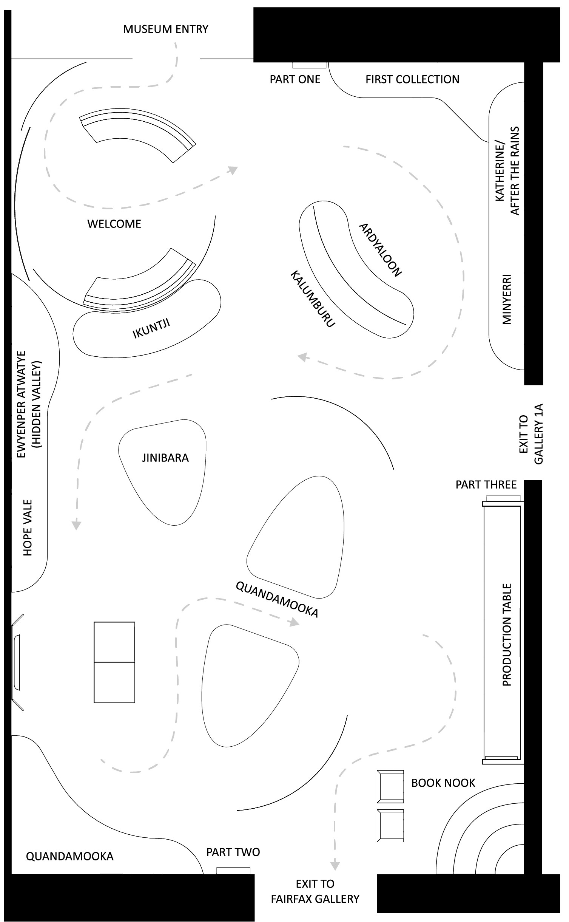
Table of Contents
Introduction 4
Acknowledgements 5
Visitor Notices 8
Welcome 10
Aboriginal Kinship Systems 11
Part One: Community Reach 13
First Collection 2016/17 17
Katherine/After the Rains 2017 33
Minyerri 2019 47
Ardyaloon 2019 63
Kalumburu 2022 79
Ikuntji 2019 97
Ewyenper Atwatye (Hidden Valley) 2024 112
Hope Vale 2019 128
Part Two: Local Focus 145
Jinibara 2018 149
Quandamooka 2025/26 162
Part Three: Production Table 186
Creating the Artwork 192
Printing the Fabric 195
Making the Garments 198
Releasing the Collection 199
Magpie Goose x Firesticks Alliance 203
Book Nook 204

Introduction

With every stitch, powerful stories of community, culture and Country come alive.

Stories You Wear spotlights the artists of Magpie Goose, a proudly Aboriginal-owned and led clothing label, and delves into the incredible stories behind their designs.

The garments here are more than just fashion statements – they are works of art, fostering respect, understanding and appreciation for the world’s oldest living cultures.

Magpie Goose is where fashion and social impact come together. In collaboration with select First Peoples communities across the country, the label creates bold and bright garments, embracing fashion as a canvas for storytelling.

We invite you to explore Magpie Goose’s early collaborations in areas of the Northern Territory, Western Australia and Queensland. Immerse yourself in the stories of the Greater Brisbane regions through the Jinibara and Quandamooka collections. Then, discover how the label keeps it ethical and sustainable through an exclusive look at their production process.

Every design tells a unique story, celebrating the richness and
diversity of First Peoples cultures and creativity.

Scan for an audio reading of the above text




Scan for an introductory Audio Description

Acknowledgements

Stories You Wear has been shaped by collaboration and consultation.

We wish to thank Elder Warunghu, Aunty Raelene Baker, for her generous contributions to the exhibition and continued guidance across Museum of Brisbane projects. We extend our thanks to the Minjerribah Moorgumpin Elders-in-Council Aboriginal Corporation (Quandamooka collection) and Jinibara Elder Uncle Noel Blair (Jinibara collection) for their cultural guidance and support.

This exhibition was curated and designed in collaboration with Magpie Goose owners, Amanda Hayman and Troy Casey. We are grateful for their guidance, generosity and trust. None of this would have been possible without them and the incredible work they do.

We acknowledge the art centres, arts organisations and independent artists whose designs are on show and thank them for their contributions and for entrusting us with their stories.
Core Project Team

Advisor: Elder Warunghu, Aunty Raelene Baker (Yuggera, Girrimay and Birri)
Curatorial: Amanda Hayman (Wakka Wakka and Kalkadoon), Troy Casey (Kamilaroi), Elena Dias-Jayasinha, Nisa Richy, Kieron Boona Anderson (Ngugi and Kullili)
Design: Melissa Blight, Craig Sproul, Dylan Bolger (Maiawali, Karuwali, Pitta-Pitta and Gomeroi)
Branding: Jenna Lee (Gulumerridjin (Larrakia), Wardaman and KarraJarri)
Graphic Design: Vanghoua Anthony Vue

We also wish to thank the broader Museum of Brisbane team and the many other individuals who have given their time and expertise to the project.

Stories You Wear: Magpie Goose is supported by the Queensland Government through Arts Queensland.

Visitor Notices

Content Warning
Aboriginal and Torres Strait Island people should be aware that this exhibition contains images, names and stories of people who are deceased. In addition, we advise viewers that the exhibition details historical experiences of, and references to, structural racism and violence towards Aboriginal and Torres Strait Island communities.

Sensory Warning
This exhibition contains moving lights, projections and sound.

Copyright
We have made every effort to trace the copyright holders of the visual material featured in this exhibition and gain the relevant permissions. We have acted in good faith and on the best information available.

If you have any questions or concerns, please reach out: curatorial@museumofbrisbane.com.au

Language Use
In Australia there are over 250 languages, including around 800 dialects, used by Aboriginal and Torres Strait Island communities. As languages are handed down through oral tradition, spelling and pronunciation can vary. Where language is incorporated in this exhibition, we have used the spellings provided by the artists and their communities.

Welcome

Prose and voice: Elder Warunghu, Aunty Raelene Baker (Yuggera, Girrimay and Birri)

Bidiayamunda (didgeridoo) and Yabayaba (clapsticks):
Dean Bingkin Tyson (Ngugi)

Audio Production: Audio Art

Animation: Sai Karlen

Aboriginal Kinship Systems

Aboriginal kinship systems are highly complex, determining a person’s identity, relationships and responsibilities to their community and to Country. Throughout the exhibition, you will see references to three key, interconnected concepts: moiety, totems and skin names.

Moiety — many Aboriginal groups divide society into two complementary halves, or two moieties. Different groups have different names for these two moieties, as well as different practices attached to them. People inherit their moiety when they are born, and they determine how they relate to others and to Country. As an example, people of the same moiety are considered siblings and cannot marry.

Totems — totems spiritually connect people to their Ancestors and to Country, shaping their identity and sense of belonging. Many Aboriginal people have several totems, either inherited or assigned to them. Totems can be animals, plants or natural entities. People are accountable for their totems, ensuring they are protected and passed down to future generations.

Skin Names — many Aboriginal people inherit a skin name at birth. Skin names are passed down through a sequential system, generally across a cycle of 16 to 32 generations, and vary from group to group. These names connect generations, are important identifiers for people within their communities, and set up a system of relational reciprocity.

It is impossible to capture the depth of these concepts in only a few sentences. For those interested in learning more, there are some key resources in the Book Nook, further in the exhibition, that you are encouraged to read.

Part One: Community Reach

Community is at the heart of everything...

In 2021, Magpie Goose became the first non-Indigenous company working with First Peoples stories and Indigenous Cultural and Intellectual Property (ICIP) to transition to Indigenous ownership. Now based on Yuggera and Turrabal Country (Brisbane), the label is headed by local entrepreneurs, Amanda Hayman (Wakka Wakka and Kalkadoon) and Troy Casey (Kamilaroi). Amanda and Troy have overseen the opening of Magpie Goose’s flagship store, and continue to work with communities across the country to develop new and exciting collections that platform and celebrate First Peoples stories and designs.

The story of Magpie Goose began northwest of here, in the Top End of the country. Co-founders Maggie McGowan and Laura Egan, two non‑Indigenous women, met in Katherine after moving there for work. Maggie had joined the North Australian Aboriginal Justice Agency, while Laura had established Enterprise Learning Projects to support the development of Aboriginal businesses. Together, Maggie and Laura developed Magpie Goose to partner with remote Aboriginal communities — many of which were already known for their strong artistic practices, including screen-printing — and share stories through wearable art, as well as create new economic opportunities.

Early collections of Magpie Goose featured communities in the Northern Territory, including Gunbalanya, Katherine, Maningrida, Wadeye and Wurrumiyanga. As the label’s popularity increased, so too did its reach. Soon enough, Magpie Goose was working with art centres, arts organisations and independent artists in Queensland and Western Australia. Nearly 10 years into business, the label is proud to have collaborated with over 70 artists from 13 regional and remote communities.

When creating a collection, Magpie Goose spends valuable time collaborating with the community. The way each collection comes together is unique and developed in close consultation with the artists. Often over several trips, Magpie Goose connects with community members, facilitates design workshops and organises photoshoots on Country. In between these visits, the team continues to consult the artists, ensuring they are involved in every step.


Scan for an audio reading of the above text

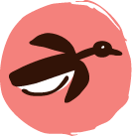
Murnubbarr Label

Magpie Goose is named after a bird of the same name. You can find these birds in northern and eastern Australia, including right here in South East Queensland.

Magpie geese are called murnubbarr by the Kuninjku people of West Arnhem Land. Can you find any murnubbarr on the clothes nearby?

Magpie Goose’s logo was inspired by Murnubbarr Karrolkan (Flying Magpie Geese), a design created by Kodjdjan D Diaguma from Bábbarra Women’s Centre.

First Collection 2016/17

For their first collection, Magpie Goose collaborated with four Top End art centres: Tiwi Design, Injalak Arts, Bábbarra Women’s Centre and Palngun Wurnangat. The Top End describes the northernmost part of the Northern Territory, stretching north to the Tiwi Islands, south to the Barkly Region, west to the Western Australian border and east to Arnhem Land.

In late 2016 and early 2017, Magpie Goose launched the first few designs from this collection at pop-ups on Larrakia Country (Darwin) and in Naarm (Melbourne). To get the business off the ground, founders Maggie McGowan and Laura Egan published a Kickstarter campaign that was met with incredible success. By the end of 2017, they were able to launch a website and make the garments available online.

Artists: Jean Baptiste Apuatimi, Graham Badari, Priscilla Badari, Bridget Bunduck, Kodjdjan D Diaguma, Merril Girrabul, Elizabeth Kandabuma, Osmond Kantilla, Alan Kerinauia, Reuben Manakgu, Audrey Nadjowh, Lynne Nadjowh, Bede Tungatalum

Art centres, First Peoples-owned and run community organisations, are at the heart of many Aboriginal communities across the country. During the 1970s and 1980s, the Australian Government began to dismantle devastating policies under which they tried to assimilate Aboriginal and Torres Strait Island people into the wider community. In the late 20th century, the government started to engage in the preservation and revival of First Peoples cultures. Art centres were developed for different purposes, operating as women’s shelters, family skin group collectives, central resource hubs and general gathering spaces. Many have become vital spaces for art making, the continuation of culture, and provide important economic contributions to communities.

About the Art Centres
Tiwi Design, located in the town of Wurrumiyanga on Bathurst Island, was one of the first art centres to be established. It was founded by local artists, Bede Tungatalum and Giovanni Tipungwuti in the late 1960s after they began working with woodblock and screen‑printing. The art centre was incorporated in 1980 and soon became a leader in screen‑printed fabrics.

A few years later in 1984, Injalak Arts was established southeast of the Tiwi Islands in the town of Gunbalanya. The art centre started as a women’s sewing group, led by educator Wendy Kennedy. After visiting nearby art centres, including Tiwi Design, a group of Gunbalanya community members set up a screen-printing studio in a local shed. By 1989, Injalak Arts had been incorporated and was operating out of a purpose-built studio.

In 1987, Bábbarra Women’s Centre was established in the remote town of Maningrida, east of Gunbalanya in Arnhem Land. Founded by Ndjébbana leader Helen Williams, with support from Helen Bond-Sharp, the centre was initially set up as a women’s refuge. In the late 1980s, the women at the centre began screen-printing with paper stencils. Throughout the 1990s and 2000s, various workshops were held, teaching different printmaking techniques, including lino-block printing and screen-printing on fabric.

Palngun Wurnangat, meaning ‘women together’ in Murrinhpatha language, opened soon after in 1990. Located 800 kilometres southwest of Maningrida in the remote town of Wadeye, the centre supports women through various initiatives, including screen-printed fabrics.

Scan for an Audio Description of the First Collection

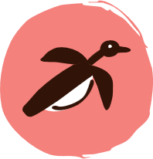
Murnubbarr Label

Many of the artists in this exhibition are part of art centres. Art centres are important places in communities where people come together to create art, share stories and pass down knowledge through generations.

Where do you go to feel connected to your culture or community?
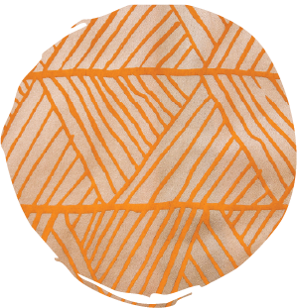
Osmond Kantilla (Tiwi Design)
Pandanus
Courtesy Maggie McGowan and Laura Egan

“My brothers and sisters follow the footsteps of my father’s clan when we dance at ceremony. My dad used to be a songwriter and a dancer and that is why I did a design called pandanus in memory of him. When you see that pandanus tree out bush it is very green with long pointy leaves. I had those ideas in mind when I made my design.”

Osmond Kantilla is a master printer who worked at Tiwi Design. His Country is Wurrurank and his skin group is Marntimapila (stone). For many years, Osmond supervised all aspects of the screen-printing process at Tiwi Design. He has designed many screens himself and enjoys the process of mixing colours and matching them to the designs and fabrics.

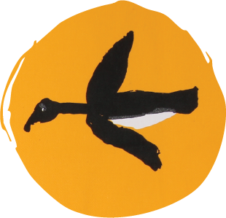
Kodjdjan D Diaguma (Bábbarra Women’s Centre)
Murnubbarr Karrolkan (Flying Magpie Geese)
Courtesy Magpie Goose

Kodjdjan D Diaguma created this design at Bábbarra Women’s Centre in 2003. Murnubbarr (magpie geese) are waterbirds found in abundance in the wetland areas of Kakadu and West Arnhem Land.

Murnubbarr are sustainably hunted and enjoy manme (bush food). They are known to fly long distances, particularly in the wet season.

Magpie Goose based their iconic logo on this design.

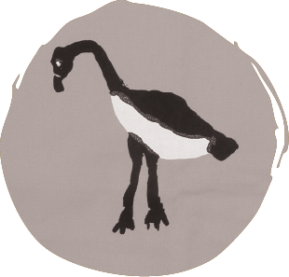
Kodjdjan D Diaguma (Bábbarra Women’s Centre)
Murnubbarr Karrolkan (Flying Magpie Geese)

Kodjdjan D Diaguma is a Kuninjku woman from Maningrida. Her moiety is Yirritja, and her homelands are Mandilbarrang and Kujdekbin. Kodjdjan D Diaguma started work at Bábbarra Women’s Centre in 2007. She later became based out of home. Her designs often depict her Djang (Ancestral Dreaming stories) and native plants and animals.

This artist passed away in 2025 and we show this with permission of her family.

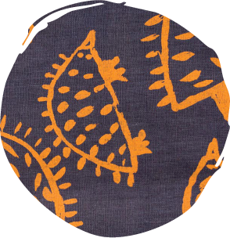
Bridget Bunduck (Palngun Wurnangat)
Ku Nguluyguy (Echidnas)
Courtesy Maggie McGowan and Laura Egan

“The echidna is one of the animals in my Dreaming. There are lots of echidnas in Wadeye, especially on the land around Air Force Creek.”

Bridget Bunduck is a Tharnpa woman from Wadeye. Her language is Murrinhpatha. Bridget is a self-taught artist and has worked at Palngun Wurnangat since 2009. She is an integral part of the art centre’s design and production team. Bridget has three children and loves fishing and picking pandanus to make dilly bags.

Model wearing Jean Baptiste Apuatimi’s Jilamara design. Photo: Rhett Hammerton.

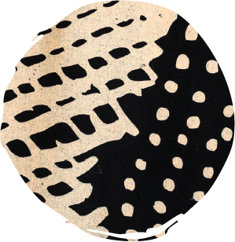
Jean Baptiste Apuatimi (Tiwi Design)
Jilamara

“All my paintings are ceremony, same like this one. We Tiwi paint our bodies with ochre for ceremony. This is our body painting design. This is olden days painting. Long ago in the early days we put Yalinga (red ochre), Arrikininga (yellow ochre) and tutuyangini (white ochre) on our face and body for Pukumani (funeral) and Kulama (yam) ceremonies. The bars going across are the Jilamara (body painting) we put across our stomach and chest. Sometimes we still do this. My husband taught me this style, he used to tell me story about that painting.”

Jean Baptiste Apuatimi is an acclaimed carver, painter and printmaker. She was born in Pirlingimpi (Garden Point) on Melville Island into the Tapatapunga (march fly) skin group. When she was young her family moved to Wurrumiyanga, where she lived in a dormitory at the convent and was educated and cared for by the nuns from the Catholic mission. She was married to her husband Declan Apuatimi at age 14 and they had 11 children. Many of her children and nieces and nephews continue to work at Tiwi Design.

This artist passed away in 2013 and we show this with permission of her family.

Molly Rex, Jordan Unghango, Trinita Bundamurra and Zerika Clement wearing Leonie Melpi’s Waves, Graham Badari’s Nabarlek deja Ngarrbek (Rock Wallaby and Echidna), Reuben Manakgu’s Wakih (Fresh Water Prawns), Bede Tungatalum’s Tiwi Birds, Kodjdjan D Diaguma’s Murnubbarr Karrolkan (Flying Magpie Geese) and Elizabeth Kandabuma’s Kun-ngol (Clouds) designs. Photo: Freedom Garvey-Warr and Kalumburu Photography Collective, Enterprise Partnerships.

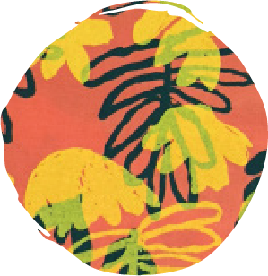
Elizabeth Kandabuma (Bábbarra Women’s Centre)
Kun-ngol (Clouds)

This artist passed away and we show this with permission of her family.

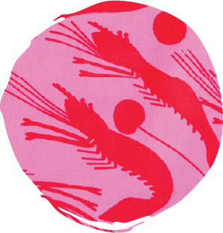
Reuben Manakgu (Injalak Arts)
Wakih (Fresh Water Prawns)

Wakih (Leptopalaemon gagadjui) are freshwater prawns found only in West Arnhem Land. The species name gagadjui derives from Gagudju, the name for the language and people of Kakadu. Bininj people still catch wakih today in deep billabongs and waterways.

A lot of wakih can be caught in the creeks of Reuben Manakgu’s Country of Mangardubu, north of Gunbalanya. He catches them with a throw net or a piece of meat on the end of a fishing line and entices them into the shallows where they can be speared.

Reuben Manakgu is a Bininj man of the Mandjuringunj clan. He is a printer and artist from Injalak Arts. His language is Kunwinjku and his Country is Mangardubu. As Injalak Arts’ screen-print production manager, Reuben is in charge of a small team of Bininj men. His graceful character and artistic eye can be noted in his management skills, technical screen-print know-how and talent for creating beautiful design colourways.
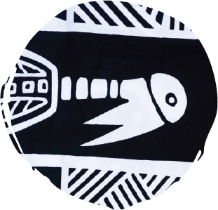
Bede Tungatalum (Tiwi Design)
Tiwi Birds

Bede Tungatalum first created this ‘Tiwi Birds’ motif in the 1970s. Its first iteration was as a woodblock print, and it soon became incorporated into the Tiwi Design logo. The design was translated into textiles in 1990.

Alan Kerinauia, another Tiwi artist, explains, “The Tiwi bird is a Jabiru — there’s lots of Jabirus around the Tiwi Islands. The dots and lines around the bird are like Jilamara — a piece of art. Each line, triangle and curve means something else — a thick line is a creek or river, a dot is a waterhole or a person, and a triangle with a dot can be a snake.”

Bede Tungatalum was born in Wurrumiyanga. His Country is Munupi, Melville Island, and his skin group is Yarrinapinilia (red ochre). Bede learned carving from his father, the well-known sculptor Gabriel Tungatalum. While at school he was taught to cut woodblocks for printing. Bede established Tiwi Design with Giovanni Tipungwuti in the late 1960s to produce hand-printed fabric that incorporates traditional Tiwi designs.
Molly Rex wearing Graham Badari’s Nabarlek deja Ngarrbek (Rock Wallaby and Echidna) design. Photo: Freedom Garvey-Warr and Kalumburu Photography Collective, Enterprise Partnerships.

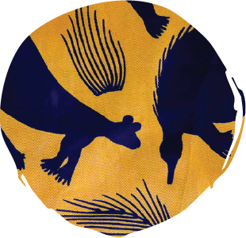
Graham Badari (Injalak Arts)
Nabarlek deja Ngarrbek (Rock Wallaby and Echidna)

Graham Badari created this design in 2014. It is inspired by the high Stone Country of the Arnhem Plateau. It features nabarlek (rock wallaby) and ngarrbek (echidna). The nabarlek survives mostly eating tough grasses as pictured in this design.

A number of Stone Country plants can be seen in this design including mandjamko (Grevillea goodii), a low growing species with red flowers. The nectar from these is sweet and can be eaten. The flowering strap-leafed plant is manburru (Patersonia macrantha), a member of the iris family with purple flowers found only in the Northern Territory.

Graham Badari is a Bininj man of the Wardjak clan. His language is Kunwinjku and his Country is Maburrinj, which is near Kudjekbinj about 120 kilometres east of Gunbalanya in the Top End. He draws much of his artistic inspiration from this region. Graham has worked with Injalak Arts since 1990 and is one of their senior screen-print designers.

Katherine/After the Rains 2017

Katherine is a small town located on the banks of the Katherine River, 314 kilometres southeast from Larrakia Country (Darwin) and 1,180 kilometres north of Mparntwe (Alice Springs). It is home to the Dagoman, Jawoyn and Wardaman people, many of
whom reside in the town and surrounding communities, including Myalli Brumby (Kalano), Rockhole, Binjari, Jodetluk (Gorge Camp) and Geyulkgan Ngurro (Walpiri Camp).

In late 2017, Magpie Goose launched its second collection, Katherine/After the Rains. The designs in this collection were created during a workshop the label facilitated in Katherine earlier in the year. The prints depict stories of Marebu (woven mats), burial sites, waterways, pandanus, Yuwurli (mangrove worms), white cockatoos and sugar gliders. Artists from Tiwi Design, Injalak Arts and Palngun Wurnangat are also featured.

Artists: Graham Badari, Priscilla Badari, Silvia Badari, Margaret Duncan, Rhonda Duncan, Steward Hoosan, Nancy McDinny, Leonie Melpi, Angelo Munkara, Katra Nganjmirra, Jock Puautjimi
What is now called Katherine has long been an important meeting place for Aboriginal people living in the region. Rock art dating back 40,000 years at places such as Nitmiluk National Park, Cutta Cutta Caves Nature Park and Elsey National Park provide an important record of past generations. The 1860s marked the beginning of sustained colonial settlement in the
region. Since then, the population of Katherine began to swell with the development of the Overland Telegraph Line, the gold rush at Pine Creek and continued pastoral expansion. This growth had devastating impacts on Aboriginal people, who were systematically displaced from their lands. Since the 1960s land rights movement, there have been significant efforts by Aboriginal communities to have their sovereignty formally recognised. These efforts led to the passing of the Aboriginal Land Rights (Northern Territory) Act in 1976. Over a decade later, Nitmiluk National Park was officially handed back to the Traditional Owners. This marked a significant achievement for the Jawoyn people, as well as the broader Aboriginal community in the region, with government acknowledgement of their enduring connection to Country.

Scan for an Audio Description of the Katherine/After the Rains collection


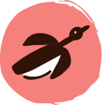
Murnubbarr Label

Pandanus is a palm tree that has long, tough and prickly leaves. The leaves can be stripped, split, soaked, dried and dyed, then used for weaving.

Many of the artists in this exhibition use pandanus to make dilly bags, baskets and mats. Some of the designs nearby depict these woven objects.

How many can you find?
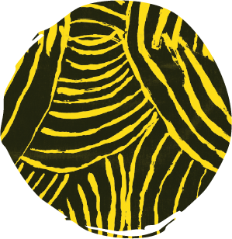
Leonie Melpi (Palngun Wurnangat)
Waves
Courtesy Magpie Goose

Leonie Melpi created this design at Palngun Wurnangat in 2007. The inspiration for the design came from the waves and ripples of the water at the beach. The community of Wadeye is about one hour from the beach on a very bumpy road. You can stand on the beach and look out to the Timor Sea. Locals love to go fishing and swimming at the beach — but you have to look out for crocodiles!

Leonie Melpi is a Wangka woman from Wadeye, a large Aboriginal community southwest of Larrakia Country (Darwin). Her language is Mari Amu. Leonie was a dedicated mother, aunty and grandmother, who spent many years working with young children at Our Lady of the Sacred Heart School. A talented artist, Leonie used painting to relax.

This artist passed away in 2017 and we show this with permission of her family.

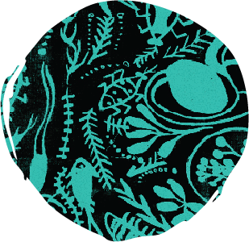
Margaret Duncan
Billabong
Courtesy Maggie McGowan and Laura Egan

“In my design I show the food and animals in the billabong. The billabong reminds me of a big shop — where you can do one big shopping. There are so many things that you can get — like the lily roots, mussels, fish, water beetles, you can get the sweet potato inside the water and other bush tucker. There’s yarlbun (water lilies) — it has a lot of seeds inside. It sits under the water. We break it off and take it out and when we get as many as we can, we then dry the seed in the sun, for a couple of days, and then we crush it up and make it into a damper. We grind it and cook it in the hot ashes. My mum used to take me all the time with my brothers and sisters to get all different types of bush tucker.”

Margaret Duncan, also known as Bowngyii, was born in Ngukurr and grew up near Urapunga. Her mother’s family is Milwarapra (kangaroo people), with connections to Urapunga, Roper Bar and Ngukurr. Her father’s Country is Elcho Island. After years spent caring for her daughter, Margaret returned to art as both a form of expression and a meaningful vocation.
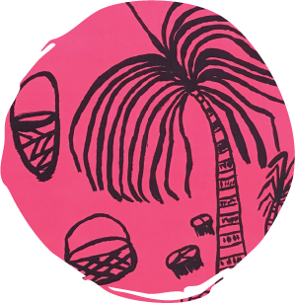
Rhonda Duncan
Pandanus Story
Courtesy Maggie McGowan and Laura Egan

“The pandanus is a very good and unique material to use. We use part of it for colouring/dying, to make a basket or a dilly bag — putting all the food in and they used to use it for fishing net. You can eat the nuts. So many things you can do with pandanus. If you want to make a basket or a dilly bag you have to go out and find the tree, take the leaves down, sit down, take the spikes out, strip it, dry it. After a while you have to do all the colouring. Many different colours can be found — red, yellow, orange, brown — you have to go and dig up the colour, and then get a bucket to get some water, make a fire and boil it, and then put that pandanus in for half an hour or one hour to make that colour. Then you got to sit down and make the basket — that takes maybe three or four weeks. It’s a long process! My design tells that story of pandanus.”

Rhonda Duncan was born in Ngukurr. Her Aboriginal name is Brongin. Her father’s language is Rittarungu and her mother’s language is Ngalakan. She moved to Katherine in 2016 and began painting, carving and weaving after learning from her siblings. Rhonda uses her art to express the way people live on the land.
Esmeralda Philmax wearing Graham Badari’s Lambalk Kangun Mannguy (Sugar Glider Eating Flowers) and Jock Puautjimi’s Burial Sites designs. Photo: Kate Harding.

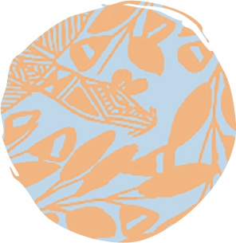
Graham Badari (Injalak Arts)
Lambalk Kangun Mannguy (Sugar Glider Eating Flowers)

This design was created in 2013 and shows lambalk (sugar gliders) feeding on mannguy (flowers). The flowers are from a tree known as mandangdang (roughleafed bloodwood). This tree is also prized amongst Kunwinjku people for making mako (didgeridoos).

Lambalk live in hollow trees and are small, omnivorous, arboreal and nocturnal possums. The common name refers to its preference for sugary nectarous foods and ability to glide through the air, much like a flying squirrel. Djirrihdiddid (sacred kingfisher), a turquoise-coloured bird that is often spotted during the dry season in the Top End, also features in the design. The intricate pattern has a sense of subtle movement, as if the leaves are rustling as the lambalk flies past.

Graham Badari is a Bininj man of the Wardjak clan. His language is Kunwinjku and his Country is Maburrinj, which is near Kudjekbinj about 120 kilometres east of Gunbalanya in the Top End. He draws much of his artistic inspiration from this region. Graham has worked with Injalak Arts since 1990 and is one of their senior screen-print designers.

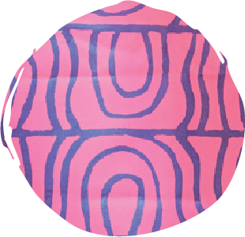
Jock Puautjimi (Tiwi Design)
Burial Sites

Tiwi people believe that the dead person’s existence in the living world is not finished until the completion of a Pukumani ceremony, in which the spirit of the mobiditi (dead person) goes into the spirit world. The ceremony occurs about 12 months after the deceased has been buried and culminates in the erection of Pukumani poles; gifts to placate the spirit of the dead, which symbolise the status and prestige of the deceased. The poles are placed around the burial site during the Pukumani ceremony.

This design was originally created in the 1990s as a linocut and was adapted to a larger screen at Megalo Print Studio on Ngambri and Ngunnawal Country (Canberra) in 2012. It depicts: “The special taboo places called Pukumani. We place Pukumani poles around burial sites during our final Pukumani ceremony. Until this final ceremony we are not allowed to go near these burial sites.”

Jock Puautjimi is an accomplished Tiwi artist. His Tiwi name is Pulawurrumayini (mullet) and his skin group is Wantarringa (sun). His mother’s Country is Pularumpi, Melville Island, and his father’s Country is Port Hurd, Bathurst Island. Jock has been creating as a ceramicist, painter, wood carver and designer for screen-printed textiles since he left school in 1979.

Esmeralda Philmax wearing Priscilla Badari, Silvia Badari and Katra Nganjmirra’s Woven Mats design. Photo: Kate Harding.

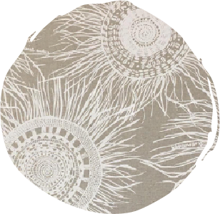
Priscilla Badari, Silvia Badari and Katra Nganjmirra (Injalak Arts)
Woven Mats

This design depicts Marebu (woven mats) — valuable items traditionally made by women. Marebu have many uses: being worn; a surface to prepare food on; rolling up and carrying children, particularly in the yekke (cold season) in June/July; a sleeping mat; and various ceremonial uses. Priscilla Badari explains that people were originally inspired to make round mats by the shape of the moon.

This design was based on real examples of woven Pandanus spiralus Marebu at Injalak Arts with all their variety of patterns and weaving techniques. It is a vibrant design that expresses the women’s love for their cultural heritage and their desire to extend it to new media.

Priscilla Badari, Silvia Badari and Katra Nganjmirra are Kunwinjku daluk (women) who work at Injalak Arts. The women are all weavers and create fabric designs reflecting their strong connection to Country and culture. This design was collaboratively created during a fabric design and screen-printing workshop run by Injalak Arts in 2013-2014.

Priscilla Badari
Marebu (Woven Mat) 2025
Pandanus and natural dyes
Courtesy Aboriginal Art Co.

Minyerri 2019

Minyerri is a remote community located in the Roper Gulf region of the Northern Territory, approximately 270 kilometres southeast of Katherine. Situated on the Traditional Lands of the Alawa people, near the Hodgson River, Minyerri is surrounded by sandstone escarpments, seasonal floodplains and billabongs. Various languages are spoken in the community, including Alawa and Kriol.

The Minyerri collection emerged after Alawa artist Samara Billy attended a Magpie Goose fashion show in Katherine. Inspired, Samara believed that designs from the Minyerri community should also be shared with the world. In 2018, Magpie Goose held a workshop with six emerging artists at the Minyerri Arts and Cultural Centre. The designs created during the workshop formed the basis of the Minyerri collection, which launched the following year. The collection shares stories of native wildlife, bush tucker and tool making on Alawa Country.

Artists: Jones Billy, Samara Billy, Samuel Daylight, Dudley Forbes, Rocklan Hodgson, Agnes Wilfred, Naomi Wilfred

Often referred to as Billabong Country, Minyerri is rich in bush foods and bush medicines, including the gulbarn tree (Melaleuca citrolens). For tens of thousands of years, Aboriginal people in the region have used gulbarn leaves to treat coughs and colds.

In the late 1800s, the lands of Minyerri were forcibly taken and converted into a cattle station by European settlers. Between 1903 and 1908, the Eastern and African Cold Storage Company acquired Minyerri and surrounding pastoral leases, and engaged in a brutal and systematic campaign to remove any Aboriginal person perceived as interfering with pastoral operations. In 1990, the Aboriginal and Torres Strait Islander Commission (1990-2005) purchased back the lands of Minyerri and returned them to the Traditional Owners, the Alawa people. Since then, many Alawa families have moved back to Minyerri from settlements such as Ngukurr. As a closed community (visitors require a permit), the Alawa people of Minyerri continue to maintain and pass on their language, Dreaming stories and connection to Country.

Scan for an Audio Description of the Minyerri collection


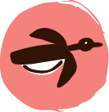
Murnubbarr Label

Billabongs are a rich source of food.

In Minyerri, did you know that you can make bread from the Yalbun (water lilies) found in billabongs? First, you collect the seeds. Then, you dry the seeds in the sun and grind them into a paste. Finally, you mix in some water and fry the dough.

Some of the designs here are of Yalbun — can you spot them all?

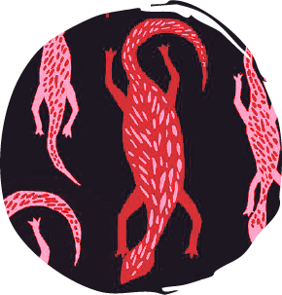
Samuel Daylight
Darbalun (Goanna)
Courtesy Magpie Goose

“This design I made is the little goanna — in our Alawa language we call it Darbalun. We have them for lunch when we go out hunting for animals. We’ve lived on this animal for 65,000 years, since time began! You catch it by lifting up a rock (they live under the rock). Then you chuck it in the coals or make a stone oven (Ardarl in Alawa language). Every meat tastes like chicken, but chicken doesn’t describe it, it’s a taste to die for! There’s a bigger goanna too — Warjindu in Alawa. The bigger goanna is my ‘second boss’. We both own each other, in our culture. We share ceremony and share the same cultural state.

Each person is connected with an animal. For me it’s kangaroo and the bigger goanna. These are my totems. My mother’s father and my grandmother — my mum’s side of family — represent the goanna. And the goanna also represents this land, Alawa Country, Minyerri. This is Goanna Country.”

Samuel Daylight is an Alawa man, born and raised in the Urapunga community. He lives in Minyerri with his wife Agnes Wilfred and her family. Samuel works at Minyerri Health Centre and was a former Chairman of Alawa Corporation. On the weekend he likes going out bush, hunting, fishing and camping with his family.

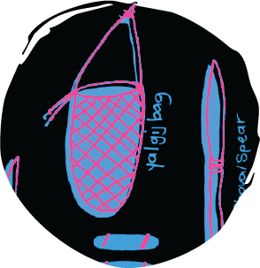
Naomi Wilfred and Rocklan Hodgson
Aboriginal Bush Tools
Courtesy Magpie Goose

“This design shows the Aboriginal tools that our past generation used. They had to make their own tools. My design has a stone axe, shovel spear, the number 7 boomerang, the normal boomerang and the gulimun. We make gulimun out of paperbark and carry the djupi berries (black currents). Sometimes people still use these tools, like if a crocodile comes out of the billabong, or a barramundi, they can use the shovel spear or maybe knock a kangaroo down with that. We’ve got the clapstick for when we have corroboree and when we have the little babies born we put them in the gulimun. If you want to make a baby go to sleep, you sing them songs and rock them.

Today when we look at these tools — it’s a bit funny — we think, how did those tools work for them? If we do it, it might not work for us!” – Naomi Wilfred

Naomi Wilfred was born and raised on Alawa Country in the Minyerri community. She is Alawa on her father’s side and Mara on her mother’s side from Ngukurr. Naomi is one of nine sisters. She created this design with her son, Rocklan Hodgson.

Jones Billy and Dudley Forbes wearing Samuel Daylight’s Darbalun (Goanna) and Dudley Forbes’ Dakawa’ (crayfish) designs. Photo: Helen Orr.

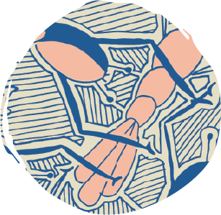
Dudley Forbes
Dakawa’ (crayfish)

“This design is about the crayfish — Dakawa’ in Yolgnu Matha (the language of East Arnhem Land). There are two kinds of crayfish — the one with the black on the side comes from the billabong and the yellow one is from the river. Around Minyerri we catch these in McDonald and Minamia Rivers, Rocky River — any river that runs! We catch the black ones in the billabong that’s here in Minyerri. We catch them with a line and a fish net. We dirty the water with our feet or with a stick (make it all muddy), then catch a heap! When we catch them, we break the claws off so we make sure they don’t bite. Then we chuck ‘em on the coals to cook them. They taste really good.”

Dudley Forbes was born in Katherine but grew up at a small outstation named Emu Springs near Daly River/ Nauiyu. His father was an artist and inspired him to develop an interest in art. Dudley lived in Bulman and Gapuwiyak in South East Arnhem Land before moving to Minyerri after meeting his now wife, Rowena. They have two girls and a boy together. Dudley has worked as a driver for the Health Clinic in Minyerri.

Jayzena, Samara Billy and Lyndell wearing Samara Billy’s Rongngyi (Bush Lillies), Jones Billy’s Garrjala (Nail Fish), and Naomi Wilfred and Rocklan Hodgson’s Aboriginal Bush Tools designs. Photo: Helen Orr.

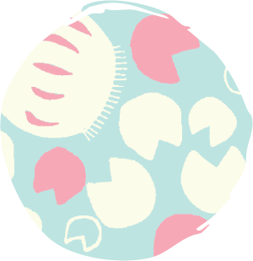
Samara Billy
Rongngyi (Bush Lillies)

“My design is about Rongngyi — lily pads and the stalk of the lily pad — that you can find in the billabong at Minyerri. Jo Jo is the stem — you can eat Jo Jo like celery. We eat it with salt. If you follow the stem of the lily pad to the mud, you find the Ganaya — the root. I did this design because it reminds me of when I used to go out and do cultural things out bush with all the Elders. The old people used to make damper with the lily seeds. You collect the seeds, dry them in the sun, ground them up, mix with a bit of water and then make a patty and fry it up — like a rissole! Everyone likes eating it with it when it’s cooked — it’s really soft, but also crunchy.”

Samara Billy is a proud Alawa woman who has lived in Minyerri her whole life. She played a pivotal role in the establishment of the Minyerri Arts and Cultural Centre and is one of the entrepreneurs behind the Gulbarn Tea business. Samara is proud of being a positive role model for her daughters — Jayzena, Ashlene and Letty. She is raising them to be smart, innovative, connected to culture and to work hard.

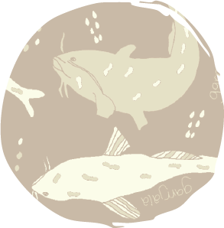
Jones Billy
Garrjala (Nail Fish)

“This design is about nail fish — or Garrjala in Alawa language. It’s also known as Balan Balang. You can find it in the billabong in Minyerri. It has what looks like a little beard, and it also has a nail coming from its back. It’s really sharp and dangerous, with poison on the tip. If it stings you, you’ll get so sore. If we get stung, we use the leaves from the white bark tree (break the leaf off and chew it) to put on the wound.

Every time we go out bush fishing we hope to get this type of fish, as well as catfish, bream and turtles. This fish can grow up to one metre. You notice it in the water by the bubbles that it makes. The kids are scared of it, if they see those bubbles in the water, they’ll get out!

We catch it by fishing — throwing a line in — using beef or water mussel or worm for bait. Or we catch it by poisoning the water with a native tree that we’ve got. You just cut the limb off the tree, then stir it in the water like a big spoon. That makes the fish gasp for air and float up to the surface, and then we catch them and cook them on the coals and eat them! Tastes sort of like barramundi. People who have diabetes like eating this fish; it’s good for them. Bush foods make them feel good, better than a medicine.”

Jones Billy was born in Minyerri. His mother Josie is one of the nine Wilfred sisters. His father’s Country is Arnhem Land. Jones shares, “Minyerri, it’s a good place to live…My grandfather was the key holder, Djungaya, for this place. Minyerri lifestyle is good — but not much happens around here! Most of the time we love going hunting and camping with our families. Now we’ve got 4WD it’s a lot better — long time ago people had to walk out to go camping”.

Edith Roberts wearing Agnes Wilfred’s Yalbun (Lily Seeds) design. Photo: Helen Orr.

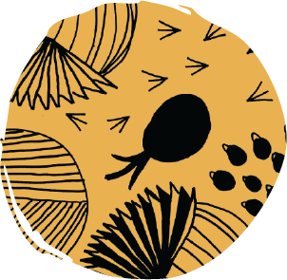
Agnes Wilfred
Yalbun (Lily Seeds)

“My design is called Lily Seeds — Yalbun in Alawa language. In the olden days my grandparents used it to make damper (da ga in Kriol). They’d go out to the billabong to collect the lily, take the seed out, spread it out to dry in the sun, smash it up with a rock into flour, put water in it, make it into a damper patty and then fry it.

In this design there’s the Yalbun (the big circular lily pad) and the seeds — that’s what we eat (the little black dots), and then there’s the Ganaya (the pineapple-shaped image) — that sits in the mud. We boil it. Inside it’s like an egg — very yellow. And then there’s Runggai (the hairy one) — that also sits below the water, in the mud, at the bottom of the stem.

We still go out and collect this bush food and eat it — it’s best after there’s lots of rain in the wet season, then in the dry season we collect it in the billabong.”

Agnes Wilfred is an Alawa Mara woman from Minyerri. Her mother’s language is Mara, her father’s language is Alawa and her first language is Kriol. Her totems are the King Brown snake and mermaid. Agnes helped set up the Minyerri Arts and Cultural Centre with other community members in 2017, because “old people wanted to acknowledge the young people, and teach them to follow law and culture, and respect each other”.

Ardyaloon 2019

Ardyaloon, also known as One Arm Point, is a small community located on Bardi Jawi Country, north of what is now called Broome on the Dampier Peninsula. Bardi Country spans the peninsula and a group of nearby islands, while Jawi Country encompasses the sea and land to the east. Bardi and Jawi people are known as gaarra (saltwater) people.

In 2019, Magpie Goose visited the Ardyaloon community to collaborate on a new collection. Ten artists created designs for the collection, sharing stories of ancient trading routes, the changing seasons and marine life, including miinimbi (whales) and odorr (dugongs).

Artists: Russell Davey, Jacqui Hunter, Eddie James, Janine Mandijalu, Karen Morgan, Rowena Mouda, Henarlia Rex, Annette Sampi, Pauline Sampi, Jody Wiggan

Bardi and Jawi people have cared for the lands, waters and islands of the Dampier Peninsula for tens of thousands of years. Significant changes occurred in 1899 when Sunday Island Mission was established on Iwany (Sunday Island). Many Aboriginal people were forcibly moved there and spent weeks at a time camped on islands, harvesting trochus (sea snail) shell to financially support the mission. After the mission closed in 1965, many Bardi and Jawi people relocated to Ardyaloon where they established their own community.

Ardyaloon is characterised by its striking contrast of pindan (red soil) and white sand plains. The turbid waters of the King Sound gulf move across the marnany (reefs), rock shelves and mudflats that fringe the coastline. These strong tidal currents create rich areas for foraging and hunting. Inshore fishing is common, and catch can include odorr (dugong), goorlil (turtle), blue bone and mangrove jacks. Ardyaloon is also well known for its trochus fishery and hatchery. These days, only Bardi, Jawi and Mayala people are licensed to commercially and sustainably harvest trochus in Western Australia. The meat of the snail continues to be an important food source, and the shell is collected for ceremony and trade, while also providing a valuable source of income for communities.
Scan for an Audio Description of the Ardyaloon collection


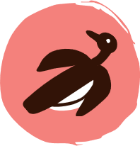
Murnubbarr Label

There are over 250 languages used by Aboriginal and Torres Strait Island communities. Speaking language is an important way to connect to Country and culture.

Let’s learn some Bardi words while exploring the Ardyaloon collection. Can you figure out what the following words mean?
- Odorr
- Miinimbi
- Manboor
- Joodarn
- Gamaloon

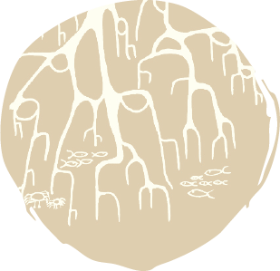
Jody Wiggan
Mangroves
Courtesy Magpie Goose

“My design reflects mangroves by the sea, Nyordnyual Gaarra in Bardi language. Mangroves are important to me because they protect sea creatures and prevent erosion along the shoreline. Mangroves protect the land and people from waves and storms.

My people built rafts from mangroves too. It was their only transport to get from island to island and to catch turtles and dugongs to feed their growing families. The mangroves around here are very light, like driftwood, and only grow on this one island called Jurnawarn (Helpman Island).”

Jody Wiggan is a proud Aboriginal woman. On her father’s side she belongs to the Bardi Jawi people and her clan group is Barnarradd (Cygnet Bay). On her mother’s side she belongs to the Mayalla people and her clan group is Ullgurd (Long Island). Jody lives in the Djarindjin community, a roughly 20-minute drive southwest of Ardyaloon.
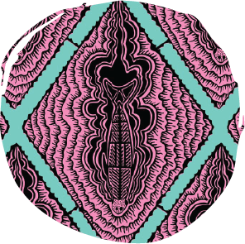
Russell Davey
Odorr (Dugong) Diamond
Courtesy Magpie Goose

“My design is of an odorr (dugong) swimming through the water, viewed from above. In the old days, men would go hunting and would see the dust and know it was a dugong feeding on the reef. It’s different from a stingray’s dust.

Dugongs come in and out of our waters depending on the season. They hang around for about three months; then when the whales come in, the dugongs move on out. At the same time the turtles start mating.

Traditionally they would go out hunting dugong on rafts — today we go out on dinghy and spear them with a big jarraja (harpoon spear). We make the spears from wongai (wattle) or woolleybutt. Traditional way is the best for cooking dugong — in the ground. It’s a bit like pork; so you can roast it, boil it, stir fry it, or make stews out of it!”

Russell Davey is a Bardi saltwater man with many connections and is a member of the Ardi’ol clan group. He creates carvings using materials such as turtle shells, boab nuts, pearl shells and ceremony shields, and will sometimes utilise a technique called wood burning. Russell is passionate about sharing Dreamtime stories of the saltwater people and ensuring that law, language and culture are kept alive for younger generations.

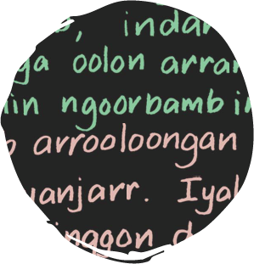
Annette Sampi
Gamaloon (Bush Pear) Bardi Language Story
Courtesy Magpie Goose

“My mum was a linguist, she helped finish off the Bardi language dictionary that was started by her older brother and sister, which was published in the ‘90s. It’s part of my family history. My brother did all the pictures, and my mum came up with all the sentences to show how the words are used.

I grew up learning the Bardi language from my old people. I find it hard now, because you don’t have people speaking it. I carry the book with me and constantly learn from it. I had it with me at the Magpie Goose workshop. I said, ‘I’m not an artist, but I can write the Bardi language that I speak’, so I decided to do a language story as my design! I chose this section of writing from the dictionary to do as a textile design because I like the gamaloon (bush pear). I know my bush fruits! You have the gamaloon at Christmas time. They are about marble size and have small yellow flowers. Some can be bitter, some can be sweet. I like the ones that are just a little bit bitter. They have a seed in the centre. When you squeeze it, the seed comes out.”

Annette Sampi lives with her family in Ngamakoon, west of Cape Leveque and before Lombadina/Djarindjin. Ngamakoon is like a secret hideaway next to the marsh flats. Beyond the mangroves is white sand, flat rocks and crystal blue waters. There is also red sand in this area. Annette says it’s hard to describe just how beautiful it is.

Models wearing Jacqui Hunter’s Miinimbi (Whale) and Rowena Mouda’s Joomoo Tree designs. Photo: Michael Jalaru Torres.

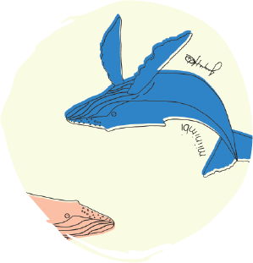
Jacqui Hunter
Miinimbi (Whale)

“You can see the Miinimbi (whales) from our family block on my father’s Country, Hunter’s Creek, where the saltwater creek runs into the Indian Ocean. It’s beautiful there. You only see the whales once a year, when the dugongs are moving out and the ‘marry turtles’ are moving in for mating season. This is a special time of year for everyone — because if we catch a marry turtle (the ones with eggs), we have a big feast and share it with all the family!

If you want to see whales down south, you have to pay lots of money! But we get to see them for free. They come in around August/September when the season is coming into Djalalayi (hot season), when we’ve finished Bargana (cold season). They’re around until December, then at the end of December, Mangal (rainy season) comes in. I don’t know where they go next — maybe down south or overseas!”
Jacqui Hunter is a Bardi Jawi person from Ardyaloon, where she lives with her whole family. She worked at the Ardyaloon school for 17 years and is now training to be a teacher in Boorloo (Perth). Jacqui has always loved painting — her grandmother was a painter and all her cousins are painters. She’s just started painting at home and loves doing it.

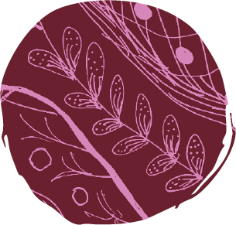
Rowena Mouda
Joomoo Tree

“I drew the seeds and the flowers of the Bauhinia tree — Joomoo tree in Bardi language. I drew it because it was in season at the time; it was flowering and fruiting. I like the Joomoo tree because of the many significances and uses it has. We can use the wood to burn; it’s good wood for cooking food on. We also suck the honey that comes from the flower pods — the birds also love it. There’s a long cup in the little flower pod where the honey sits. We just get it and suck the honey out. It’s light — not thick honey. Very sweet.

There’s soft sweet gum that also grows on that tree. The gum has its own taste: not sweet, not sour. We didn’t have access to the shop growing up, so we’d go and eat all sorts of bush fruits. So the Joomoo tree is actually a food resource for us!

It’s always got the beautiful leaves on it — it doesn’t lose its leaves that much — so it’s always a shady tree. But if the leaves do drop, it’s good soil for growing other plants under it. So that’s the other thing about it. I’m a keen gardener, and when I lived in Ardyaloon, we had a big Joomoo tree at our house that I did all my gardening under. It’s got good shade and good native soil that I could use. It’s so moist from the tree.

There are colours naturally on the Joomoo tree — a black, rough trunk, then the long brown seed pods, the green of the leaves — not a high pitched green, but not too dull — and then the red flowers. The Joomoo tree is not just a tree, it has many uses. That’s just like people! There are many parts of us that do different things. This tree is like that too.”

Rowena Mouda was born in Derby and raised in Ardyaloon. She is a descendent of the Oomeday and Yowjabi (mother’s father) and Nyikina and Bardi (mother’s mother) tribes of the West Kimberley region. She and her husband James live in Derby and have four children and five grandchildren. Rowena has been involved with many different community organisations, including as Chairperson of Ardyaloon Community. She was also heavily involved in securing Native Title for her grandparents’ Country.
Model wearing Eddie James’ Joodarn (Crayfish) Manboor (Ghost Crab) & The Moon design. Photo: Michael Jalaru Torres.

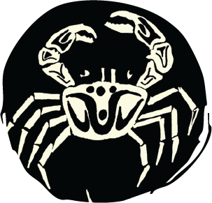
Eddie James
Joodarn (Crayfish) Manboor (Ghost Crab) & The Moon

“This is my design about catching crabs and crays. It’s also got the new moon, and the half moon. The moon tells you about the tides. We follow the moon. It tells us what we go fishing for and when we should go fishing. We don’t look at tide charts. There’s a big tide — big springs — for the new moon. You’re talking nine, maybe 10 metre tides. Then, neap tide for half a moon. Most people go fishing on neap tide. At full moon people go to the fish traps. They’ve been round way before my time — the old Bardi stone trap — people are still using it today! Mainly for fish or stingray. When the tide is low, the big rocks trap fish in there and you can catch them easily. In the olden days, the old people used to chase the fish into the shallows, into the pools, then spear them.

In my design you’ve got the painted cray — joodarn — and the ghost crab — Manboor. Then there’s lines representing all the tides and holes where they go in. The crayfish will go in under the bigger rocks, into big open caves, but it won’t go into small holes. But all the other crabs — mud crabs, ghost crabs, blue swimmer — bury themselves in the sand. Manboor dig holes up on the sandy beach — we use them for bait to catch fish. The mud crab will go into deeper holes probably about three to four metres deep. Not many people go out of their way to hunt for painted crays, because they’re hard to catch — but we know some secret places. Secret agent club. But mud crab; they’ll go out all the time. You get the mud crab from the mangroves, when the tides come out from the mud.

To catch a crab, you put a spear through them — we make these out of wongai (wattle), or pick them up with a metal hook. You cook the crab on the open fire. Painted cray probably boil or steam them up. We go out and catch crab when we feel like eating it; we collect it for the grandchildren, or the older people, or for ourselves. Go down catch a crab, light a fire on the beach, cook them up straight away. That’s how people do it around here.”

Eddie James is from the Bardi tribe. His mother is from Pannawonica, near Karratha. He was born in Broome, later moving to Beagle Bay and, eventually, to Ardyaloon to be with his father’s family. Eddie used to work for One Arm Point Aboriginal Corporation, including as a landscaper, labourer and machine operator. He only recently started making art and particularly likes painting. Eddie has three sons and 10 grandchildren with his partner Annette.

Kalumburu 2022

Kalumburu is the northernmost settlement in Western Australia, located on the banks of the King Edward River, upstream from Malindjar Gorge. Home to the Wunambal and Kwini people, Kalumburu has a population of nearly 400 people. During the wet season, roads are typically cut off due to flooding, meaning access is only possible by boat or plane.

In 2022, Magpie Goose launched a collection in collaboration with the Kalumburu Strong Women’s Centre. This centre was first established to support female artists living and working in the Kalumburu community, often using art as a means of creative expression and healing. Featuring eight artists, the designs in the Kalumburu collection speak to cultural practice, bush food, fishing, going bush and mission history.

Artists: Catherine Budamurra, Nina Maraltadj, Rosa Marnga, Sally-Anne Milgin, Jacinta Undalghumen, Cissy Unghango, Dominica Williams, Dulcie Williams

The Kalumburu community is guided by the Traditional Owners, who are dedicated to protecting cultural knowledge and practices, creating opportunities for residents, and celebrating their culture, language and connection to Country.

In 1905, Drysdale River Mission was established on the coastline of what is now called Mission Bay. Many young Aboriginal children were forcibly moved to the mission, which was designed to ‘civilise’ and catholicise them. Punishments were handed out to those found speaking in language, performing ceremonies or engaging in cultural activities. Forced removals were carried out across the country for decades, brutally separating many Aboriginal families. In 1932, Drysdale River Mission began moving 30 kilometres south to Kalumburu due to water shortages.

During the Second World War, the mission became a frontline Royal Australian Air Force base, supporting operations against Japanese forces in the Timor region. On 27 September 1943, a
devastating Japanese air raid killed six people, including five Aboriginal community members, four of whom were children. Although the mission stopped housing children in 1982, it
continued to play a role in the daily activities of the Kalumburu community until 2014.

Scan for an Audio Description of the Kalumburu collection



Murnubbarr Label

The designs here tell many stories. Rosa Marnga shares the story of her Ancestors who traded with Macassan sailors from present-day Indonesia. Rosa’s Ancestors would exchange sea cucumbers for a unique type of fruit called tamarind. Tamarinds taste both sweet and sour. Tools, knives and spearheads were also traded.

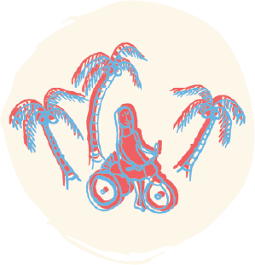
Nina Maraltadj
Sister Scholly
Courtesy Magpie Goose

“Sister Scholly (Scholastica) was a nun here in Kalumburu. She came over from Spain when she was very young — maybe 20. Sister Scholly was one of the first nuns here when they started the mission — there were about six nuns — and she was here until she died (aged 90)! The missionaries came on a boat from Spain to New Norcia, near Perth, then came up to the Kimberley area. They wanted to help Aboriginal people, so they came to Kalumburu to start a mission up here. All the nuns learned the community language (mostly Kwini language, also known as Bela) from the old people that used to help out at the mission.

Sister Scholly saw me grow up — I was in my 20s when she died. She was like a mother and a grandmother to all of us in Kalumburu. All the women who grew up in the convent used to call her mum — my mother was one of them. My grandmother died giving birth to my mother, so my grandfather came in from the bush and dropped her off here with the nuns. She also raised some of the old ladies who are here now in Kalumburu; old girls now. My mother used to work for her milking the cows and taking the fresh milk back to the convent to make cream and butter. Sister Scholly always had breakfast waiting for me when I went with mum.

As she was getting older Sister Scholly couldn’t walk around the community, so the community got her a quad bike! With her quad bike she used to go to all her favourite swimming spots, go to the beach, down to the river. She used to love taking us kids for a ride everywhere!”

Maria Maraltadj, often referred to as Nina, is a Kwini woman whose language is Bela. Nina lived in Kalumburu all her life and often spent her time gathering with women at the women’s centre to yarn and paint. She also taught Bela language courses to young kids in the community and regularly took her family to McGowan Island Beach to teach them about which foods to eat and what to find in the bush.

This artist passed away in 2023 and we show this with permission of her family.
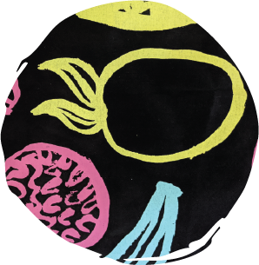
Cissy Unghango
Mission Fruits
Courtesy Magpie Goose

“I drew the fruit that we used to have back in the old days, during the mission times. The mission people planted a fruit orchard. There were so many fruits — banana, watermelon, cashew nut, pineapple, tomato. When I was growing up, we still had big mob of fruits to try — I loved the cashew nut tree. Now there’s mostly just lots of mangos. This is all way before my time, so I get Rosa (who’s an Elder) to help tell the story.” – Cissy Unghango

“The mission garden had a lot of fresh veggies, fresh fruits. We did peanut farming too. Pineapples, mangos, dates, custard apples, tropical fruits, paw paws, bananas, we had everything down at the mission. Beetroots, carrots, silverbeets, capsicums, lettuce, you name it — we had everything here. It was our Garden of Eden. We all helped in the garden after school.” – Rosa Marnga

Cissy Unghango lives in Kununurra with her family. She is a Gaambera person on her mother’s side, and a Kwini person on her father and grandmother’s side. Cissy enjoys taking her children to the basketball court, going fishing, walking to the airport, visiting the creek and going out bush. For Cissy, making art is something that gives her a lot of joy.

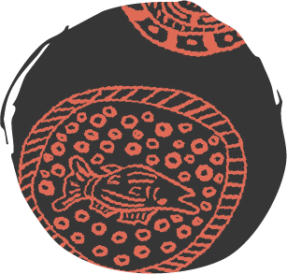
Jacinta Undalghumen
Boab Nuts
Courtesy Magpie Goose

“I did this design about the boab nuts that I used to see my two uncles carve and sell to tourists in Wyndham. Since I was a small girl, I used to watch them carve. All around the Kimberley you can find people doing boab nut carving; for a bit of money, just to keep them going. Some do outlines on the boab, others do painting with lots of colours on the boab nut. When I came here (to the Magpie Goose workshop) I had that thought, I know how to carve boab nuts, so I may as well paint it — and tell the story!

The old people used to crack the boab nut and eat it — they said it was a bush medicine, for the stomach ache. You can crack the boab nut and there’s fruit inside. It’s dry. We used to eat lots of that when we were kids. Some are sweet, some are sour. You can mix it with sugar or honey and water, get it with a spoon and eat it. It tastes nice. When we were waiting for our parents to catch fish for dinner we used to eat the boab nut.

We tell stories on the boab nut; boabs are special, they only grow in the Kimberley. In my design, I’ve done the animals that we eat, that we hunt for out in the bush, like barramundi, bream, goanna. Then there’s the snake; the Dreaming that creates the rivers and the waterholes.”

Jacinta Undalghumen is a Kalumburu artist belonging to the Kwini people. She loves to spend her time going out bush, hunting, camping, fishing, swimming and walking. When she visits Kalumburu, she goes to the women’s centre to paint stories and memories from her childhood. Jacinta enjoys using art to express herself.

Gina Williams, Trinita Bundamurra and Zarika Peumora wearing Nina Maraltadj’s Marlingu (Oysters) and Dulcie Williams’ Lily Pads designs. Photo: Clare Wood, Enterprise Partnerships WA and Maria Fredericks, Kalumburu Photography Collective.

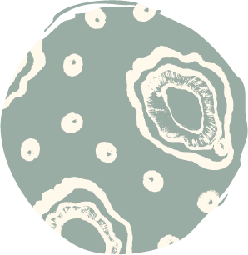
Nina Maraltadj
Marlingu (Oysters)

“I created this Marlingu (oysters) design for Magpie Goose in August 2018. We get a lot of oysters at McGowan Island Beach. The old people used to tell us that oysters are good medicine for when we have chest problems, like heavy colds and flus. We eat them raw, but sometimes we cook them on the coals; they’re more yummy this way! We get them straight off the rocks; we get a hammer or an axe and just chip it off the rocks. You can get them all along the coast; so if we get too much from McGowan, then we go to the next beach.

Our whole family goes out camping at the beach. Makes us feel good — to be out on Country and to feel the spirit of the bush. There’s no stress. Nothing stressed about the bush! Just peaceful there. My design also has the pearls that you can find in the oysters — but we don’t get them as big as the ones you see in Broome! Some people they just keep it when they find pearl; some people make necklaces out of it! I have found little black small pearls before. There’s a lot of pearl farming in Broome.”

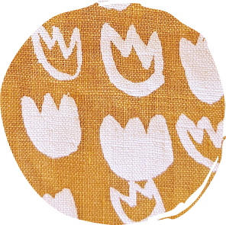
Dulcie Williams
Lily Pads

“My design is the lily pads in the waterholes. The lily pads are along the waterhole in Oombulgurri. Oombulgurri was a small community. It got shut down and everyone had to leave. Some moved to Wyndham. I came to Kalumburu. There’s biggest mob of waterholes in Oombulgurri — freshwater waterholes, no crocodiles. It’s beautiful.

I painted the lily pads because I like drawing them. It reminds me of my favourite place. Every time I go to the waterhole, I look at the lily pads. And I just jump in the waterhole and smell the lily pads. They smell good. I dive under the water and forget all my troubles. It’s my happy place.”

Dulcie Williams was born in Wyndham and raised in Oombulgurri by her grandparents. At the age of 18, she moved to Kalumburu. She has one sister and three brothers. Reflecting on her time in Kalumburu, Dulcie shares, “I like living in Kalumburu — it’s quiet, I go for a walk every afternoon and look at the views. Sometimes I go to church, say prayers”. Dulcie now lives in Derby, Western Australia.

Chelsea Bundamurra, Trinita Bundamurra and Zarika Peumora wearing Dominica Williams’ Lanky design. Photo: Maria Fredericks, Kalumburu Photography Collective.

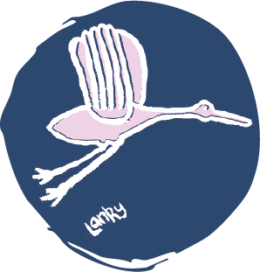
Dominica Williams
Lanky

“I did the lanky design for Magpie Goose in 2018. It’s a brolga that became a part of our community. Sylvester found him in the bush when he was a little chick, and he grew him up here in the community. Since then, he was always around, he never left the community. Lanky was part of the community — he was part of us. He was like the next person. The kids loved to play with him. He was a community friend. He would even come to the discos! The dogs chased him a lot. He had a family too of his own. He had a few chicks with his girlfriend. He would go down to the billabong and wait for his family to come visit him.

When his owner (Sylvester) passed away, after everyone left the grave, he stuck around. He came and sat down at the grave. I think he knew; his dad had passed on. He still came round visiting with his little family. A lot of people fed him. He was okay in everybody’s houses. People here were used to him. He was around for three or four years, when I was a teenager. I reckon Lanky will look good on clothes — people would be proud of him on clothes.”

Dominica Williams is a young Kwini and Gaambera woman from the Kalumburu community. Her grandmother is Wunambal Gaambera and her great-greatgrandmother is Kwini. Although she grew up in Kalumburu, Dominica has also lived in Broome and Derby. She enjoys spending time at the women’s centre, where she sews and makes jewellery.

Zarika Peumora wearing Rosa Marnga’s Macassans design. Photo: Maria Fredericks, Kalumburu Photography Collective.

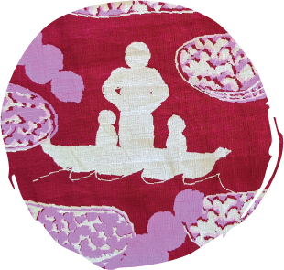
Rosa Marnga
Macassans

“My design is about the Macassans coming across from Indonesia and trading with our old people. They would bring their tamarinds and trade them for our sea cucumber (trepang). We had many sea cucumbers growing on our islands here. They would trade other things as well — tools, knives and spearheads.

The ‘giant’ in the design was the one the Macassans used to deal with. He was my Ancestor. He was the leader of the Gaambera people, he was the one who looked after our Country.

He was the biggest fella, maybe six foot tall. The Macassans had to go through him. He would make the deal with the Macassans, and then other people from our Country and surrounding Country would come to him to trade goods for the tamarinds. This was all happening a long time ago — before the missionaries came around. People wanted the tamarinds, they liked the taste. Sometimes they would mix it with the fish for extra flavour but mostly they just ate them — just like lollies! The tamarind trees grow wild around here now, because of when the Indonesians came across to trade.”

Rosa Marnga lives in Kalumburu and is a proud Kwini and Wunambal Gaambera woman. Her father is a Kwini man and a Traditional Owner of the lands stretching from Pago to Kalumburu, with her paternal family recognised as guardians of this Country. Her mother is a Wunambal Gaambera woman from the Bougainville Peninsula. Rosa is deeply committed to protecting Country from threats such as mining and plays an active role in her community. She is a member of the Wunambal Gaambera Corporation and regularly helps with cultural responsibilities.

Ikuntji 2019

Ikuntji (Haasts Bluff) is located 230 kilometres west of Mparntwe (Alice Springs) on Luritja Country. Nestled within the West MacDonnell Ranges, the community is characterised by red soil and desert vegetation, with nearby mountains reaching 1,400 metres high. There are stories of people from various language groups travelling to the area over many thousands of years. Today, the community is home to 150 people from a diverse range of backgrounds.

Magpie Goose visited Ikuntji Artists at the end of 2018, having connected earlier in the year at Darwin Aboriginal Art Fair (DAAF). In 2019, they launched the Ikuntji collection together. Five artists took part, and their vibrant designs speak to Ngurra (Country) and Tjukurrpa (Dreaming). The collection was highly successful and became a finalist in the 2020 National Indigenous Fashion Awards and the 2020 Design Files + Laminex Design Awards.

Artists: Alice Nampitjinpa Dixon, Eunice Napanangka Jack, Mitjili Napurrula, Mavis Marks, Keturah Zimran OAM

Anangu people have maintained strong connections with this region for tens of thousands of years. Today the artists of Ikuntji, who hail from across the desert, continue to keep culture strong through art making.

In the late 1800s, the building of the Overland Telegraph Line, connecting Adelaide to Darwin, brought an influx of European settlers to Central Australia. Aboriginal people fought and resisted occupation, but over time, were systematically displaced from their lands. In 1941, Haasts Bluff Native Settlement was established as a ration depot for Aboriginal people. A year later, it became an outpost of Hermannsburg Mission, or Finke River Mission. The mission eventually closed due to water shortages, and residents were sent 40 kilometres away to Papunya Native Settlement. It was here, in this region, that the Western Desert Art Movement began. This movement inspired Aboriginal communities to start creating works on canvas.

The movement grew beyond the region, especially as people began to move away to outstations and other communities. Ikuntji Artists was established in 1992 and was the first art centre established for and by women of the Western Desert Art Movement. The art centre has since become internationally recognised for fine art and textile design.

Scan for an Audio Description of the Ikuntji collection

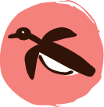
Murnubbarr Label

Tjukurrpa (Dreaming) is the foundation of Anangu culture. It is a very big concept that connects to all parts of life, linking Anangu people to their Ancestors and the environment. One aspect of Tjukurrpa is passing down stories through song, dance and painting.

On display are two works by Keturah Zimran OAM. Both works share stories that were passed down to Keturah from her mother and grandmother.

Are there any stories that have been passed down through your family?

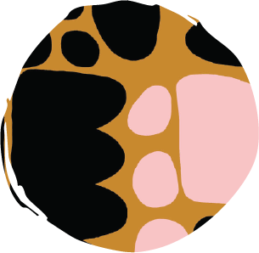
Keturah Zimran OAM
Puli Puli (Rocks)
Courtesy Maggie McGowan and Laura Egan

In this design, Keturah Zimran OAM depicts the puli puli (rocks) at two different sites. She reflects on the landscapes at Ikuntji (Haasts Bluff) where she grew up and also at Karrkurrutintja (Lake McDonald) in Pintupi, west of Walungurru (Kintore) along the Western Australian border. This story was passed down to Keturah from her grandmother, Narputta Nangala Jugadai. Narputta was passed down this story from her father, Talaku Tjampitjinpa. Both Keturah’s grandmother and mother, Molly Napaltjarri Jugadai, painted this same Country.

“The sand hills I paint are my mother’s story and the rocks I paint are my own story. My paintings are about my story and my mother’s…I like to paint; painting helps me forget my troubles. I paint every day. My grandmother used to say to me when I was younger, ‘One day you will paint.’”

Keturah Zimran OAM is an Arrernte, Luritja and Pintupi artist. She is the youngest daughter of Molly Napaltjarri Jugadai and Smithy Zimran. Her maternal grandmother, Narputta Nangala Jugadai, painted since the beginning of the Western Desert Art Movement and was a founding member of Ikuntji Artists. Keturah’s two brothers also paint, as does her aunt, Yukultji Napangati. Since her grandmother and mother passed away, Keturah has continued to paint their stories.

Keturah Zimran OAM
Puli Puli Rocks
Acrylic on Belgian linen
Courtesy the Children’s Health Queensland collection

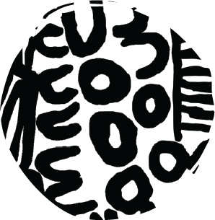
Mavis Marks
Women’s Business
Courtesy Magpie Goose

In this design, Mavis Marks depicts women’s business. She paints women’s ceremonial dancing at Watiyawanu (Mount Liebig), close to where she was born and lived most of her life. Through bold brush strokes, she renders designs traditionally used for ceremonial body painting.

Mavis Marks, a Luritja and Pintupi artist, was born in Newhaven, 360 kilometres northwest of Mparntwe (Alice Springs). She moved to Ikuntji (Haasts Bluff) as a teenager with her mother. When she married, she moved to Watiyawanu (Mount Liebig) with her husband and began to paint at the art centre there. Mavis returned to Ikuntji (Haasts Bluff) at the death of her husband, later moving to Papunya. She raised five children and her daughter, Sylvana Marks, is also an artist.

This artist passed away and we show this with permission of her family.
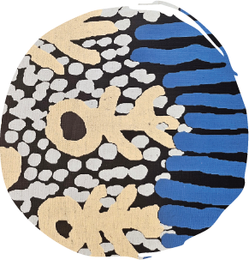
Eunice Napanangka Jack
Kuruyultu

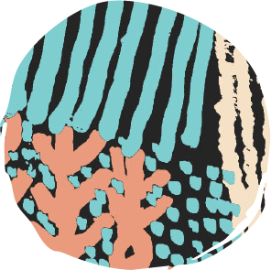
Eunice Napanangka Jack
Kuruyultu
Courtesy Magpie Goose

“This is my Country. I can’t remember how it all happened, because it happened before I was born. I have a scar on my back from it. My grandfather speared a wallaby at Kuruyultu. That night he ate that wallaby. At the same time my mother could feel me moving inside her. She was heavily pregnant with me. That next morning, after my grandfather had speared the wallaby, killed it and eaten it, I was born.

I was born at Kuruyultu, near the rockhole there...we left that place, Kuruyultu. My father, my mother, my big sister and my father’s brother, we all left together and went to Haasts Bluff. I grew up in Haasts Bluff. I have been back to Kuruyultu for visits, but I never lived there again in my Country. I think about it every day.

Only my father knows all the stories for that Country and he painted them too… all the men’s stories. I know the story of the wallaby mother and daughter which left me with a birthmark. That’s what I paint: the wallaby mother and daughter.”

Eunice Napanangka Jack, a Luritja, Ngaanyatjarra and Pintupi artist, was born at Lupul in the Sir Frederick Range, Western Australia. When she was little, food shortages forced her family towards the ration stations being set up in Central Australia. She remembered her mother piggybacking her all the way to Ikuntji (Haasts Bluff). Eunice’s father and husband were founding members of Papunya Tula Artists, and she often assisted them. Later at Ikuntji (Haasts Bluff), she created several collaborative works with her husband. An important woman in her community, Eunice was known for her hunting skills, dancing and Traditional Law knowledge.

This artist passed away in 2022 and we show this with permission of her family.
Lornie Djana wearing Alice Nampitjinpa Dixon’s Tjilkamala Rockholes design. Photo: Christian Koch. Courtesy Ikuntji Artists.

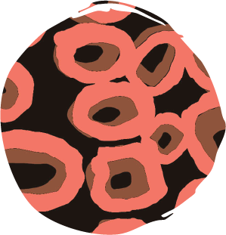
Alice Nampitjinpa Dixon
Tjilkamala Rockholes

“This is the story of Tjilkamala — the porcupine man. He is travelling around Talaalpi, east of Walungurru (Kintore) and is looking for ants. He digs for them in the ground and creates holes. Meanwhile tracking behind him are women out hunting, hoping to make the porcupine their tucker for the evening. These holes fill with water after the rain and with the morning dew. Over many years they have become rockholes.”

Alice Nampitjinpa Dixon, a Luritja and Pintupi artist, was born near Talaalpi, a swamp east of Walungurru (Kintore) on the Western Australian border. Alice’s personal Tjukurrpa (Dreaming) is Tjilkamala (the porcupine). Before she started painting, Alice taught young girls at Kintore School. She was an active ‘dancing woman’ who travelled widely to participate in annual ceremonies and ‘women’s law’ meetings.

This artist passed away in 2020 and we show this with permission of her family.

Lornie Djana wearing Alice Nampitjinpa Dixon’s Tali Tali design. Photo: Christian Koch. Courtesy Ikuntji Artists.


Alice Nampitjinpa Dixon
Tali Tali

In this design, Alice Nampitjinpa Dixon depicts the Tali Tali (sandhill) Tjukurrpa (Dreaming). Her work draws on the vast and desolate sandhills of her Country near Taalalpi, east of Walungurru (Kintore) on the Western Australian border. When it rains at Taalalpi, water collects between the sandhills, providing sustenance for Tjilkamala (the porcupine), Alice’s personal Tjukurrpa.

Lornie Djana wearing Mitjili Napurrula’s Watiya Tjuta design. Photo: Christian Koch. Courtesy Ikuntji Artists.

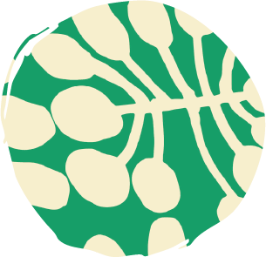
Mitjili Napurrula
Watiya Tjuta

In this design, Mitjili Napurrula paints her father’s Tjukurrpa (Dreaming), the ceremonial spear straightening on Uwalkari Country (Gibson Desert). Watiya Tjuta (acacia trees) are used to make these spears.

This story was passed down to Mitjili by her mother: “After I got married, my mother taught me my father’s Tjukurrpa in the sand, that’s what I’m painting on the canvas”.

Mitjili and her brother Tjupurrula both inherited the right to paint works related to Ilyingaungau. This site, south of Walungurru (Kintore), some 520 kilometres west of Mparntwe (Alice Springs), is where the artist’s Mutikatjirri Ancestors assembled their kulata (spears) for a conflict with the Tjukula men.

Mitjili Napurrula is a Luritja artist. Her mother, Tjunkayi Napaltjarri, ‘came in’ from drought-stricken Pintupi and Luritja Country, seeking refuge and rations in Ikuntji (Haasts Bluff). Along with her extended family, Tjunkayi was settled at Papunya, where Mitjili was born. Mitjili grew up in Papunya and moved to Ikuntji (Haasts Bluff) with her late husband Long Tom Tjapanangka. The couple started painting in 1992 when Ikuntji Artists opened.

This artist passed away in 2019 and we show this with permission of her family.

Ewyenper Atwatye (Hidden Valley) 2024

Ewyenper Atwatye (Hidden Valley) is a town camp in Mparntwe (Alice Springs) on Arrernte Country. The camp is home to a community of just over 100 people, most of whom speak Arrernte and Warlpiri. In Central Arrernte language, Ewyenper means ‘spearwood’, a variety of rambling shrub, and Atwatye means ‘gap’. The name of the camp references its location, situated between two hills dotted with spearwood.

In 2024, Magpie Goose collaborated with Ewyenper Atwatye Artists. Established in 2015, Ewyenper Atwatye Artists is a satellite project of Tangentyere Artists — the creative hub for all town camps in Mparntwe (Alice Springs). Twelve artists took part, and their designs tell stories of local flora and fauna, the changing seasons, and camping and riding horses on Country.

Artists: Alan Collins, Janelle Driver, Tim McNamara, Christopher McMillan, Janelle McMillan, Marita McMillan, Stella McMillan, Cassandra Neil, Loretta Neil, Phyllis Stevens, Bianca Turner, Carol Young
Mparntwe (Alice Springs) has long been a meeting place for the Arrernte people, the Traditional Owners of the region. Significant changes occurred in 1872, when the Alice Springs Telegraph Station was established. European settlers began invading Central Australia and opening pastoral stations. The introduction of cattle greatly impacted the abundance and diversity of local flora and fauna, and eventually, pastoralists took control of all major water sources. Aboriginal people fought and resisted occupation, but over time, were pushed to the outskirts of settlement. In 1932, telegraph operations moved to the adjoining town of Stuart, which became Alice Springs. Aboriginal people continued to camp in and around the town, despite settlers’ many attempts to remove them. In the 1970s, the Northern Territory Government began issuing perpetual leases (a form of land tenure) to Aboriginal communities living in these ‘town camps’. Although the leases were designed to create stability, they continued to prevent Aboriginal people from having control over their own land. In 1977, the same year Ewyenper Atwatye (Hidden Valley) was incorporated, a group of town campers formed Tangentyere Council to support the land rights and self-determination of residents — a fight that continues today.
Scan for an Audio Description of the Ewyenper Atwatye (Hidden Valley) collection


Murnubbarr Label

Ewyenper Atwatye (Hidden Valley) is a town camp in Mparntwe (Alice Springs). Mparntwe (Alice Springs) is right in the very centre of Australia.

Let’s look at Bianca Turner’s Kwatye Iperte (Waterholes) design. In this design, Bianca shares with us her deep knowledge of Country.

Did you know you can find water underground, even in the middle of the desert, if you know where to look?
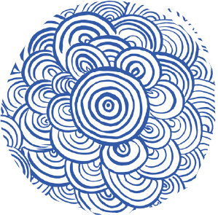
Bianca Turner
Kwatye Iperte (Waterholes)
Courtesy Magpie Goose

“This design represents the soakage you can find in the desert, in every area, different Country. You can dig with your hands, deep down and you can find Kwatye (water), even in the desert. This was the First Peoples drinking water when there was nothing to drink. In the old days, people know where to dig, they can tell by looking at what’s around. All year round, every time the rain falls you get that soakage and from natural springs under the ground, always be Kwatye there.”

Bianca Turner is a proud Aboriginal woman. She grew up in Mparntwe (Alice Springs), but was born 80 kilometres north at Sandy Bore outstation. She has been living in Ewyenper Atwatye (Hidden Valley) for more than 10 years. Bianca enjoys bush life, camping, hunting for kangaroo tail and other things, and connecting to Country.

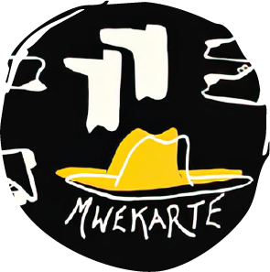
Tim McNamara and Phyllis Stevens
Hats and Boots
Courtesy Magpie Goose

“My mwekate (hat) design is inspired from my childhood, growing up with my brothers and uncles, riding horses out bush, mustering wild horses wearing wide-brimmed hats and sturdy boots. We would do horse races, where I’d fall off many times, but I would just jump straight back on. Our special day was Koprilya, which was a day where all of us would dress up as cowboys and there would be a prize for best dressed. This memory inspired the making of Hats and Boots, which transports me back to when I used to dress up with my brothers and uncles, feeling like a true cowboy.” – Tim McNamara

“I grew up seeing my cousins from Ltyentye Apurte (Santa Teresa) riding horses and wearing long boots. I would only wear my stepfather’s boots when it was hot, walking to get water. I would complain to him, ‘It’s too hot dad — can I wear your hat as well?’ Sometimes he would let me. When my dad would return from mustering in the bush, he would give his hat to the little ones who would want to look like him too. He’s now in a home and when I visit him he always asks me for his pute (boots) and mwekate (hat).” – Phyllis Stevens

Tim McNamara is a Western Arrernte man from Hermannsburg. He began his art journey with Tangentyere Artists about seven or eight years ago and still goes there now. He started making T-shirts and tea towels, and has since had his designs worn on the runway and modelled in Vogue Australia. Tim now lives in Mparntwe (Alice Springs).

Phyllis Stevens has lived in Mparntwe (Alice Springs) her entire life. She first lived in a humpy, then moved from a tent to a tin shed to brick houses. Phyllis and her cousin Tim create art together at Ewyenper Atwatye (Hidden Valley). They gather at the art centre, where they also garden and look after kids when their parents are busy.

The hat band features on a custom-designed hat created by Hats on Country, a fashion label owned and operated by Letishia Murray, a proud Darambul woman.
Rosina McMillan and Carol Young wearing Christopher McMillan’s Inarlenge (Echidna) and Marita McMillan’s Antherrtye (Ranges) designs. Photo: Sara Maiorino. Courtesy Magpie Goose.

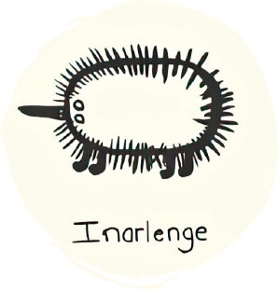
Christopher McMillan
Inarlenge (Echidna)

“Inarlenge means ‘echidna’ in Arrernte language. We also call it prickly meat. Echidnas come out during the cold months for the mating season. You can find them down at the creek bed hiding in the hollow logs. You poke them with a stick to get them out. If you carry them in a pillowcase, they won’t spike you. We put them on the fire until the quills can be knocked off, then you can eat them. They are very good bush tucker and have very rich meat. They’re tasty like pork. Echidnas are best cooked in the ground on hot coals. The quills can be used for jewellery making.”

Christopher McMillan is an artist living in Ewyenper Atwatye (Hidden Valley). In his spare time, he likes to hang out with family, telling stories and eating together. When his family have a special gathering, they eat kangaroo tails as the main course, with damper and sweet potatoes. Christopher often travels out of town and goes camping to teach kids about connecting to Country. They talk about local plants and animals.

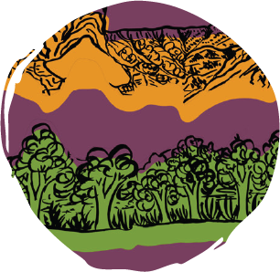
Marita McMillan
Antherrtye (Ranges)

“This is a landscape painting that came into my vision. It’s a memory of the Antherrtye (range) that I can see from my Country. You can see the range all around Mparntwe (Alice Springs). The lovely view of the trees and the range can be seen from a creek we swim in and drink from. I love to take children out bush and teach them about their identity and the Country they belong to, and the range is an important part of the story.”

Marita McMillan is an Arrernte woman. She was born in Ltyentye Apurte (Santa Teresa), southeast of Mparntwe (Alice Springs). She grew up and went to school there, then later in life, moved to Sandy Bore outstation. For the past 65 years, Marita has lived in Ewyenper Atwatye (Hidden Valley). She is an early childhood educator and paints at the art centre.

Loretta Neil, Tim McNamara, Carol Young and Cassandra Neil wearing Loretta Neil’s Arlepe (Prickly Wattle), Marita McMillan’s Antherrtye (Ranges), Janelle Driver’s Apere (River Red Gum) and Christopher McMillan’s Inarlenge (Echidna) designs. Photo: Sara Maiorino. Courtesy Magpie Goose.

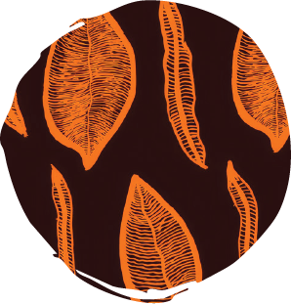
Loretta Neil
Arlepe (Prickly Wattle) Leaf

“Arlepe is the Arrernte name for the prickly wattle tree and this design has the leaves in it. Back in my homeland, I like to sit under the shade of a large tree. We have lots of different trees in Mparntwe (Alice Springs) and some are sacred and used to make bush medicine. There are a big mob of Arlepe down by Lhere Mparntwe (Todd River) and after the rain they might bloom. They have beautiful yellow flowers that attract insects. It has seeds that you can eat cooked or raw, and the sap is sweet and you can eat that too. Sometimes we collect green seeds and when they have dried out a bit you cook them. The design has two different shaped leaves and I love the patterns on them.”

Loretta Neil grew up in in Ltyentye Apurte (Santa Teresa) and now lives in Ewyenper Atwatye (Hidden Valley). She has been painting for a long time and taught herself. She likes to go to the art centre to paint and sometimes takes canvases back home to finish them off. Loretta would love to see her designs in fashion parades and see kids wearing them.

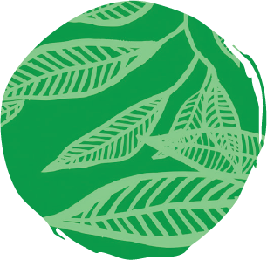
Janelle Driver
Apere (River Red Gum)

“Apere is Arrernte language for river red gum. People here use the eucalyptus leaf for medicine, drinking and smoking ceremonies. I like the smell. I chose to draw it because it is important for a lot of Aboriginal cultures. My dad told me that he used the leaves to cook kangaroo but nowadays everyone uses aluminium foil. There are lots of different types of trees and this native gum is found in my home in the Northern Territory.”

Janelle Driver’s family are Warlpiri, but she has lived in Ewyenper Atwatye (Hidden Valley) for more than seven years. She has always loved making art and works on designs with her in-laws. Janelle likes going to the art centre and participating in workshops and activities, especially painting. She is really happy to have worked with Magpie Goose, as this was the first time her work had been used for clothing. She was very excited to show her family.

Cassandra Neil, Carol Young, Loretta Neil and Tim McNamara wearing Carol Young’s Angkulye and Kwatye (Clouds and Rain), Bianca Turner’s Kwatye Iperte (Waterholes), Tim McNamara and Phyllis Stevens’ Hats and Boots, and Alan Collins’ Camp Out designs. Photo: Sara Maiorino. Courtesy Magpie Goose.

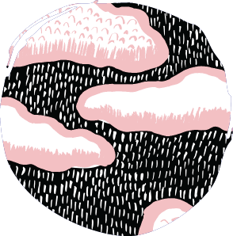
Carol Young
Angkulye and Kwatye (Clouds and Rain)

“This design is about Kwatye Dreaming: the rainstorm. In Mparntwe (Alice Springs), the weather gets very hot (in summer) and very cold (in winter), and it doesn’t rain very often. The Todd River floods when it rains, only once in a blue moon, and it’s lovely because there is a lot of dry heat then it cools down. In Arrernte language, alharrkentye means lightning, angkulye means clouds and kwatye means water or rain.”

Carol Young started painting at Ltyentye Apurte (Santa Teresa). When she moved to Ewyenper Atwatye (Hidden Valley), she started working at Tangentyere Artists and creating more works. She loves living in Ewyenper Atwatye (Hidden Valley), because all her family gets together and paints, screen-prints and sometimes makes pottery. She is happy when they are all together.

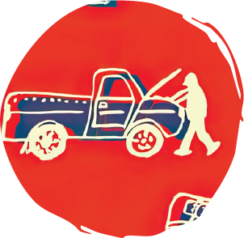
Alan Collins
Camp Out

“My design is about a person out camping in Desert Country and the things that they would bring with them on their journey. The billycan is shown here as well as a fireplace and rolled out swag to lay. Beside him is also a car which he fixes along the way. My design is inspired from travelling long distances by car with my family and relatives to sacred sites, and at the end of the day enjoying a nice warm tea on the fire at sunset. We gather around the crackling fire, enjoying the smell of roasting goanna or kangaroo on the cook up, always with a cup of tea. This artwork brings me joy, from the calm found in the silent desert and the sounds of night owls.”

Alan Collins is an artist from Yuendumu, west of Mparntwe (Alice Springs). He currently lives in Ewyenper Atwatye (Hidden Valley) and creates most of his work at the art centre. In his spare time, he likes to go camping on Country in his homeland of Yuendumu.

Hope Vale 2019

Hope Vale is a small township located on Guugu Yimithirr Country in Far North Queensland. Home to 13 clan groups of the Guugu Yimithirr Warra Nation, the township is 46 kilometres northwest of Gundarr (Cooktown) on the Cape York Peninsula. Nestled in a valley, Hope Vale is surrounded by tropical bushland, mountain ranges and coastal plains.

In 2019, Magpie Goose collaborated with Hope Vale Arts and Culture Centre. Six artists participated in a workshop with printmaker Bobbie Ruben, and the resulting designs became part of the Hope Vale collection. The incredible stories behind these designs speak to Ancestral knowledge, childhood memories, forced displacement and mission life.

Artists: Madge Bowen, Dora Deemal, Gertie Deeral, Wanda Gibson, Grace Rosendale

The Traditional Owners, the Guugu Yimithirr people, have cared for the place now known as Hope Vale and surrounds since time immemorial. In 1872, European settlers invaded Far North Queensland and began extracting gold from the Palmer River. The colony expanded with little regard for the Traditional Owners, who actively resisted occupation, and the ensuing decades saw the dispossession of many Aboriginal communities.

In the late 1880s, Cape Bedford Mission, later known as Hope Valley, and eventually Hope Vale, was established as a Lutheran mission, supported by the Queensland Government. Many Aboriginal people were forcibly moved to Cape Bedford, where they lived under strict regulations for many years. Forced removals were carried out across the country, brutally separating many Aboriginal families. In 1942, amidst the Pacific War, without warning, military authorities evacuated Cape Bedford, fearing the purported influence of Japanese pearlers. Most of the community were sent nearly 1,500 kilometres away to Woorabinda Mission, south of Rockhampton. After almost a decade, Hope Vale was re-established as a Lutheran mission and families started to return. It remained as such until 1986, when the community accepted a Deed of Grant in Trust (DOGIT) and became self-governing on Crown Land.
Scan for an Audio Description of the Hope Vale collection


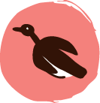
Murnubbarr Label

There are two beautiful designs by Madge Bowen on display. Both designs depict Madge’s mother’s Country of Bulgun Warra.

This story is sad but important to share. When Madge’s mum was a little girl, she was taken away from her family and community by the police. She was forced to live in a place called a mission that was not on Bulgun Warra.

Madge’s art is an important way for her to maintain her connection to the Country her mother and uncles were taken from.

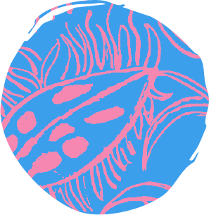
Gertie Deeral
Yarrun (Wattle Flower)
Courtesy Maggie McGowan and Laura Egan

“Different signs in the bush tell you the different seasons of the year, what things you can touch, what you can use and what you can eat. When you see that the wattle is in bloom, you know that the seafoods are ready to go — the crabs and the prawns are fully grown and ready to catch. The fish, sea urchin, oysters, even the turtle, are fat and really yummy. I don’t know what time of year it is but we just look at the wattle in bloom, then we know! Our grandfathers and grandmothers didn’t know the months of the year — they’d just look at the flowers.”

Magpie Goose reprinted this design in different colourways in 2021 as part of their Neon Reef collection. This garment is from that collection.

Gertie Deeral is a Dingaal Warra artist belonging to the Guugu Yimithirr people. Her family totem on her mother’s side is the Walmbaar (stingray) and her mother’s Country is Dingaal/Cape Flattery. Her family totem on her father’s side is Bunjarr (small owl) and her father’s Country stretches from Maytown, Bloomfield and Mossman down to the Daintree Rainforest. Gertie was born in Woorabinda after her family was forcibly moved there from Cape Bedford Mission. Her family returned to Hope Vale when she was four, and she has lived there ever since.

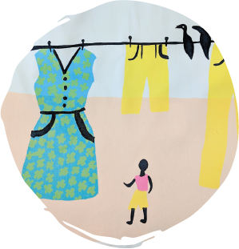
Wanda Gibson
Family Washing
Courtesy Maggie McGowan and Laura Egan

“My design takes me back to my childhood when we used to go to the beach for a holiday every year. We only got two weeks holiday from mission life. It would take us two days to walk to the beach! It’s 45 kilometres, so if we left at 6am on the first day we’d arrive by 6pm the second day. We had to carry everything - food, blankets, clothes — so we could only take three dresses: one to wash, one to wear and one spare. We’d build a humpy down there to sleep under. When we had to do our washing, we’d roll a 44-gallon drum down to the creek, boil water in the drum, hang it up and wait for it to dry! I drew the style of dresses the Lutheran church used to give us for Christmas. At Christmas time we would receive second-hand dresses or pants, a jacket maybe, and a few toys. We used to look forward to our ‘new clothes.’”

Wanda Gibson is a Nugal Wurra woman of the Guugu Yimithirr people (on her mother’s side). Her father is a Yiithu Warra man and his Country is around Cape Melville. Her totem on her father’s side is the Thagay (goanna). Both of Wanda’s parents were part of the Stolen Generation and were brought to Cape Bedford Mission as children. During the Second World War, her parents were forcibly moved to Woorabinda. Wanda was born there in 1946. When she was three years old, Wanda’s family brought her back to Hope Vale, where she has lived ever since.

Wanda Gibson
Jaan (Family Washing Day) 2025
Synthetic polymer paint on canvas
Courtesy Hope Vale Arts and Culture Centre

“When I was 12 years old, my mother died and my sister got married and moved away at that time too. It meant that I did not get to see my family very often, but some of the happiest memories I have are of the days my sister and I met up to do the washing. We would push a 45-gallon drum of water through the streets of Hope Vale to boil our clothes by the river and it would take us a whole weekend to get through all of our washing. It took a very long time and it was very tiring, but we did not mind because we also laughed a lot and had fun while we worked together.”

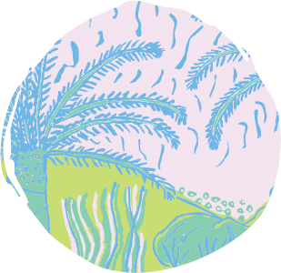
Madge Bowen
Bulgun Warra (Sacred Lake)
Courtesy Magpie Goose

“This design depicts my mother’s Country of Bulgun Warra. My totem from my mother’s side is the Mirrgi (large night owl). Bulgun Warra stretches from south of Gundarr (Cooktown) up to Leggett’s Crossing (a branch of the Endeavour River). This is the place of my Ancestors. My mother and her brothers were taken from this Country as part of the Stolen Generation — the white police came in and took them — the boys to Cape Bedford, my mum to Yarrabah. My mother’s brother who is also from this Country tells me a lot of Dreaming stories about this place. In this design there’s a big mountain with a lake — this is the northern boundary of Bulgun Warra. There’s lots of wildlife in this area — kangaroos, echidnas, goannas — all sorts.

In the lake there’s long neck turtles and lily pads growing. In the trees there’s lots of different kinds of birds. This tree — the curtain fig tree — has become famous now! Every time I’m asked to draw something, I have to draw this tree, this scene.”
Magpie Goose reprinted this design in different colourways in 2021 as part of their Neon Reef collection. This garment is from that collection.

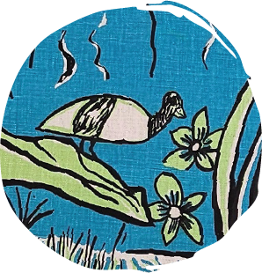
Madge Bowen
Bulgun II

“My tribal land is Bulgun (Kings Plains). My mother’s family lived there in the early days and lived on whatever food they hunted for. They were content with what they had and happily lived a simple life. The lagoons had plenty of wildlife including the dugal (albino freshwater turtles). The Gangurru (kangaroo) and burriwi (emu) lived on the plains. The lagoons have pink waterlilies. My paintings are based on my mother’s Traditional Land on which she lived. My mother passed away when I was eight and I was sent to live in Hope Vale. My paintings are a memory of my family. The plains, the lagoons, the wildlife and the lilies are all still there today.”

Madge Bowen was born in Yarrabah. Her mother Myrtle’s language is Western Kuku Yalanji and her Country is Bulgun Warra (Kings Plains, south of Gundarr (Cooktown)). Her father Nolan’s Country is up around Maytown, north of Laura. Madge’s parents were both part of the Stolen Generation and taken to Yarrabah Mission. After her mother died, Madge was sent to Hope Vale to live with her mother’s brothers. Later in life, after many years of working at the local school, she became involved with the art centre. Madge belonged to the Gamba Gamba (senior women) at the art centre.

This artist passed away in 2024 and we show this with permission of her family.

Model wearing Dora Deemal’s Babatha Nganga (Gum Flower) design. Photo: Sarah Mackie.

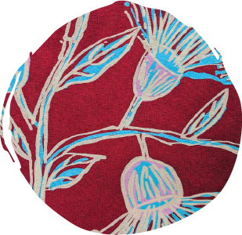
Dora Deemal
Babatha Nganga (Gum Flower)

“This is a design about gumnut flowers — which we call Babatha Nganga in Guugu Yimithirr. Babatha grows around here, around the bush. Our gum trees come out with white flowers during the wintertime (but I’ve seen pink and red in Cairns). It’s beautiful to see them on top of the hills — white amongst the green. There’s lots you can do with Babatha. The dead gum trees are good for making cooking fires; we cook damper and fish on the coals of that kind of tree. We make necklaces from the nuts; and you can make a whistle out of the gumnut. The bees make lovely honey from the flowers.”

Dora Deemal is a Senior Elder of the Binthi clan. Her totems are Gaalaya (centipede) and Ngurraarr (black cockatoo) from her father’s side, and Burriwi (emu) from her mother’s side. Dora’s mother’s family are from Stonehenge (near Winton). When her grandmother was bitten by a death adder, her mother was taken to Cape Bedford Mission. During the Second World War, the Cape Bedford community was forcibly relocated to Woorabinda. Dora was born there and returned to Hope Vale when she was five. She began working at the art centre after retiring from working in aged care to keep her mind busy and work with the other ladies. Dora now belongs to the Gamba Gamba (senior women) at the art centre.

Delankah Ross wearing Grace Rosendale’s Yangarr (Green Ants) design. Photo: Sarah Mackie.

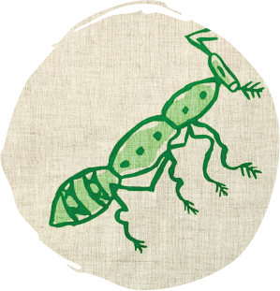
Grace Rosendale
Yangarr (Green Ants)

“My design is green ants. Yangarr in my language. This is one of the best medicines for colds and flus. To make the medicine — we get the ants, put them in a bowl and make sure none of the ants crawl away. Before Christmas is the best time to get it, because that’s when they lay the eggs. But you can get it at any time of the year. You just squash all the ants together and rub it all over yourself: on your chest, under your nose. It’s just like Vicks. It’s got that very acidy smell. When we were growing up in mission days we used to go out with a bowl, get the ants, cut up onion, make some damper — eat it that way. We didn’t have much to eat those mission days.”

Grace Rosendale is a Guugu Yimithirr Elder of the Binthi Warra clan (between Hope Vale and Cape Flattery). Her totems are Gaalaya (centipede) and Ngurrarr (black cockatoo) from her father’s side, and Burriwi (emu) from her mother’s side. Grace was born in Woorabinda after her family was forcibly moved there during the Second World War. Her family returned to Hope Vale later on, where her father became a house painter and her mother a midwife. Grace came to art after retiring and joining the art centre, and now belongs to the Gamba Gamba (senior women) at the art centre.

Part Two: Local Focus

Collections that tell stories of this region...

Magpie Goose’s long-standing relationships with local communities have continued to evolve and strengthen since the label became Aboriginal-owned and led. Collaborations with the Jinibara and Quandamooka communities honour the deep cultural knowledge and creative strength of these people, who hold unbroken connections to this region.

The Jinibara collection, released in 2018, features designs by influential Elder Uncle Noel Blair and Jason Murphy. Uncle Noel and Jason are Traditional Owners of Jinibara Country, which stretches north to the Blackall Range, south to Mount Nebo, east to the Glasshouse Mountains and west to Cressbrook. Their designs share personal and cultural stories that are candid, vulnerable and important acts of truth-telling. Most recently, Magpie Goose collaborated with the Quandamooka community, who care for the lands and waters of Minjerribah/Tjerrengarri (North Stradbroke Island), Mulgumpin (Moreton Island), the Southern Moreton Bay Islands and Nandeebie (Cleveland). Conversations with Sonja Carmichael instigated this collection, which will be released in stages throughout 2025 and 2026.

Here, the Jinibara collection is displayed alongside jini (lawyer vine) and bunya wood collected from Jinibara Country, with permission and support from Jason and Christopher Emerson, both Traditional Owners, and the Jinibara Rangers. Nearby, the Quandamooka collection is presented amongst driftwood and rocks gathered from Minjerribah/Tjerrengarri (North Stradbroke Island), under the guidance of the Minjerribah Moorgumpin Elders-in-Council Aboriginal Corporation with the support of Quandamooka artist Kieron Boona Anderson. These materials have been carefully chosen to connect us to the Jinibara and Quandamooka regions and remind us that these places continue to be shaped by people, spirit and time.

The garments in the Jinibara and Quandamooka collections are not just clothes; they are powerful expressions of story, sovereignty and strength. Brought together here on Yuggera and Turrabal Country (Brisbane), they highlight the importance of these rich artistic communities to the Greater Brisbane narrative
Scan for an audio reading of the above text

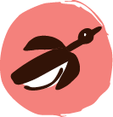
Murnubbarr Label

Every three or so years, when there was a bumper harvest of bunya nuts, groups from near and far, including the Quandamooka, Yuggera, Wakka Wakka and Kabi Kabi/ Gubbi Gubbi people, would meet on Jinibara Country. At these gatherings, people would feast, trade, arrange marriages and settle disputes.

Jinibara 2018

Jinibara Country stretches north to the Blackall Range, south to Mount Nebo, east to the Glasshouse Mountains and west to Cressbrook. The Jinibara people are known as ‘people of the lawyer vine’. In Jinibara language, jini means ‘lawyer vine’, a prickly vine that grows in the mountains and valleys of Jinibara Country, and bara means ‘people’. The group encompasses four clans: the Dala, Dungidau, Garumngar and Nalbo people.

In late 2018, Magpie Goose launched a capsule collection at Woodford Folk Festival’s 25th birthday celebrations on Jinibara Country. The collection featured designs by Jinibara artists, Uncle Noel Blair and Jason Murphy. Uncle Noel’s designs speak to the practice of carving and burning wood to create clapsticks and other cultural objects, as well as the animals found on Jinibara Country, while Jason’s design is a self-portrait, reflecting how other people see him.

Artists: Uncle Noel Blair, Jason Murphy

The Jinibara people, among other groups, are recognised for their long and important connection to bunya trees. Every three or so years, if there was a bumper harvest of bunya nuts, groups from near and far would gather at what is now Baroon Pocket and Villeneuve on Jinibara Country, as well as in the Bunya Mountains on Wakka Wakka Country. At these gatherings, groups would feast on the nuts, exchange knowledge, perform ceremonies and settle disputes. The significance of bunya trees did not go unnoticed by European settlers who, in the early days of the colony, referred to the Jinibara people as ‘bonyi bonyi people’. In 1842, the importance of bunya trees was acknowledged in the Bunya Proclamation, a piece of legislation that protected bunya groves from settlement (although it was largely tokenistic and later repealed in 1860). Widespread violence took place as settlement expanded. As the government began to forcibly remove Aboriginal people onto missions and reserves, the Jinibara people continued to resist and actively maintain their culture. In 2012, a historic court decision ruled the Jinibara people Native Title holders.

Scan for an audio reading of the above text


Scan for an Audio Description of the Jinibara collection



Murnubbarr Label

Jinibara Country is very close to Yuggera and Turrabul Country (Brisbane).

In Jinibara language, jini means ‘lawyer vine’ and bara means ‘people’. So, Jinibara means ‘people of the lawyer vine’. Language can tell us a lot about Country.

Can you spot the jini on display? It was carefully brought here from Jinibara Country and will be returned after the exhibition closes.

The garments from this collection have been presented alongside jini (lawyer vine) and bunya wood from Jinibara Country. The process of gathering these materials was informed by consultation with Uncle Noel Blair and Jason Murphy. The gathering itself was led by Jason and Christopher Emerson, both Traditional Owners, with the support of the Jinibara Rangers. We are also grateful to environmentalist and bush regenerator, Spencer Shaw, who helped ensure the process was sustainable and environmentally conscious.

In September 2025, we travelled to the Mary Cairncross Scenic Reserve, a site rich in ecological and cultural significance. Together with the Jinibara Rangers, we collected five coils of jini — one for each of the four clans of the Jinibara people and one to represent the meeting of the four clans. A slab of bunya wood was also sourced from Jinibara Country.

Each material was chosen very carefully. It was important that cultural practice, community and Country were honoured throughout the entire process. Every step of the way, we were guided by deep respect for cultural protocols and the living landscape, as well as the enduring cultural authority of the Jinibara Custodians.

All materials will be returned to Jinibara Country after the exhibition closes

Scan for an audio reading of the above text


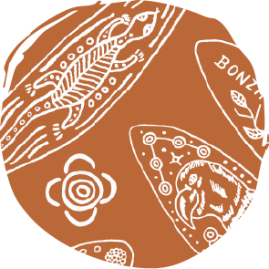
Uncle Noel Blair
Clapsticks

“I’ve been carving things out of wood since I was young, living at Cherbourg settlement. I carved my first walking stick for my dad in 1969. I love burning images onto the wood — because it’s there straight away. You don’t have to wait for paint to dry, or wash up the brushes afterwards! Clapsticks weren’t really part of our early teachings and traditions; for music we used to clap bigger things — like boomerang and woomera — together. Clapsticks were traditionally used for lots of things — music, hunting, ceremony and as message sticks — to travel from one Country to another. You had to have them to have access to and be allowed to enter onto other people’s land. Sometimes now I write a message on a clapstick and then give it to someone. It’s a modern way to pass on a message! One time I wrote, ‘I’m sorry, so sorry, it won’t happen again’. I showed it to one of the fellas and he said, ‘I’ll have a dozen of them!’ I reckon he’s breaking a lot of hearts.”

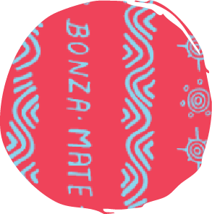
Uncle Noel Blair
Aussie Slang
Courtesy Maggie McGowan and Laura Egan

“I like to write words on my wooden carvings — especially on the clapsticks. I thought it might add a bit of variety to these clapsticks, a bit of interest, and a bit of an Aussie touch. I started writing slang, like ‘I’m sorry, so sorry’, but then I started running out. So I looked up more slang on the internet — and now I have heaps! Like ‘have a go ya mug’. The motifs are different meanings that symbolise our culture; writing them down makes sure it’s there forever and teaches our kids about it.”

Uncle Noel Blair is a Traditional Custodian of Jinibara Country. He burns traditional and contemporary designs onto hand-carved wooden objects, including clapsticks and boomerangs. As a child, he was moved from his birthplace of Wondai to Cherbourg Aboriginal Reserve, which was controlled by the Queensland Government from 1905 to 1986. When he was 14, he was sent to Quoin Island near present-day Gladstone to work as an indentured labourer. Uncle Noel ended up “breaking free”, and has since worked across Queensland, drawing and making art.
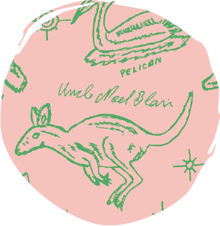
Uncle Noel Blair
Jinibara Country Animals
Courtesy Maggie McGowan and Laura Egan

“This animal design is inspiration from years of drawing. I usually burn them onto wood — but these ones I drew onto paper and we scanned them onto the computer to make this print. I usually think of all the animals I can and burn them onto clapsticks and give them to my relatives — especially to my kids, to give them inspiration. They really love the animals. Most of the animals are from Jinibara Country — though we don’t have any sea in our area, but we knew of the sea creatures from stories and paintings.”

Uncle Noel Blair
Boomerang and clapsticks
Burnt wood
Courtesy Munimba-ja and the artist

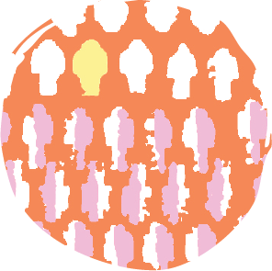
Jason Murphy
Yellow Fella: A Dysfunctional Self-Portrait
Courtesy Magpie Goose

“This design is a response to being called a ‘yellow fella’, because I am of mixed blood. It also responds to Aussies with European heritage saying, ‘You’re not a full blood’. This design questions the European caste system and also the Traditional People calling us yellow fella ‘cos we’re mixed blood. There has always been different words, none of them positive. Why do we have to justify ourselves through negative connotation? This is a self-portrait of how other people see me — but how they see me is not right. When I look at myself and this design — I know it’s not a self-portrait. It’s a dysfunctional self-portrait, focusing on the external things of me, looking at how other people see me. It’s me saying, ‘You’re wrong, you don’t know me, stop doing that.’”

Magpie Goose reprinted this design in different colourways in 2021 as part of their Neon Reef collection. This fabric drop is from that collection.

Jason Murphy is a Traditional Owner of Jinibara Country, who grew up on Yuggera and Turrabul Country (Brisbane). He became interested in art when he was seven years old and started drawing and painting. Jason’s works are purposefully difficult to categorise: “I think the words ‘traditional’ and ‘modern’ are antiquated. Culture is a growing thing; always changing, always moving, always alive. If we categorise it with something that diminishes its growth, we diminish our own growth.”

Jason Murphy
Policy and Procedure 2018
Acrylic on canvas
Courtesy Sunshine Coast Cultural Collections

“This artwork is a representation of the policy and procedure the coloniser enforced upon our community. Each panel relates to changes in the actions of the coloniser over time. The artworks are positioned vertically to represent an exclamation mark. The bottom and first panel represent ‘genocide’, then ascending to the second panel representing ‘segregation’. Followed by three panels representing ‘assimilation, easy as 1,2,3’. The colour red symbolises David Gulpilil’s statement and title of his documentary One Red Blood (2002), referencing all human beings. The black shape is referencing Darwin’s theory that we are all from Africa, while the white shapes in the panels ‘assimilation, easy as 1,2,3’ represent Darwin’s theory that we would breed out over time. The images are made by using a stamping technique referencing the stamping of permits for our community.”

Quandamooka 2025/26

The Quandamooka people are the caretakers of the lands and waters surrounding Moreton Bay, including Minjerribah/Tjerrengarri (North Stradbroke Island), Mulgumpin (Moreton Island), the Southern Moreton Bay Islands and Nandeebie (Cleveland). The name ‘Quandamooka’ refers to the collective identity of three primary clans: the Ngugi, Nunnukul and Goenpul.

In late 2024, Quandamooka artists participated in a workshop on Minjerribah/ Tjerrengarri (North Stradbroke Island) with Magpie Goose owners, Amanda Hayman and Troy Casey. The resulting concepts and designs became part of the Quandamooka collection — a collection rich in stories of Ancestral knowledge, ancient techniques, cultural resources and sustenance. Over the next year, the Quandamooka collection will expand to include more artists. It is anticipated their designs and stories will be showcased as part of this exhibition.

Artists: Kieron Boona Anderson, Mahala Burns, Belinda Close, Elisa Jane Carmichael, Sonja Carmichael, Casey Coolwell-Fisher, Kyra Mancktelow, Dean Bingkin Tyson

Quandamooka is known for its sand islands, tidal wetlands, mangroves, eucalyptus and melaleuca forests, sacred freshwater lakes and abundant marine life. For thousands of years, the Quandamooka people have lived in deep relationship with this Saltwater Country.

The colonial history of what became known as North Stradbroke Island began in 1825 with the establishment of the penal colony at Amity Point — a pilot station that marked the start of European settlement. Tensions soon escalated, leading to a significant act of resistance remembered as the Battle at Arranarraway or Big Creek. In 1843, German Catholic missionaries set up the Myora Mission near Dunwich, where children from all over were forcibly sent. The Queensland Government established the Benevolent Asylum in the township of Dunwich, where Aboriginal people were segregated and employed in low-paid roles under harsh conditions. Through the 1940s to 1960s, the fight for equal wages gained momentum, as Quandamooka workers joined a broader national movement demanding fair treatment. From the 1950s to the 1970s, Aboriginal families began moving into the One Mile community closer to Dunwich’s town centre, reclaiming their place on Country and laying the foundation for cultural and political resurgence.

Scan for an audio reading of the above text


Scan for and Audio Description of the Quandamooka collection


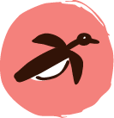
Murnubbarr Label

Quampi is a type of pearl oyster and a sacred food resource from Minjerribah /Tjerrengarri (North Stradbroke Island). The oysters have a strong inner shell layer composed of nacre, also known as mother-of-pearl. The shells are used for jewellery, and the delicate meat inside can be eaten once cooked.

Ngali Bapudja Djarrala (We’re on Creators Country)
Trees and rocks from Minjerribah/Tjerrengarri (North Stradbroke Island) are incorporated into this display, connecting the garments to the Quandamooka region. The process of collecting these materials was led by Kieron Boona Anderson, a First Peoples caretaker of the Quandamooka Nation and one of the artists featured in the Quandamooka collection. After consulting the Minjerribah Moorgumpin Elders-in-Council Aboriginal Corporation, Kieron identified an appropriate location from which the materials could be collected. He was careful not to intrude upon sacred sites or remove established trees.

In the aftermath of Cyclone Alfred, a group of trees had fallen into the ocean due to coastal erosion. Over time, the sea and surrounding environment had naturally stripped the trees of bark. What remained were incredible sculptural forms, many of which are scattered along the shoreline of Toompany Beach in Pullen Pullen (Amity Point).

In August 2025, Kieron worked closely with Museum of Brisbane staff to respectfully gather branches from Toompany Beach. Each piece was carefully selected to ensure cultural, environmental and artistic integrity. The collection process was further supported by environmentalist and bush regenerator Spencer Shaw, whose expertise ensured the gathering was carried out with deep care for the surrounding landscape.

After the exhibition closes, all materials will be returned to the island.

Scan for an audio reading of the above text


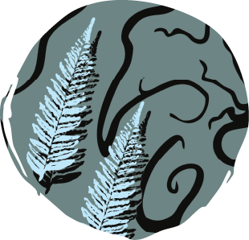
Belinda Close and Mahala Burns
Bungwal Ferns
Courtesy Magpie Goose

“This flowing design honours the vital relationship between freshwater systems and the bungwal fern on Minjerribah (North Stradbroke Island). Inspired by the winding creeks, wetlands and underground springs that nourish the island, the artwork reflects the deep interconnection between plant life, water and culture.

The bungwal fern is a traditional food source for Quandamooka people. Its starchy rhizomes were harvested, baked and eaten — especially during times of food scarcity. The fern thrives in moist, low-lying areas, often growing along freshwater creeks and swamps. These environments are not only ecologically rich but also culturally significant, sustaining generations through knowledge, resourcefulness and care for Country.

The artwork’s flowing lines trace the movement of water across Minjerribah — from spring to swamp to sea — while the fern motifs celebrate the role of native plants in supporting both people and place.”

Belinda Close is a respected Quandamooka Elder who has lived her whole life on Minjerribah/Tjerrengarri (North Stradbroke Island) from One Mile to Dunwich.

Mahala Burns is an emerging Quandamooka artist who is following in her mother’s footsteps. Together, they explore the textures and colours of Country through their art, blending Belinda’s knowledge and experience with Mahala’s contemporary approach to art and printmaking. Their collaboration speaks to the power of family, shared creativity and cultural continuity

Belinda Close
The Spirit of the Dolphin 2025
Paint pen on canvas
Courtesy the artist

“My name is Belinda Close. I’m a Quandamooka woman who loves to tell her stories of culture and memories from living back in the day when I’d see our people hunting over way over in the swamps, ferns and creeks. We many Aboriginal families out One Mile would be eating ‘parrot stew’ tonight. Before my time, our Ancestors hunted fish with the help of dolphins, who are very spiritual and held in high regard to our Quandamooka people. In my story you can see the dolphin swimming in the rough ocean of Quandamooka waters and then chills out in the calm bay.

Please help us keep our waters clean for the next generation of memories and stories.”

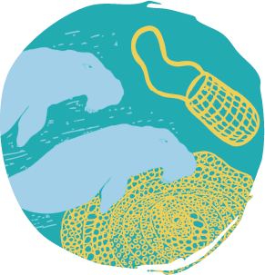
Kieron Boona Anderson
Ganunda & Bagirang (Sugar Bag Bee Honey & Dugong)
Courtesy Magpie Goose

“When I was in my 20s an uncle took me out into the bay and taught me how to hunt dugong. He said to me, ‘My son and I will teach you,’ and off we went in the boat. This cultural business is strictly men’s and women are forbidden. He shared with me how he gained this knowledge from the old men, and this is a customary practice that I hold very close to my heart. I acknowledge his family for sharing this knowledge with me.

This design is my interpretation of the dugong, sacred men’s woven bag, sugar bag bee and the hive. I choose these resources because of my extensive background in cheffing, and intergenerational knowledge passed down by the men. Dugong and sugar bag bee honey would have to be my favourite foods from the sea and land. We only hunt and collect them at certain times of the year. From a young age we have been taught not to be Gubbinge which means ‘greedy’, and we should only take a small amount to sustain ourselves and family. They are not only foods to nourish us, but they are also used for medicine. I have heard many stories about the precious healing properties from these resources and our community still use dugong oil and sugar bag honey to heal sick family. Everything from our Saltwater Country is sacred but to me personally I believe these two are the most special of all.

Together, the blues and vibrant yellow colour form a story of saltwater connection and the caretaking of knowledge. Dugongs swimming in the hunting ground, sacred men’s bag, the bee taking flight and a precious story I learnt about the sacred geometry design of the native sugar bag beehive. I acknowledge the Gowar speaking families for the use of this language.”

Kieron Boona Anderson is a direct descendant of the Ngugi people of Mulgumpin (Moreton Island). Kieron is deeply connected to the continuation and sharing of knowledge from the sacred systems that have been entrusted to him across the Quandamooka Nation. He brings together his professions as a trained chef and emerging contemporary artist to share old and new stories, with an emphasis on cultural resilience and food sovereignty.
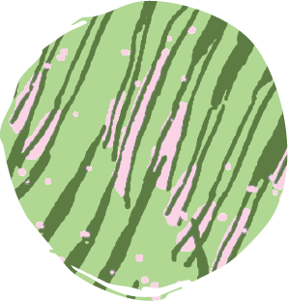
Elisa Jane Carmichael
Ungaire Reeds
Courtesy Magpie Goose

Necklace
Courtesy the artist

This vibrant design draws inspiration from ungaire (freshwater swamp reeds) used by Quandamooka women for weaving. Growing along the wetlands of Minjerribah/Tjerrengarri (North Stradbroke Island), these reeds are deeply embedded in cultural knowledge and seasonal practices.

The bright green background reflects the lush vitality of the wetland environment, while the strands of ungaire stretch diagonally across the fabric, a visual homage to the diagonal weave patterns seen in local woven bags. A pink blush at the base of the reeds represents their roots emerging from Country. This pink hue signals when the reeds are mature and ready to be sustainably harvested, showing how environmental knowledge guides cultural practice, while the scattered pink speckles symbolise the spirit of Country.
Through this print, Elisa Jane Carmichael celebrates the enduring connection between women, water and weaving; a continuation of cultural memory passed down through fibre, form and story.

Elisa Jane Carmichael’s artistic practice draws on Ancestral knowledge, matrilineal connections, memories of place and relationships with Country. Elisa and her mother, Sonja, have collaboratively been at the forefront of gathering knowledge, learning and experimenting to revitalise the unique traditional practice of Quandamooka weaving and explore its creative applications to contemporary fibre art. Elisa has further developed her practice through both new techniques and materials, acknowledging, nurturing and protecting her culture and the local environment.

Elisa Jane Carmichael
We see your hands weave with us 2018
Wire, sea rope and ungaire
Collection of The University of Queensland, purchased 2018

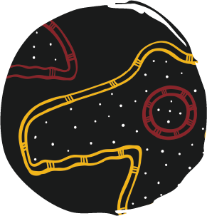
Dean Bingkin Tyson
My Island Home…
Courtesy Magpie Goose

Necklace
Courtesy the artist

“In this dynamic design, I feature meriginpa (the sea eagle), undacal (mullet fish), and two shellfish known as eugarie and quampi, each one deeply significant as a food source but also for their cultural knowledge and lore with seasonal cycles.

At the heart of the piece is the sea eagle, a powerful hunter and significantly important to all Gorenpul, Noonucal and Ngugi people. On sea and Country, flight patterns signal the arrival of mullet season, guiding people to gather and fish in harmony with nature. The inclusion of eugarie and quampi shells, traditional food sources gathered along the shoreline, grounds the design in the lived practices of coastal life.

My use of paint, colour and shapes reflects my unique artistic style. The texture and energy of the colours add movement and depth, echoing the vitality of ocean life and the ever-changing tide. This design is a tribute to the way Country communicates — and the importance of the lore, listening, observing and living in tune with nature, while that knowledge keeps getting passed down through generations, that culture remains alive.”

Dean Bingkin Tyson is a proud Quandamooka Traditional Owner and creative artist whose work often explores the connections between land, sea and spirit. With a strong background in cultural practice and arts, Dean combines clan designs with contemporary techniques to tell the stories of his people and place. His designs are layered with meaning and story, offering a fresh lens through which everyone can connect to Goori culture and Goori knowledge.

Dean Bingkin Tyson
Tjalo dirr 2025
Milla Milla (ochre pigment) and synthetic polymer paint with native seashells on Tawalpin (native hibiscus) and Dhakabin (native grass tree) wood
Museum of Brisbane Collection

“Tjalo dirr (firesticks) is a technology and science of its own. True working artefacts that can bring warmth, farm the land, cook your food and signal communication from long distances. These firesticks represent the making of flames and lessons passed on from the old people. May our fires burn on forever.”

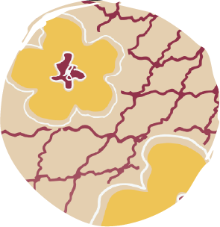
Sonja Carmichael
Talwalpin and Kowinka
Courtesy Magpie Goose

Gulayi
Courtesy the artist

“My design honours the cultural significance of native plants growing on Quandamooka Country: Talwalpin (cotton tree) and Kowinka (red mangrove).

The print pays tribute to Oodgeroo Noonuccal’s story of Talwalpin and Kowinka, published in her Stradbroke Dreamtime book. In this story, Talwalpin and Kowinka represent relationships of deep interconnections between people and Country. I bring this story to life through my drawings of Talwalpin’s hibiscus flowers and nets made from wood fibres, and the distinctive mangrove pods of Kowinka.

As told by Oodgeroo: ‘Talwalpin with bright yellow flowers, grows in the sand and Kowinka stands in the water guarding Talwalpin, growing side by side…one on the bank and the other in the water, with the love they shared for one another so strong that they can never leave one another.’ This artwork continues the storytelling from past generations and transmission of rich cultural and lived experiences.”

Sonja Carmichael is a Ngugi woman of Quandamooka, Minjerribah/Tjerrengarri (North Stradbroke Island) and Mulgumpin (Moreton Island). She is a renowned fibre artist who lives on Minjerribah/Tjerrengarri (North Stradbroke Island) and grew up in the Quandamooka region. Her work draws on the many stories connected to Quandamooka weaving, with a particular focus on continuing weaving practices established by past generations. She works with both traditional fibres and reclaimed materials on Country. Guided by Ancestors’ hands, Elders’ memories and deep respect for Country, Sonja’s work honours her matriarchal lineage and shares powerful stories of Country, cultural regeneration, resistance and resilience.

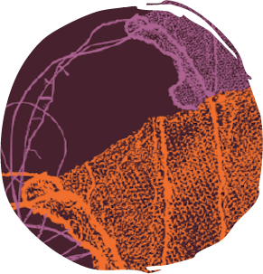
Kyra Mancktelow
Woven in History
Courtesy Magpie Goose

“Woven in History honours the weaving practices of our Quandamooka women. Where each diagonal stitch is a thread of culture, a quiet strength passed from hand to hand, generation to generation.

In my work, the Gulayi is reborn as an interpretive print where tradition and modern materials meet on paper, then transformed into textile, to be worn with pride.

This shift from object to garment embodies resilience, both past and present — where colour and fibre preserve Ancestral knowledge, while inviting it to live again in contemporary form. Woven in History becomes more than a garment: it becomes a strength, a story worn on the body, and a living symbol of survival and culture.”

Kyra Mancktelow is a Quandamooka woman with strong cultural connections to Eulo and the South Sea Islander community of Vanuatu. Her multidisciplinary practice spans printmaking, sculpture, ceramics and bronze casting — each medium offering a unique and distinct aesthetic that brings her stories to life. Kyra’s work is grounded in her rich heritage, using diverse materials and techniques to share cultural knowledge, challenge colonial narratives and invite audiences into deeper understanding. Her practice is both educational and poetic — layering symbolism, texture and form to express identity, memory and resilience in ways that resonate emotionally as well as intellectually.

Kyra Mancktelow
Yesterday’s Today 2020
Monoprints
Museum of Brisbane Collection

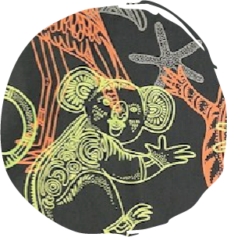
Casey Coolwell-Fisher
Ancestral Cousins
Courtesy Magpie Goose

“This vibrant design celebrates the deep and diverse relationships between Quandamooka people and the animals of land, sea and sky. Featuring Garumun (kangaroo), Buwangun (bottle-nose dolphin), Kabul (carpet snake), Marimari (butterfly), Yalingbila (whale), Bunbiya (turtle), Bombebi (koala), Yuwan (goanna), Mirrigimpa (sea eagle) and Gurrial (curlew), each element reflects the rich biodiversity of my Country and the stories passed down through generations.

For me, creating artwork that features animals is also a way of reviving language and cultural knowledge. Through this design, I share how I have been teaching my young son, Roy, our traditional Jandai language, using the names of animals as a starting point for connection, learning and pride in identity.

The artwork becomes more than a visual story; it’s a living educational tool that nurtures the next generation and keeps culture strong. In honouring these animals, I also honour my role as a mother, artist and cultural storyteller.”

Casey Coolwell-Fisher is a Quandamooka Nunukul woman of Minjerribah/Tjerrengarri (North Stradbroke Island). Her bold, contemporary designs draw on traditional patterns and cultural identity, blending modern aesthetics with deep cultural meaning. Casey’s work highlights the beauty of Aboriginal design and the importance of visibility and representation in creative industries. She is co-founder of CHABOO, a design business specialising in graphic and cultural design and hand-painted home décor.

Quandamooka artist interviews 2025
Duration 24 mins 51 secs
Cinematographer: Zac Mulquin

Featuring:
Kyra Mancktelow
Elisa Jane Carmichael
Dean Bingkin Tyson
Casey Coolwell-Fisher
Sonja Carmichael
Kieron Boona Anderson
Belinda Close
Mahala Burns

Filmed with permission on Minjerribah/Tjerrengarri
(North Stradbroke Island).

Quandamooka art film 2025
Duration 5 mins 42 secs
Cinematographer: Zac Mulquin

Filmed with permission on Minjerribah/Tjerrengarri (North Stradbroke Island).

Part Three: Production Table

Care is woven throughout all stages of production...

Fashion can be a powerful agent of change. Magpie Goose embeds ethical and sustainable practices at every stage of the collection development process, ensuring their garments embody care and respect for people and the planet.

Community is the ‘why’ behind every collection. Magpie Goose is passionate about creating a platform for artists to share their culture, stories and experiences. The label is committed to working on the ground and fostering long-term connections through deep engagement. After proposing a collaboration, Magpie Goose works closely with the artists to ensure they are comfortable with how their designs will be used, as well as how they will be acknowledged and remunerated. It is important that, first and foremost, the collaboration meets the needs and aspirations of the community.

Community consultation continues as the collection moves into production. All garments are designed, hand screen-printed and ethically manufactured here in Australia. Every collection is made from natural biodegradable materials and fabric offcuts are repurposed to make accessories. By embracing a slower, greener approach, Magpie Goose creates high-quality garments that last a lifetime. Producing garments this way is less environmentally damaging and focuses on caring for Country.

On completion of a collection, Magpie Goose returns to the community to celebrate what they have achieved together. Often, the community is involved in photoshoots to promote the collection.

We invite you to explore the label’s step-by-step process for creating a collection, from concept through to launch.

Scan for an audio reading of the above text


Scan for an Audio Description of the Production Table


Murnubbarr Label

The garments in this exhibition have all been screen-printed. To make a screen-print, you start by creating a stencil using a mesh screen. Next, you place the screen on top of a piece of fabric, then push paint through the tiny holes in the mesh. Finally, you lift up the screen for the big reveal — your design will be printed on the fabric!

You can use the same stencil over and over again, and you can also keep changing the colour of paint you use.

Creating the Artwork

Collaboration and consultation are key to every collection. Magpie Goose adopts an artist-led approach, tailoring the way they work to each community. This model fosters long-term connections through deep engagement.

Every artist’s creative process is different, as is their source of inspiration. The designs in the Quandamooka collection draw on many different subjects and stories, connecting to community, culture and Country.

In most cases, Magpie Goose holds workshops where the artists come together to create their designs. For the Quandamooka collection, instead of holding a group workshop, the label provided the artists with sketchbooks.

After the designs are created, they are scanned and shared with a graphic designer. Magpie Goose and the artists work with the graphic designer to determine the placement of each element in the overall composition of the design, as well as where the design repeats. They also choose the base cloth and colourways for the design.

Elisa Jane Carmichael’s design, Ungaire Reeds, was inspired by ungaire (freshwater swamp reeds). Ungaire grows along the wetlands of Minjerribah/Tjerrengarri (North Stradbroke Island) and is used by Quandamooka women for weaving.

Belinda Close and her daughter Mahala Burns worked collaboratively to create their design, Bungwal Ferns. Belinda painted the freshwater systems of Minjerribah/ Tjerrengarri (North Stradbroke Island), while Mahala made prints of bungwal ferns. The duo combined these elements to create their design.

Belinda Close and Mahala Burns’ design, Bungwal Ferns, was mocked-up in three different colourways.

Here you will find eugarie (pipis), quampi (pearl oysters) and feathers used to represent meriginpa (the sea eagle) in ceremony. These animals all feature in Dean Bingkin Tyson’s design, My Island Home…Several ochres are also on display. They form an important part of Dean’s creative practice and inspire his use of colour.

Casey Coolwell-Fisher made these cards to teach her young son, Roy, animal names in Jandai language. This process inspired her design, Ancestral Cousins, which celebrates the deep and diverse relationships between Quandamooka people and the animals of land, sea and sky.

Kieron Boona Anderson created his design, Ganunda & Bagirang (Sugar Bag Bee Honey & Dugong), using linocut printing. This drawer contains one of the lino blocks he used, as well as early test prints for his design.

Fabric swatches are used to choose base cloths.

Printing the Fabric

After the artworks are created, they are transformed into textiles.

All fabrics are hand screen-printed at Publisher Textiles and Papers, based on Gadigal Country (Sydney), and Kudji Handprints, located on Wiradjuri Country in Wagga Wagga, New South Wales.

Committed to treading lightly, Magpie Goose only invests in small batches of limited-edition garments. Natural fibre base cloths — such as linen, cotton and Tencel — are used with water-based inks. These materials are biodegradable, meaning the textiles will decompose after use, instead of adding to landfill.

The Screen-Printing Process

The first step is to prepare the screens:
- Print the design on transparency film.
- Coat the screen with a photographic emulsion and leave it to dry.
- Position the transparency film on the front of the screen, then place the screen against the glass of an exposure unit.
- Expose the screen to UV light. This will cause the photographic emulsion to harden, except where the design blocks the light.
- Blast the screen with water to leave only the hardened emulsion and reveal the design.
A separate screen is needed for every colour in a design.

Next you need to prepare the printing table:
- Adjust the stops on the printing table rail. This will allow the precise, repeatable registration of each screen. In other words, it will make sure the design lines up properly.
- Roll out and secure the fabric on the printing table.

Now it’s time to start printing:
- Place the first screen at the first stop on the printing table.
- Use a squeegee to pull the ink across the screen. This can be a two-person job.
- Make sure the first layer of ink is dry before moving onto the next colour.
- Align the next screen using the stops, then apply the second colour.
- Repeat this process for all remaining colours in the design.

Final steps:
- Once dry, place the fabric in the heat setter to permanently cure the ink.
- Roll up the fabric — it is now ready to use.

Photos: Helene Cochaud.

Making the Garments

The next step is deciding what garments to make.

Magpie Goose works closely with Arts Law and the Copyright Agency to ensure all artists are paid fairly. Artists receive an upfront bulk payment, calculated per metre of printed fabric. This approach ensures the artists are paid immediately, instead of waiting for royalties from sales.

Once the styles are chosen and the collection is planned out, the sewing patterns can be made. Most of Magpie Goose’s patterns are made by Gina Lambropoulos on Gadigal Country (Sydney).

The printed fabrics are then sent to a manufacturer to be made into garments. Magpie Goose works with Sphinx Australia, based on Darug and Eora Country in Bankstown, New South Wales, and DNA Manufacturing, located on Yuggera and Yugambeh Country in Logan, Queensland. Both Sphinx Australia and DNA Manufacturing are proudly accredited by Ethical Clothing Australia.

Mock-ups are created to see what the designs look like in different styles. It also helps to envision the collection as a whole.

Releasing the Collection

With all the garments made, it’s time to release the collection.

Magpie Goose publishes the garments on their website, often over several months, one design at a time. The label ships all over the world and is increasingly being recognised internationally.

Sustainability is core to the practice and to reduce waste, all fabric offcuts are sent to Second Stitch and The Social Studio. Based in Naarm (Melbourne), these two social enterprises support people from migrant, refugee and asylum-seeking backgrounds through textile production. They work with Magpie Goose to transform the offcuts into scrunchies, hairclips and other accessories.

Eco-friendly materials are used for marketing, packaging and shipping.

Country to Couture 2025

In August 2025, Magpie Goose debuted the Quandamooka collection at Country to Couture, a runway showcase celebrating First Peoples fashion and wearable art. Held on Larrakia Country (Darwin), Country to Couture is run by Indigenous Fashion Projects (IFP) and held alongside the National Indigenous Fashion Awards (NIFA) and Darwin Aboriginal Art Fair (DAAF).

Brought to you by Indigenous Fashion Projects (IFP), part of the Darwin Aboriginal Art Fair (DAAF) Foundation

Supported by the Northern Territory Government through Northern Territory Major Events Company and Country Road, with premium media partner Peppermint Magazine

Learn more: IFP.ORG.AU

It takes many hands to make a single garment. Magpie Goose wishes to thank their collaborators and production team:

Production Manager: Belinda Crossley
Graphic Designer for Screens: Millie Shorter and Sanna Williamson (former Blaklash team member)
Screen-printers: Publisher Textiles and Papers and Kudji Handprints
Patternmaker: Gina Lambropoulos
Sample Maker/Runway Looks: Jimmy Eng
Manufacturers: Sphinx Australia and DNA Manufacturing
Photographer: Georgia Wallace
Accessories Collaborators: Second Stitch and The Social Studio
Marketing Partner: Common Intent

All materials on display courtesy Magpie Goose, Kieron Boona Anderson, Mahala Burns, Elisa Jane Carmichael, Sonja Carmichael, Belinda Close, Casey Coolwell-Fisher, Publisher Textiles and Papers, and Dean Bingkin Tyson.

Interested in diving deeper into the world of Magpie Goose?

Explore the designs from every collection here:

Magpie Goose x Firesticks Alliance

In 2024, Magpie Goose collaborated with Firesticks Alliance to create a capsule collection of three T-shirts. Firesticks Alliance is an Indigenous-led charity that supports communities to heal and protect Country through Cultural Fire Practices. The T-shirts were inspired by the 2024 NAID0C Week theme: Keep the Fire Burning! Blak, Loud and Proud. They featured the designs of local artists Tristan Schultz (Gamilaroi), Keisha Leon (Waanyi and Kalkadoon) and Casey Coolwell-Fisher (Nunukul).

Tristan Schultz
Fire Country
Courtesy Magpie Goose

Book Nook

Welcome to the Book Nook

This is a space for you to engage more deeply with the stories and experiences touched upon in the exhibition.

It's also a space for you to take a break If you need, reflect on what you've learned and share your thoughts with family and friends.

What is your favourite design in the exhibition and why?
How did the stories in the exhibition make you feel?
Did you learn anything unexpected?

If you were to design clothing, what stories would you share?
What stories has your family passed down to you?

MUSEUM COPY

PLEASE DO NOT REMOVE
FROM EXHIBITION AREA

