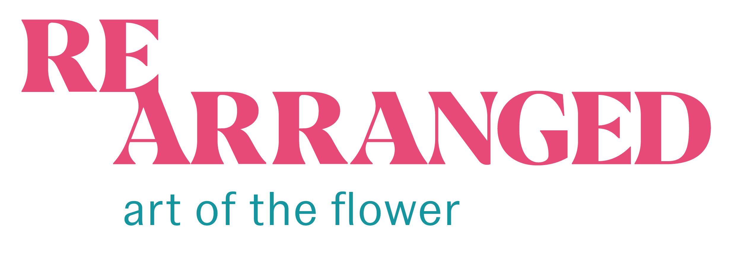

Rearranged: Art of the Flower Exhibition Labels

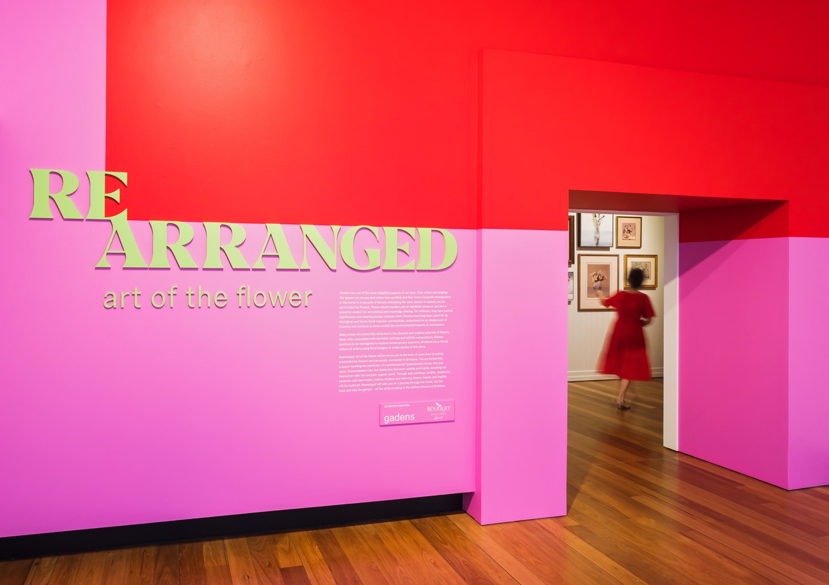

Exhibition Introduction

Flowers are one of the most delightful aspects of our lives. They soften and brighten the spaces we occupy and colour how we think and feel. From a bespoke arrangement in the home to a cascade of blooms overtaking the yard, season to season, we are surrounded by flowers. These natural wonders are an aesthetic pleasure, but also a powerful conduit for storytelling and knowledge sharing. For millennia, they have carried significance and meaning across cultures. Here, flowers have long been cared for by Aboriginal and Torres Strait Islander communities, understood as an integral part of Country, and continue to thrive amidst the environmental impacts of colonisation.

Many artists are powerfully attracted to the physical and creative potential of flowers. Most often associated with domestic settings and still life compositions, flowers continue to be reimagined to explore contemporary concerns. Brisbane has a strong culture of artists using floral imagery to evoke stories of this place.

Rearranged: Art of the Flower will immerse you in the work of more than 20 artists enchanted by flowers and personally connected to Brisbane. You are invited into a space recalling the sanctuary of a quintessential Queenslander house. Airy and open, Queenslanders blur the distinction between outside and inside, enriching our interaction with the rampant organic world. Through lush paintings, textiles, sculptures, ceramics and new media, notions of place and memory, history, beauty and fragility will be explored. Rearranged will take you on a journey through the home, out the back and into the garden – all the while revelling in the brilliant blooms of Brisbane.

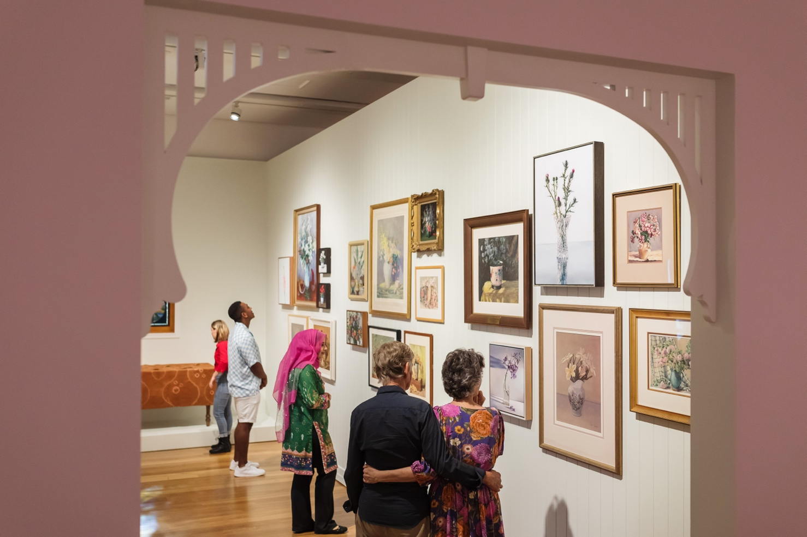

Contained

Cut from the plant that bore them, trimmed and confined to vessels, flowers displayed in the home evoke comfort and domesticity. Centuries of art depict flowers arranged inside. Popular and decorative, ‘still life’ paintings have long been a reliable source of income for artists. In Australia, still life in the European tradition became a significant genre by the 1920s. Surrounded by floral abundance, Brisbane artists could scarcely resist expanding on the tradition.

Brisbane’s greatest proponents of still life are represented in the Museum of Brisbane Collections. Vida Lahey’s and Margaret Olley’s intimate studies feature in a salon hang alongside paintings by contemporary artists who continue to sustain the genre. While Keith Burt, John Honeywill and Bronwyn Searle evoke the gentle presence of flowers, Judith Sinnamon and Michael Zavros acknowledge the seductive beauty of invasive weeds. Traversing a range of styles and techniques, these paintings offer insight into still life today.

Within this space, there are also conceptual and crafted works by other artists that further explore flowers in the home.

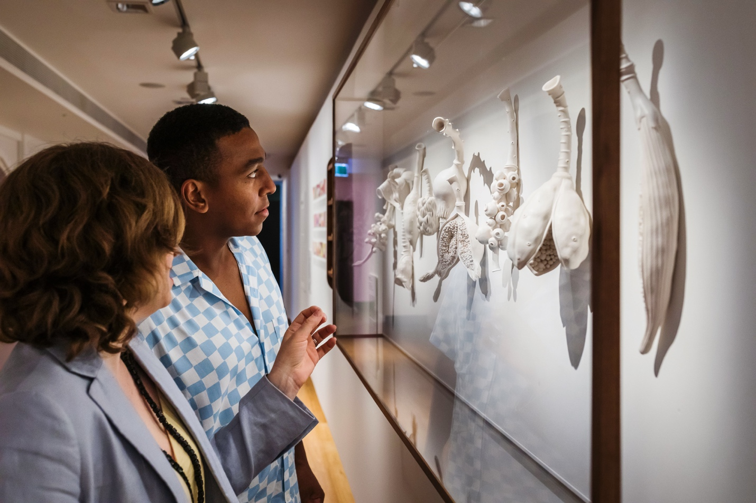

Collected

Built to suit a humid subtropical climate, Queenslander houses often feature distinct spaces that are used to nurture flowers. Merging indoor and outdoor living, a verandah walled with hanging plants or a dedicated nursery under the house can not only afford cool shelter, but serve as a combined sanctuary and laboratory, a zone in which hours may pass in the cultivation, curation, shaping and ordering of specimens. The appearance of the first flower, signalling the oncoming of buds and blooms, is thrilling.

The artists in this area consider Brisbane’s flora in the context of historical and contemporary collection, documentation and categorisation. Their works encourage reflection on different knowledge systems, the ways in which flowers can be used and what flowers represent, literally and metaphorically. The artists’ thoughts and processes range as widely as their finished works. Sarah Rayner’s sculptures express a disquieting combination of sensual intimacy and clinical investigation. Through painstaking embroidery, Lyndall Phelps refers abstractly to uncelebrated female botanical collectors and the specimens they gathered. Boneta-Marie Mabo’s uniform set of seed packets confronts Queensland’s history of incarceration. While revelling in flowers, each of the artists in this space thinks deeply about and beyond them. Researching, peering, poring, making, delineating: all take time, like the cell-by-cell development of flowers themselves.

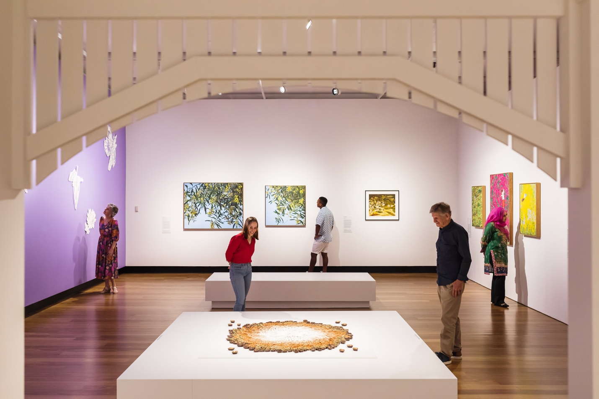

Grown

As the seasons change, Brisbane becomes a magnificent playground of buds and blooms. Gardens, both private and shared, grow populated with rambling shrubs and lofty trees, accented by flowers of myriad shapes and colours. Try as we may to bend flora to our will, they find a way to creep up where we least expect them. The golden yellow of wattle, the brilliant coral of trumpet vine, the fiery red of poinciana, the rich magenta of bougainvillea; native and introduced species alike blossom throughout Brisbane, casting the city in a fragrant palette distinct to this place.

Stepping outside, flowers abound. In this space, artworks have been arranged to emulate a lush garden, enveloping you in a kaleidoscope of blooms. Such a space can elicit moments of unbridled delight but also invite quiet meditation and deep contemplation. While visually stunning, the works suggest stories of place and migration, fragility and transience, self-identity and well-being. Pamela See (Xue Mei-Ling)’s large-scale papercuts emerge from extensive research into the contribution of Chinese communities in Brisbane. Jaishree Srinivasan’s complex ceramic installation reflects the cyclical nature of existence. All the works in this space celebrate flowers in the open landscape, riotous, sprawling and untamed.

Rearranged: Art of the Flower Extended Artwork Labels

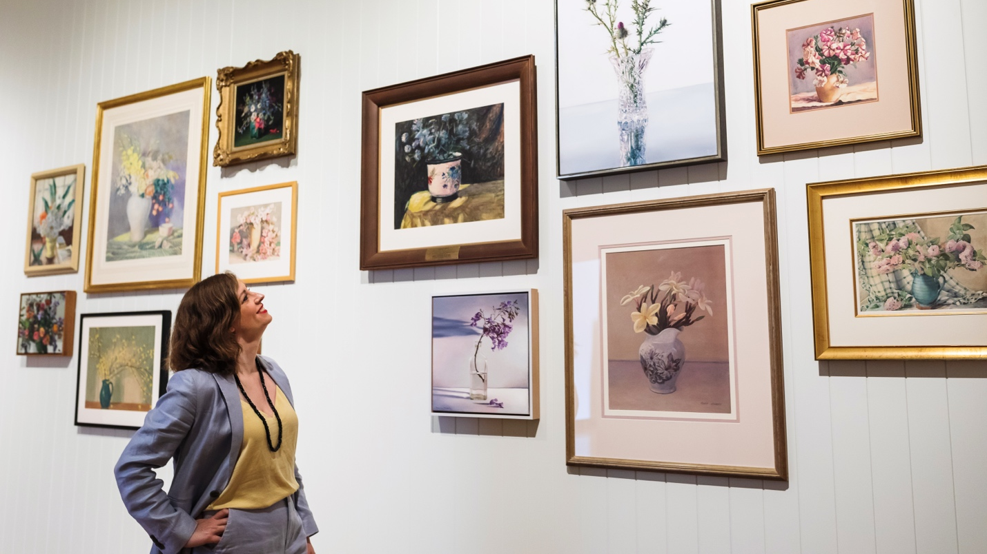

Norton Fredericks

Ipswich, Qld b. 1990
Murri
Banksia 2023
Silk, bronze and botanical dyes
Museum of Brisbane Collection

Norton Fredericks is a queer artist with Indigenous Australian and European heritage. They specialise in botanical dyeing and wet felting, with an overarching focus on sustainability. Through their practice, which extends to educational workshops, they advocate a deeper level of care for Country.

Here, Norton has recreated a formal table setting. A series of polished ‘dishes’ sit atop a richly coloured ‘tablecloth’ – it seems all that is missing is a ﬂ oral centrepiece. Upon closer look, you realise that each element is made from green waste and other recycled materials. To create the tablecloth, Norton sourced a length of silk noil, a knobbly type of fabric made from the short ﬁbres discarded during the production of high-quality silks. Norton gave the textile a second life by overdyeing it. This involved soaking the noil in alum and iron mordants (a type of ﬁxative that helps bind dyes to fabric), then bundling and heating it with native ﬂowers and seedpods. Norton then employed shibori, a Japanese resist dyeing technique, to add different patterns to the textile. To create the dishes, Norton used banksia seedpods to create silicon moulds to shape Precious Metal Clay (PMC), a material made from recycled powdered metal, organic binder and water. PMC acts like modelling clay but once ﬁ red in a kiln, the binder burns away, leaving solid metal.

Through their use of materials, Norton encourages reﬂection on the waste produced by the cut- ﬂower industry. Once a bouquet has wilted, more often than not, it is tossed in the bin. Here, Norton considers what happens to ﬂowers after they have ﬁnished serving as decoration. Their interest in ‘what comes next’ is emphasised through their use of seedpods, which emerge after a ﬂowering plant has completed its blooming cycle.

Norton’s ‘table setting’ exempliﬁes ways in which green waste can be repurposed. Once the tablecloth reaches its natural end, it will decompose and return nutrients to Country. Although Norton’s dishes will not break down, they are the product of recycled materials, and will live in perpetuity as part of the Museum of Brisbane Collection.

Julian Podmore

Newport, Wales b. 1970

Daffodils c2012
Leadlight and stained glass window
Courtesy the artist

Julian Podmore, born and raised in Wales, backpacked through Brisbane in his 20s and soon returned to make the city his home. He found work in his trade – stained glass design and fabrication – and over 35 years, grew his business, Leadlight Craftsman in Newmarket.

In Australia, decorative glass windows are often interchangeably referred to as ‘leadlights’ or ‘stained glass’. Specifically, ‘lead’ refers to the framework holding coloured glass in place, and ‘stain’ to elements painted and fired onto the glass. Stained glass windows have been created since the 10th century, and are often found in churches and grand buildings. Oddly enough, they are also a common feature in modest timber Queenslanders.

In the 1880s and 1890s, mechanisation and mass production enabled companies such as Brisbane’s John Campbell & Sons to design and start supplying prefabricated housing products. A Campbell ‘Redicut’ home arrived with pre-cut joinery and glazing, and every nail and lick of paint required for the owner or handyman to erect the structure. A choice of layouts and trims gave buyers the chance to achieve their own unique house. Ornamental leadlight became an included feature, reflecting wider global fashions and modern glass design. A Campbell’s catalogue of 1935 notes that the ‘bull’s-eye window’ or ‘porthole’, lends a ‘distinctly modern touch to the home’.

Daffodils is a contemporary window, more sophisticated than most original Redicut home leadlights. Julian has chosen to highlight the national emblem of Wales, symbolic of his own origins. His design incorporates staining and an intricate lead framework. Demand for new leadlight has decreased since the 1930s, but artisanal craftspeople such as Julian remain essential to restoration and maintenance of Brisbane’s heritage buildings.

Vida Lahey

Pimpama, Qld 1882-1968

The white vase c1946
Watercolour on paper
Donated through the Australian Government’s Cultural Gifts Program by Kay Bryan 2016
Museum of Brisbane Collection

Autumn roses 1960s
Watercolour on paper
Gift of the City Hall Historical and Arts Committee 1969
City of Brisbane Collection, Museum of Brisbane

Untitled [Still life with fuchsias and ginger jar]
1930s-1940s
Oil on canvas on panel
City of Brisbane Collection, Museum of Brisbane

Untitled still life 1940
Watercolour and graphite on paper
City of Brisbane Collection, Museum of Brisbane

By the window c1940s
Watercolour on paper
Courtesy Judith Sinnamon

Untitled 1950s
Watercolour on paper
Courtesy John Hewson

Vida Lahey MBE was born into a family of arrowroot farmers and timber merchants with properties at Pimpama, Canungra and Brisbane. Late in life she recalled that when her father made long trips from the country to Brisbane, he would carry with him a small bunch of wildﬂowers for the family’s pleasure.
Vida trained in art with Godfrey Rivers in Brisbane and Frederick McCubbin at the NGV School in Melbourne before moving to London during the First World War. Overseas, she studied works of great artists, painted landscapes and took some further classes. From the 1920s, when she lived in Brisbane and Hobart, she concentrated increasingly on painting ‘ﬂower pieces’ in oil and watercolour, such as the six works hanging in Rearranged. Soothing and decorative, they were a reliable source of income for the artist, as ﬂoral still lifes have proved to be for many others. They sold well in Brisbane, Sydney, Melbourne and Canberra.

As Vida consolidated her reputation as a painter, she became a force on the Brisbane art scene, active in fundraising, teaching, lecturing, writing, advocacy and advising; at the age of 77, she published the invaluable book Art in Queensland 1859-1959. From 1946 Vida lived in St Lucia, Brisbane with her sister Jayne in a house built from family-milled timber. Amongst their gramophone records, original artworks and colour reproductions of European paintings, the siblings lived out Vida’s belief that art is a ‘power that works for peace’.

Clairy Laurence

Brisbane b. 1966
Croc vase 2 2022
Stoneware with 22 carat lustre (gold and platinum)
Museum of Brisbane Collection

Clairy Laurence, ceramicist, grew up in Indooroopilly in a house with her mother’s pottery studio downstairs. Her father was an academic, and the house was ﬁlled with books and artworks by her parents’ friends on the walls, shelves and tables. In the early 1990s, Clairy opened the Amfora Gallery, which occupied various premises: ﬁrst, a shop on Musgrave Road, Red Hill; secondly, a gallery and studio space upstairs in the old Elizabeth Arcade; and at last, from 1995, a gallery beneath a Queenslander on Latrobe Terrace, Paddington with a view over the city and huge doors opening into a courtyard for events. While setting up a ceramics department at Monte Lupo, Eight Mile Plains, where she worked as a mentor for nine years, she gained qualiﬁcations in studio ceramics and art therapy. In 2013, she became an independent full-time maker and teacher of ceramics, working in a studio in her home overlooking bush in Indooroopilly.

Clairy is best known for petite, ornate and original ceramic ﬁgures of female entities that she calls ‘Lil Babes’. Uncanny, sweet and dangerous all at once, they are often accessorised with skulls, snakes and coronets and almost always surrounded by bedecked with or blanketed in ﬂowers. Over time, she has extended her productions to reﬂect the ‘other place’ in which she imagines her ‘babes’ dwell. In sugary pastels or glossy black, her sculptures encompass strange, often genetically hybrid ﬂora and fauna such as humanoid monkeys and lions with fearsome fangs, birds with eyelashes of petals, ﬂower-crowned fawns, winged insect-like creatures with human eyes in their backs and reptiles crusted with pearls and blossoms. Details on these works can be very challenging for Clairy to create. Chasing each other around this vase, the ﬂoral crocodiles frolic and sing in their gilt star fascinators; but the artist says resolving the playful forms ‘nearly killed’ her.

Margaret Olley

Lismore, NSW 1923-2011

November lilies 1963
Oil on Masonite
Gift of the City Hall Historical and Arts Committee 1969
City of Brisbane Collection, Museum of Brisbane

Margaret Olley AC grew up in the Tweed Valley, New South Wales and Tully, North Queensland, and completed school as a boarder at Somerville House in Brisbane. Having attended Brisbane’s Central Technical College in 1941, she proceeded to study art at East Sydney Technical College. For four years from early 1949 she lived in Europe, yet in 1950 she sent works to Brisbane for two exhibitions, one at the Moreton Galleries in the AMP Chambers at 5 Edward Street, and the other at Brian and Marjorie Johnstone’s Marodian Art Gallery in Upper Edward Street. Within months of the opening of the Johnstone Gallery in the Brisbane Arcade in 1952, she had a solo show there.

For a decade from 1953 Margaret lived in Brisbane, in her mother’s home, Farndon, close to the river in Hill End. On her neighbourhood walks she would pick ﬂowers and foliage that grew along her route. In a lattice-panelled space under the house, she began to paint the kind of works for which she was to gain renown: gorgeously coloured paintings of vases of ﬂowers set on tables and sideboards within rooms she inhabited. In 1954 she wrote of ‘trying to tackle the problem of colour’; her art was becoming more personal, she said, ‘and I’m afraid to say more feminine’.

As time passed, her compositions combined ﬂowers with more and more books, pictures, textiles and objects from her extensive overseas travels. Farndon, full of Margaret’s paintings and treasures, burned down in late 1980; it was only from then that she felt that Sydney, where she had lived from the mid-1970s, really was her home. From 1975 until her death in 2011 – by which time she had become a major arts philanthropist and a designated National Living Treasure – Margaret exhibited at the galleries of her good friend, Philip Bacon, in Brisbane.

William Grant

Brisbane 1876-1951

Still Life, Yellow Cloth undated
Watercolour on paper
Gift of the Lady Mayoress’ Social and Welfare Committee 1980
City of Brisbane Collection, Museum of Brisbane

William Grant, son of a stone-house builder, drew keenly as a child and was instructed in art at Brisbane Grammar School. When he was in his teens his family moved to a house called Craigellachie, built by his father at Lutwyche (now Windsor). After William left school he began a 53-year career as an accountant with JC Hutton’s in Roma Street. At lunchtimes he sketched in the city, and he took night classes with Godfrey Rivers at the Central Technical College. For seven years between 1907 and 1915 he was the Honorary Treasurer of the Queensland Art Society; he ﬁrst exhibited pictures at its annual exhibition in 1909, and was awarded Life Membership in 1937. During the 1920s he was an adviser to the Queensland National Art Gallery, of which he was later a trustee.

A proponent of a distinctively Australian – and Queensland – kind of art, William made pictures of local landscapes and buildings populated by farmers, woodcutters and farm animals; he illustrated some ‘Red Reader’ textbooks for Queensland schoolchildren. In 1915, he married fellow artist Gwendolyn Stanley, and in the mid-1920s they built a barn-like house, to Gwendolyn’s design, in Nundah (now Wavell Heights). In 1929
it was reported that ‘in the happy atmosphere of Mr and Mrs Grant’s home, Bimbimbie, at Nundah, Miss Jessie Traill was entertained by Mrs WG Grant and Miss Vida Lahey. Miss Traill, the well-known Southern artist, delighted those present with an informal talk on the work of El Greco and Velasquez’.

At Bimbimbie, William grew bright nasturtiums, zinnias and marigolds and allowed weedy ﬂowers of ageratum, dandelions and scurvy weed to bloom wild on the edges of the block. In and out of the well-lit studio on its upper storey, he created many views of their home’s interiors, garden and surrounding area that capture the quiet pace of life in their times.

Judith Sinnamon

Brisbane b. 1963
Weeds (Lantana, Blue Billygoat Weed, Privett Berries, Clover Flowers) 2023
Oil on canvas
Museum of Brisbane Collection

Judith Sinnamon grew up in Red Hill and studied painting at Queensland College of Art’s Seven Hills campus in the mid-1980s. For the last two decades Judith and her family have lived near Maleny, on land that was rainforest before it was cleared in the 1920s for soldier settlement. Through years of hard physical work and commitment, Judith and her husband have regenerated the land which is now planted with ﬂora endemic to the region. When Judith breaks from painting, she swaps brushes for a machete and clears swathes of the invasive lantana that constantly encroaches.

Judith’s abiding interest in Australian native ﬂora is expressed in both her regenerative land practices and in her paintings. While she painted exotics in earlier years and is also known for evocative portraits, her primary focus is the ﬂowers, plants and trees of South East Queensland.

Here, Judith has departed from native ﬂora and the muted palette she usually chooses. A bright bunch of ﬂowers, seemingly innocuous, is in fact the contrary. The still life comprises the invasive weeds lantana, blue billygoat weed and privet,
all collected from Judith’s property though they are species she has been trying to eradicate for years. Having repeatedly painted Australian ﬂora endemic to this region, Judith feels that the colours in this bunch are ‘all wrong’: the greens are too strong, with the blooms disconnected, jarring visually with the landscape. Viewed through a childlike lens, however, the motley ﬂowers of the lantana and blue billygoat weed – likely escapees from a Victorian-era garden – have a lolly-like prettiness. In the interior context of a still life, the invasive stems are a harmless delight.

Frank Waldo Potts

Sandgate, Qld 1888-1970

Petunias undated
Watercolour on paper
City of Brisbane Collection, Museum of Brisbane

Untitled 1930s
Watercolour on paper
Courtesy John Hewson

Frank Waldo ‘Wal’ Potts, son of a Brisbane tailor, learned his father’s trade and studied art with Godfrey Rivers at the Central Technical College before the First World War. He left for the war
in May 1917, aged 28. Embarking the same day in the 2nd Light Horse Field Ambulance was David McHafﬁe, also 28, listed as a Presbyterian clergyman. Both served in the 8th Sanitary Section, Moascar, Egypt. On their return, Wal and David established a pineapple and mandarin farm at Flaxton, 105 kilometres north of Brisbane in the Sunshine Coast Hinterland. There, between sessions of hard work on the farm, Wal settled into painting landscapes and still lifes in watercolour. Many artists enjoy the skill challenges of working in watercolour, which behaves very differently from oil paint. Watercolour also has the advantages of being less expensive to buy, and easier to clean up, than oil paint (a boon for an artist such as Wal, who painted his still lifes in his living room). In the little spare time they had, Wal and David played key parts in their small community. They were central to social activities such as fundraising evenings for the Brownie Pack and local recreation facilities, for which Wal sometimes donated a painting as a prize. It was reported that at one such event in 1934, ‘the hall was taxed to the utmost capacity…Mr
D McHafﬁe, in the role of announcer, caused considerable merriment with the patter he introduced between various items, and Mr FW Potts acted as accompanist throughout the performance’. A competent ﬂautist, Wal was also in demand for magic tricks and led a mouth organ band called the Flaxton Mouth Organ Melody Makers. In 1949 Wal and David retired to the coast at Woody Point, Moreton Bay, where Wal continued to paint and exhibit his popular and well-regarded watercolours.

Tony Johnson

Ipswich, Suffolk, England 1941-2019

Untitled still life undated
Acrylic on canvas
Museum of Brisbane Collection

Untitled still life undated
Acrylic on canvas
Museum of Brisbane Collection

Frangipani Flowers 1985
Gouache on paper
Museum of Brisbane Collection

Tony Johnson gained a diploma with honours in painting and drawing at the University of London before moving to Australia in 1962. Commencing full-time work as an artist in 1969, he was that year highly commended in the competitive Redcliffe Art Prize for watercolour. His painting, titled 238 Petrie Terrace, depicted the elegantly-deteriorating Illawarra and O’Keefe’s buildings, clad in iron lace, which accommodated various artists at the time. Tony won the Redcliffe prize in 1970 for his work Terraced Gardens, Red Hill and was highly commended again for a Glen Innes landscape in 1972. In the 1970s and 1980s, during which he took four European study tours with his artist wife, Pat Daley, he exhibited both internationally and in Brisbane (at the McInnes Gallery in Rowes Arcade, Adelaide Street; Cintra House Galleries in Boyd Street, Bowen Hills; and Cintra Galleries in Park Road, Milton).

Tony painted some still lifes incorporating Chinese-style ceramics, such as these studies of cyclamens, but most of his Brisbane works were gentle, decorative vignettes with titles such as Spring Hill Doorway, Paddington Cats, Doorway with Bougainvillea, Washing Trolley with Nasturtiums and Poinsettia Time, Red Hill. Paintings such as Red Hill Window and Brisbane Afternoon depict women sitting by vases of ﬂowers, accompanied by cats and books in shady, comfortable rooms. Others feature gardens with touches of lattice, bamboo verandah blinds and rambling geraniums. Now, such works afford glimpses of places and rhythms of life in a city largely lost, and dimly recalled.

John Honeywill

Brisbane b. 1952

Snap 2023
Oil on linen
Museum of Brisbane Collection

John Honeywill, painter, gained a diploma in art teaching at Kelvin Grove College of Advanced Education in the 1970s. At the age of 20 he moved north to teach at Bundaberg, where he remained for 12 years. There, he took lessons from Merv Moriarty and other instructors with the renowned Flying Arts Alliance. In 1987 he began his 30-year career as head of art at Somerville House school in Brisbane. By the time John completed his bachelor’s degree in education, in 1992, he had had three solo shows at Grahame Galleries and Editions in Paddington. After two more, he was invited to show at Philip Bacon Galleries, where he has exhibited ever since. He now paints full-time in his home studio in Kedron.

John says he is often attracted to painting an object because of its beauty. Sometimes, though, he is persuaded to paint something by a quality of ‘otherness’, which will alter ﬁrst when it is rendered by the artist, and again when a viewer contemplates his painting. His meticulous works have been described as ‘pure distillation of presence’ – but what may be present in the painting may be a paper bag, a couple of eggs, a meringue, a pile of folded fabric, pink Turkish delight, red jelly, lemons, shells or a raspberry macaron. Equally, it may be a perfect snapdragon, orchid, kangaroo paw or magnolia. ‘I paint the quiet visual conversations between everyday objects,’ John says, describing still life as a kind of art that ‘links the intimate world with the public’.

Bronwyn Searle

Brisbane b. 1954

Jacaranda Ink 2023
Oil on canvas
Courtesy the artist

Bronwyn Searle is recognised for her detailed paintings of leaf litter and still life. Born and raised in Brisbane, she gained her associate diploma in graphics from Brisbane College of Art. Bronwyn started her career as a graphic artist, then in 1984, joined the art department at Queensland Museum. Working across exhibition design and illustration, she contributed to a range of social and natural history displays and publications. After leaving the Museum in 2002, Bronwyn pursued freelance illustration, receiving regular commissions from publishers John Wiley & Sons Australia.

Ever since she was a child, Bronwyn had dreamed of becoming a painter. From the age of 50, she attended the Brisbane Institute of Art every Friday for two and a half years, studying oil painting under Warren Palmer. Over time, she reﬁned her skills and developed her own style. Bronwyn realistically renders the details of her subjects, paying close attention to the interplay of light and colour. She searches for the beauty in the ordinary aspects of life, creating compositions that spotlight everyday objects, often overlooked. Flowers are one of her favourite subjects to paint.

An avid gardener, Bronwyn is particularly fond of freesias and nasturtiums. Aside from her own garden, she tends to her local community plots. Every time she enters the gate, she is welcomed by a huge jacaranda. Although jacarandas are not native to Brisbane, they have become icons of the city. From mid-September, they cast the streets in a lavender haze that evokes the changing seasons. They have also become part of local superstition, reminding students to knuckle down as exams are fast approaching. Here, Bronwyn has painted a sprig of jacaranda drawn from her community garden.

Dorothy Thornhill

Cheshire, England 1910-1987

Oleanders in cornucopia vase 1940
Oil on canvas
Gift of the City Hall Historical and Arts Committee 1978
City of Brisbane Collection, Museum of Brisbane

Dorothy Thornhill came to Australia from England in 1929, returning to London in the early 1930s to study at the Royal Academy. Returning to Sydney, she undertook more training at East Sydney Technical College, where she was to become renowned and respected as teacher of drawing from 1937 to the mid-1970s. Her husband from 1941 was Douglas Dundas, who was head teacher of painting from 1938 to 1960. Margaret Olley AC was a student of both, and would have dinner with the couple from time to time. In May 1940 Dorothy took part in a group show of ﬂower pieces at Macquarie Galleries, Sydney. At this time, people were arguing about the relative value of modern and traditional art. Opening the show of gentle, decorative pieces, Miss Ethel Ranken called for polite behaviour, saying, ‘This is a place for pleasant discussions on art and not pronouncements’.

A reviewer of Dorothy’s ﬁrst solo exhibition at Macquarie in October 1940 judged them ‘highly competent pictures…all graceful in colour and design’, adding, ‘they do not add anything very exciting to Australian methods and subjects, but what she attempts Miss Thornhill carries to completion’. Oleanders in cornucopia vase may well have hung in one of these shows. Dorothy probably painted this vase several times, with and without the arrangement of poisonous garden blooms it supports here. This work belongs to the City of Brisbane Collection, comprising works acquired by the City Hall Historical and Arts
Committee in the 1960s and 1970s. Many were donated in response to persuasive approaches by well-connected members of the Committee, led by the charming Lady Mayoress, Sylvia Jones.

William Bustard

Terrington, Yorkshire, England 1894-1973

Untitled [Still life ﬂowers in vase] undated
Watercolour on paper
Museum of Brisbane Collection

William Bustard left school in Scarborough, Yorkshire with a scholarship to study science and technology at London’s Battersea Polytechnic Institute. Proceeding to the Slade School of Art, he came to specialise in stained glass, a ﬁeld in which he worked both before and after his service in the First World War. In 1921 he and his wife Lily left England to settle in Brisbane. He was soon active in the Queensland Art Society, becoming its president in 1932. While teaching part-time at the Central Technical College from 1924 to 1933, he embarked on his long career of creating windows for churches and civic buildings throughout Australia, including Brisbane’s City Hall. He was also to paint landscapes, views of developing Brisbane, scenes of the Queensland countryside and artwork for travel posters. In group exhibitions of the 1920s he was singled out as the ‘shining star’ and commended for his ‘continual experimenting’; his ﬂower studies in 1929 were judged to be of ‘outstanding merit’. His ﬁrst solo exhibition, at the Grifﬁth Brothers Tea Rooms
in Queen Street in 1931, was lavishly praised, recommended especially to lovers of watercolours.

He was chair of the Art Advisory Council for the Queensland Art Gallery from 1931 to 1937. During the Second World War he served as an RAAF camouﬂage ofﬁcer, yet still, for a solo show in 1945 he provided a remarkable 93 pictures. In 1948 he illustrated an edition of Robinson Crusoe for Jackson and O’Sullivan publishers in Queen Street, a copy of which was presented to Queen Elizabeth II on her visit to Brisbane in 1954. In 1953 his commissioned painting of the Gabba was sent to hang at Lord’s Cricket Ground, and in 1954 one of his paintings of City Hall was presented to the town of Largs, Scotland (birthplace of Sir Thomas Brisbane).

Michael Zavros

Brisbane b. 1974

Crystal/ Thistle 2013
Oil on canvas
Private collection

Michael Zavros, one of Australia’s highest-proﬁle contemporary artists, grew up on land owned by his schoolteacher parents, inland from the Gold Coast. There, he became a competitive horse rider, and learned from his grandmother to strike plants from sneaked cuttings. Michael moved to Brisbane to attend the Queensland College of Art, where he majored in printmaking and gained his Bachelor of Visual Arts in 1996. Upon graduation, he operated a trompe l’oeil mural painting business for a few years. By 2000, however, he was featured in Primavera: Young Australian Artists at Sydney’s Museum of Contemporary Art. Provoking argument and in-demand ever since, his arresting works typically feature designer goods and opulent interiors, meticulously painted from photographs he takes pains to compose.

Since 2007 Michael has worked in a studio on his property in Chandler, 15 kilometres east of the Brisbane CBD, where he cultivates his garden and chickens, struggling to keep them apart. Floral arrangements recur throughout his oeuvre, often arranged into sculptural shapes ratiﬁed in his titles: inverted stems of red and yellow gladioli conjure an Octopus, a yellow vase with a tower of blue hydrangeas comprise Marge Simpson, costly mixed blooms and a gorgeous Gucci scarf make The Lobster.

‘Flowers are short-lived in the Queensland heat, and it’s hard to ﬁnd certain blooms at certain times, so there is a rarity to the work, an almost imperceptible layer of luxury that I am very conscious of,’ he says. In an age where political commitment is widely expected of artists under 50, Michael asserts that within his artworks, ‘nature is not the subject of environmental concern’. The spikes of the thistle in this painting make a witty counterpart to the cuts in the glittering vase, and the words ‘crystal’ and ‘thistle’ sit well together in the title. Traditional ﬂower pieces are cosy and comforting, but this painting gives off no more of an air of snug homeliness than any of the artist’s paintings of cars, glossy steeds or designer accessories.

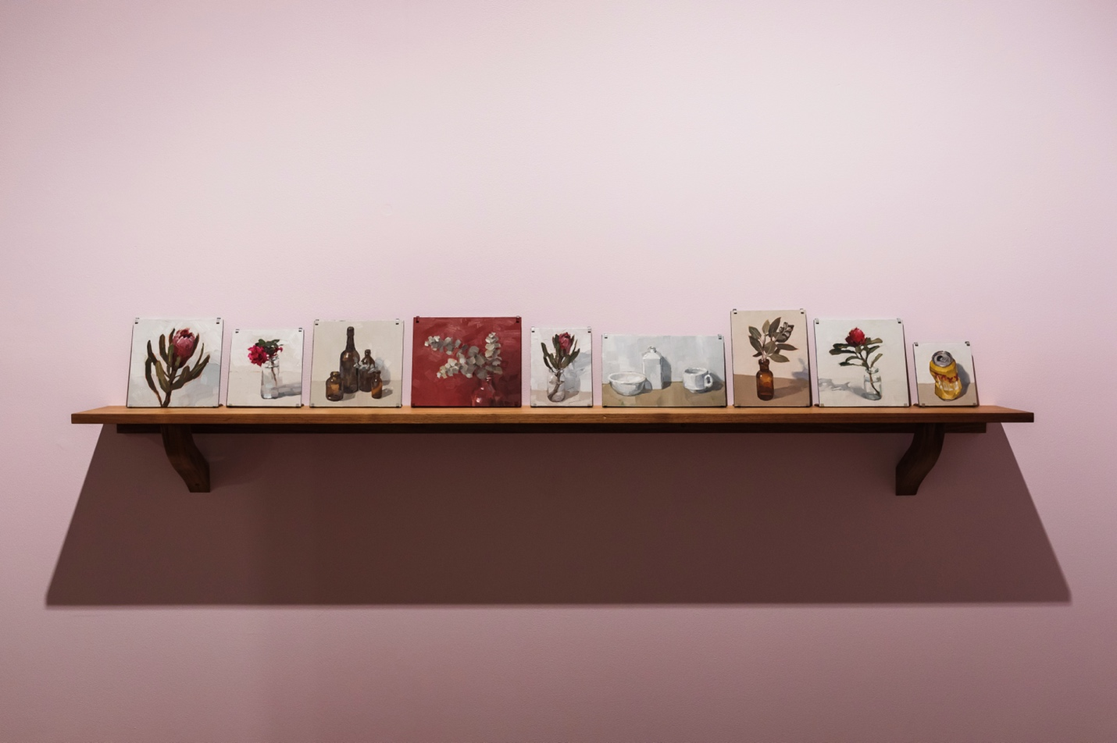

Keith Burt

Sydney, NSW b. 1969

Protea 1
Bougainvillea
Brown bottles
Leaves on red
Protea 2
White trio
Leaves in brown bottle
Waratah
Goldie
All works 2023
Oil on board
Museum of Brisbane Collection

Keith Burt is recognised for his evocative yet exacting still lifes, portraits and landscapes. Raised in Melbourne, he enjoyed a brief stint at art school before moving into animation. One of his main jobs involved building environments for PlayStation and Dreamcast games (despite having never played video games before). After his children were born, Keith began freelance illustration for The Big Issue and other political magazines. In 2008, he moved with his family to Brisbane, settling in West End. Following the move, he found painting helped him adapt to his new surroundings. After the success of his first exhibition of landscapes at Metro Arts (then in the CBD), Keith transitioned to full-time painting.

Although well-known for landscapes and portraits, Keith enjoys painting still lifes. He builds his compositions in his West End studio, constantly rearranging objects on a makeshift stage, considering each element for its colour and shape; ability to reflect, transmit and absorb light; and relationship to other objects. Once he finds the right balance, he begins painting. While deliberate in his brushstrokes, Keith applies paint loosely to render his direct observations and enhance the tactility of each object. This suite evokes the presence of objects from his everyday life: bougainvillea from his neighbour’s garden, protea from Woolworths and one of his favourite flowers, waratah, nestle beside brown bottles, white tableware and a crumpled XXXX Gold beer can.

Keith’s studio is always peppered with small studies of flowers and wares, often painted as part of his process of ‘warming up’. His gallerist recently encouraged him to exhibit a selection of these loose studies on a custom-made shelf. Displayed as a series, Keith’s studies highlight the joy of noticing what is around you.

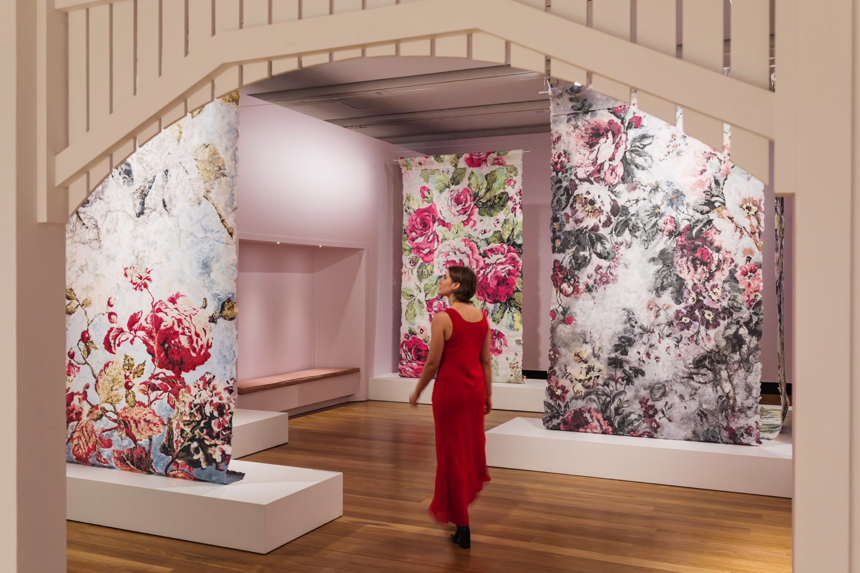

Karen Stone

Wollongong, NSW b. 1957

“That candy pink fibre’s a b****! Bit harsh. Maybe she’s just misunderstood?” 2018
Roses on teacups…raspberry ripple cream biscuits 2018
Both works cotton and linen fibre
Museum of Brisbane Collection

Blue roses…the paralysis of perfection 2018
“Oh dear,” the pale pink rose sighed, then tightly squinched her petals so she could better concentrate. “It’s so very hard to remember exactly what colour I’m supposed to be! Green today? Grey tomorrow?” 2019
Yellow expectations…“This is m’daughta, she won’t do what she oughta” 2020
Falling into hope 2021
All works cotton and linen fibre
Courtesy the artist

Karen Stone is a Brisbane-based artist who creates large-scale ‘paper-arabesques’ inspired by floral patterns found in the home. She explores ‘home’ as both a physical place and emotional concept, drawing on her personal experiences as a single, older and non-homeowning Australian woman.

Karen has always been delighted by flowers. In the homes of her childhood, she was surrounded by floral patterns – on curtains, wallpapers, carpets, couches and tea towels. In these spaces, she recalls her mother and grandmother performing ‘home duties’, enacting the model of femininity expected of them. As Karen grew up and rejected the societal norms laid out for her, she continued to collect floral fabrics in the spaces she rented. In her paper-arabesques, Karen employs floral motifs to explore her relationship to ‘home’ as a space that is both comforting and nurturing, but also saturated with patriarchal values.

Karen’s process begins with the sourcing of second-hand cotton and linen clothes. She tears apart the garments then processes the fragments in a Hollander beater, grinding them into a pulp. Depending on what fabrics and original dyeing processes are used, the colour of the pulp will vary. Her pulps are transferred into squeeze bottles, which she uses to ‘paint’ the coloured medium onto a four-by-two-metre silkscreen. As she applies the different coloured pulps onto the screen, layers build up. Over time, the pulp fibres bind together to create a single sheet, which Karen carefully peels off the screen once dry.

Karen’s paper-arabesques have been arranged to evoke the rooms of a house. They captivate you as you move around them, enveloping you through sheer scale. For Karen, the experience recalls hiding behind her grandmother’s floral-patterned couch as a child, imagining the flowers come to life. Here, the flowers accompany Karen as she reclaims ‘home’ as a place free of patriarchal expectations.

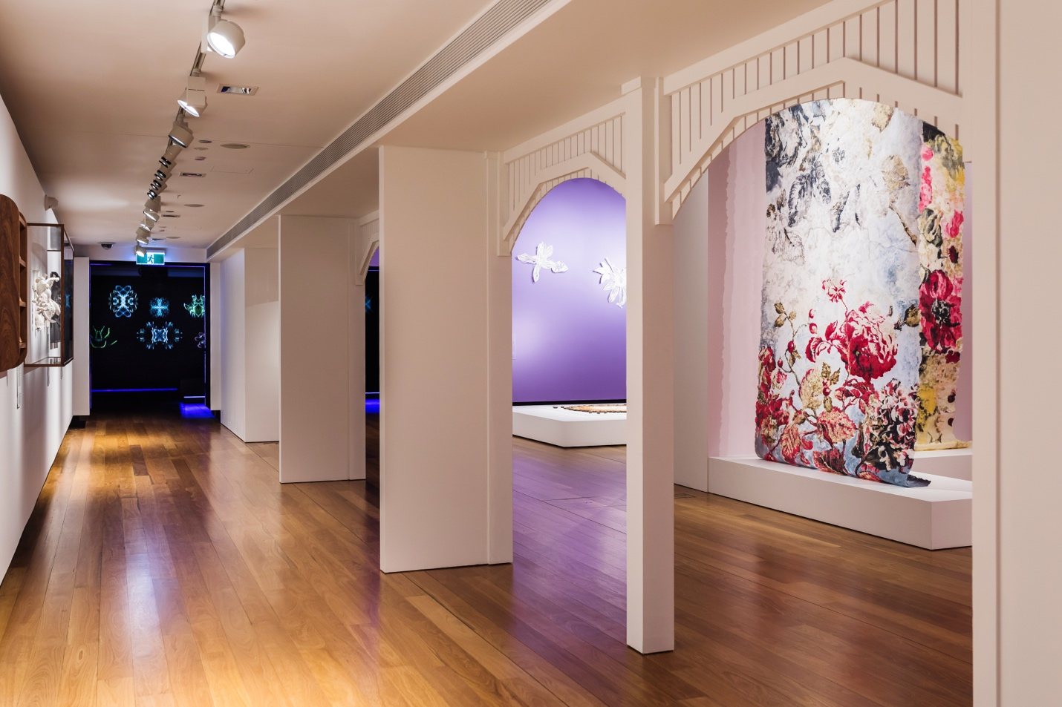

Lyndall Phelps

Casino, NSW b. 1958

Re-collect 2023
Perforated card, embroidery thread, herbarium card, lead pencil and polyester thread
Museum of Brisbane Collection

Lyndall Phelps is an artist working in many different mediums. Born in Casino, she gained her master’s degrees in art and art administration at the College of Fine Art, University of New South Wales while working at the Museum of Contemporary Art, Sydney. In 1999 she moved to the UK, where she worked and exhibited until her return to Australia in 2019.
With strong interests in museums and natural history, Lyndall is an avid collector and re-interpreter of objects. These preoccupations inform her ongoing mixed media series Re-collect. These 30 embroideries relate to Australia’s first herbarium, developed by Ferdinand von Mueller, who was appointed Victoria’s first government botanist in 1853. While von Mueller himself collected many specimens, he relied greatly on amateur collectors to send him material for the herbarium. More than 200 of these collectors were women – a fact only known now from the information that accompanies their specimens. The locations in which the plants were collected suggest that many of these women lived in isolated areas of Australia. Lyndall activates our interest in these historically obscure women through works that recall traditional women’s work – tiny, detailed panels of handstitched threads, completed laboriously in solitude. These embroideries resemble groups of small, similar natural history items such as beetles or shells in museum displays; they also evoke museum object identification cards kept in files and drawers before the age of digitised records. Each embroidery represents a single Queensland plant species. While preserved botanical specimens lose their colours, Lyndall took care to match her threads to the colours of the living flowers, buds and fruit of each plant species. In a clean and regulated museum environment, she thus introduces both the collectors, and the kinds of material they collected, to a new and vivid phase of existence.

Boneta-Marie Mabo
Mackay, Qld b. 1984

Meriam, Munbarra and Nywaigi people
Colonial Seeds Packet – Industrial Reformatory School for Girls
Colonial Seeds Packet – Karrala House
Colonial Seeds Packet – Industrial School for Girls
Colonial Seeds Packet – Cleveland Youth Detention Centre
Colonial Seeds Packet – Sir Leslie Wilson Youth Centre 1983-1993
Colonial Seeds Packet – John Oxley Youth Detention Centre
Colonial Seeds Packet – Sir Leslie Wilson 1993-2001
Colonial Seeds Packet – West Moreton Youth Detention Centre
Colonial Seeds Packet – Brisbane Youth Detention Centre
All works 2023
Digital print on paper and plastic beads
Museum of Brisbane Collection

Boneta-Marie Mabo is a proud Meriam, Munbarra and Nywaigi artist. Her research-based practice spans a range of mediums, and extends her activism as a prison abolitionist. In particular, Boneta-Marie is dedicated to supporting girls and women affected by the criminal legal system.

In her ‘Colonial Seeds’ series, Boneta-Marie employs floral imagery to confront Australia’s fraught history of incarceration. In 1788, the First Fleet led by Captain Arthur Phillip docked in Sydney Cove. There, the first British settlement in Australia was established as a penal colony to relieve overcrowded British prisons. In 1824, the British expanded into what is now Queensland to set up the Moreton Bay penal colony, intended for repeat offenders. When the Moreton Bay area opened to free settlement, prison facilities continued to operate throughout Brisbane and the rest of Queensland. Using photo editing software, Boneta-Marie designed nine ‘seed packets’ that align Queensland prisons for girls with flora brought over by the First Fleet. She suggests prison systems that were brought to Australia are akin to introduced species of flora. As Boneta-Marie explains, ‘These systems continue to be cultivated on Custodial Lands, yet the imprisonment rate of Aboriginal and Torres Strait Islander people remains wildly disproportionate to the rest of the population. In Queensland alone, Aboriginal and Torres Strait Islander people are 12 times more likely than non-Indigenous people to be jailed’.
Boneta-Marie’s series reflects on how the language used to describe prisons has shifted over time. From ‘Industrial Reformatory School’ to ‘Detention Centre’, more palatable words have long been used to cloak the brutal reality of these places. Yet Boneta-Marie has included the same ‘seeds’ within each packet to emphasise that no matter what name they are given, these facilities are all the same thing: prisons.

Sarah Rayner
Chesham, Buckinghamshire, England b. 1965

Flowerbones of Meanjin 2023
Porcelain with terra sigillata and entomology pins
3 pieces Museum of Brisbane Collection
8 pieces Courtesy Gallery Sally Dan-Cuthbert and the artist

Sarah Rayner majored in textiles and printmaking at the University of Southern Queensland, Toowoomba in the 1990s. From a young age, she was curious about biological science, historical apparel, makers’ techniques, the classification of plants and animals, and the practice of collecting. Having worked as a lecturer in textiles, she co-founded a handbag and accessories label, making collectable pieces by hand for sales and exhibitions. A period of making sculpture in fibre, found objects and plaster led her to porcelain. Although she had never liked gritty clay, she was attracted to porcelain’s silky texture and its rich historical associations. She has been sculpting in this medium for almost a decade now, forming a shape that will nestle in her cupped hand, waiting until it dries to a leathery consistency and painstakingly carving, incising and poking it to its realisation as one of the exquisite ‘flowerbones’ for which she has become renowned.

Sarah lives and works in protected bushland at Wootha in the Sunshine Coast Hinterland teeming with living, reproducing plants and animals. Rambling along bush tracks she notes details in the organic litter underfoot and wild branches overhead. She does the same on her regular walks along city footpaths, which she has combed for this body of work relating to native Australian trees growing in the Brisbane region. Wherever she is, she picks up twigs, seedcases, fruits and flowers that have dropped, burst, shattered and scattered. In her studio, she slices into buds and flowers, and breaches the pods that have formed from others. She peels and dissects the seed containers – puffy and papery, skin-like or woody-hard – to expose linings that can be hairy, velvety, woolly or spongy. She looks into botanical books for classificatory details; she draws, then slowly sculpts, the intricate structures she observes. Satiny smooth under their pale finish of terra sigillata, the flowerbones are Sarah’s abstractions of natural forms, distilled and exaggerated to share knowledge of, and encourage wonder at, the planet we share with them.

Edith Rewa
Ballarat, Vic b. 1991

Hakea benthamii, (Queensland Hakea)
Leptospermum polygalifolium, (Tantoon)
Boronia rosmarinifolia, (Forest Boronia)
All works 2023
Digital giclee print
Museum of Brisbane Collection

Edith Rewa, textile designer and illustrator, studied screen printing in Melbourne before working for a textile design company in Sydney. At the time, native flowers were too spiky for fabrics for the fashion industry; she painted roses and peonies, and found it grating. It wasn’t until Edith moved to Blackheath in the Blue Mountains of New South Wales that she was able to ground herself amongst endemic plants, and establish herself as an illustrator and designer concentrating on native flora. Her delicate textile designs, limited prints, collaborations, book covers and other projects are now widely recognisable.

Before moving to Brisbane, Edith imagined all of Queensland might be rainforest, but afterward, she was delighted to find the wallum ecosystem of coastal South East Queensland has abundant wildflowers and diverse landscapes, including the sclerophyll forests of Brisbane. She decided to stay for the mild winters and the joy she derives from the local flowering season.

Moving slowly through the bush, where the sun illuminates the subtle wildflowers, Edith takes time to get to know each plant before she draws it. Notes she takes about the visual elements, scent and structure of each plant assist in accurately identifying species. Little studies of details at different angles and photographs are made on the spot. From these, in the studio, she makes her final compositions.

These three ‘plant portraits’ highlight species found in Toohey Forest; an ecological gem surrounded by Brisbane suburbs. Physical and sensory reactions drew Edith to the species: she saw stunning wild foliage of Hakea benthamii (Queensland hakea) reaching up to the light; Leptospermum polygalifolium (tantoon or wild may) brushed her face and arms; and Boronia rosmarinifolia (forest boronia), growing low to the ground, invited her to sit and draw for a while.

Elisa Jane Carmichael
Brisbane b. 1987
Ngugi people

ragi #4
ragi #7
ragi #11
ragi #13
ragi #23
ragi #24
ragi #31
ragi #41
ragi #45
ragi #49
ragi #54
ragi #59
ragi #65
ragi #66
ragi #75
ragi #76
ragi #79
ragi #81
ragi #83
ragi #85
ragi #87
ragi #93
All works 2023
Cotton and linen fibre
Museum of Brisbane Collection

Elisa Jane Carmichael is a descendant of the Ngugi people, who along with the Nunukul and Gorenpul people, are the Traditional Owners of Quandamooka Country, comprising the lands and waters of Minjerribah (North Stradbroke Island) and Mulgumpin (Moreton Island). Elisa adapts traditional techniques to create paintings and textile works that reflect her saltwater heritage and the beauty of Country.

Elisa’s ragi series – ragi means ‘bush’ in Jandai language – celebrates the wildflowers on Quandamooka Country, blossoming and fading with the changing seasons. The series began one spring day in 2021, when Elisa gathered a bunch of wildflowers on the sand tracks of Minjerribah. She preserved them using a flower press created with her father, then two years later, printed them alongside ungaire (freshwater swamp reed), gulayi (women’s bag) and string. She included these elements to honour her ancestors gathering wildflowers in dillybags and tying them together with string. Elisa later embroidered the prints with floral motifs and blanket stitched the edges. She did so to connect different Quandamooka weaving practices. The talwalpin (cotton tree) thread used for the floral motifs is also used to create fishing nets. When the wildflowers bloom, the nets are cast to catch mullet. The blanket stitch is the same technique used in coiled basketry.

Although Elisa’s ragi prints can be viewed individually, together they become a collection of memories, providing insight into her life on Minjerribah. Each print is a cyanotype, created by placing objects on chemical-coated fabric later exposed to the sun. Over time, the objects leave a white silhouette against a deep blue background, which for Elisa recalls the Quandamooka sea. In the early 1840s, this process was pioneered by botanist Anna Atkins to record specimens. Elisa is not drawn to cyanotypes to satisfy a scientific curiosity, but rather to build a relationship with her materials, which are actively involved in what is ultimately revealed and concealed. Here, she embraces the potential of plants, imbued with ancestral memory and reflective of the richness of Country.

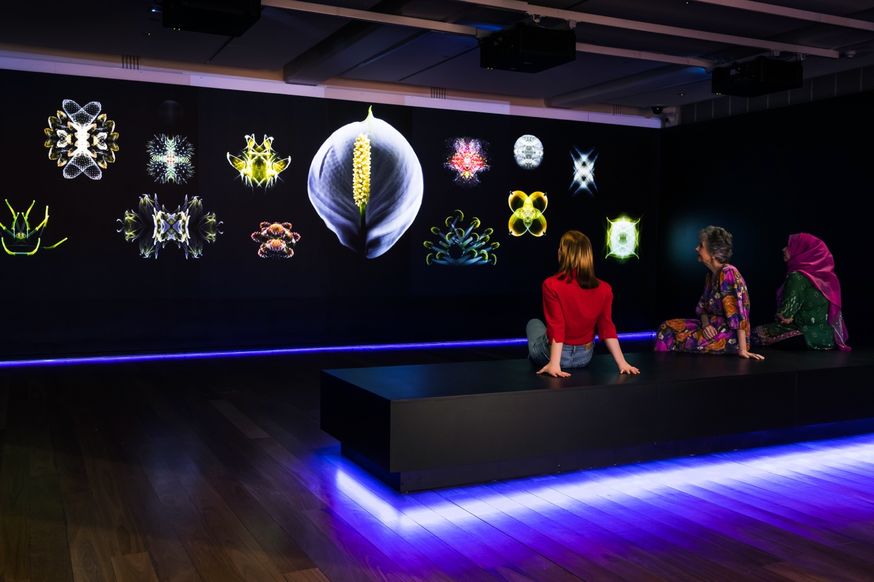

Man&Wah

Brisbane b. 1978

Celeston 3 2023
Digital video with audio by Jonn Serrie
Museum of Brisbane Collection

Man&Wah are twin brothers and creative partners inspired by the beauty and diversity of nature within the broader context of the cosmos. Both graduates of Queensland College of Art, Griffith University, they create immersive experiences that combine a range of audio-visual elements, encouraging people to slow down and wonder openly about their connection with nature.

Celeston 3 is a multisensory experience that celebrates the beauty of flora from a cosmic perspective. Entering the space, you feel as though you have stepped through a portal into another realm. Lights glow beneath the seats. You are invited to sit down and look up at seamlessly unfolding scenes of floral imagery, lush environments, sacred geometries and mesmerising fractals, imagining yourself on a floating journey through the universe in its micro and macro states. The brothers coined the term ‘celeston’ to describe the inextricable relationship between celestial and terrestrial bodies. Hypnotic and mysterious, Man&Wah’s video work alters your sense of time and perception, creating space for wonder and reflection on your connection to nature and more broadly, the cosmos.

Man&Wah’s video work is accompanied by ambient electronic music composed by Jonn Serrie. The sonic rhythms expand our earth-centric perception, inspiring you to wonder with an infinite perspective. Man&Wah seek to bridge the distance between humans, nature and cosmic processes through beauty.

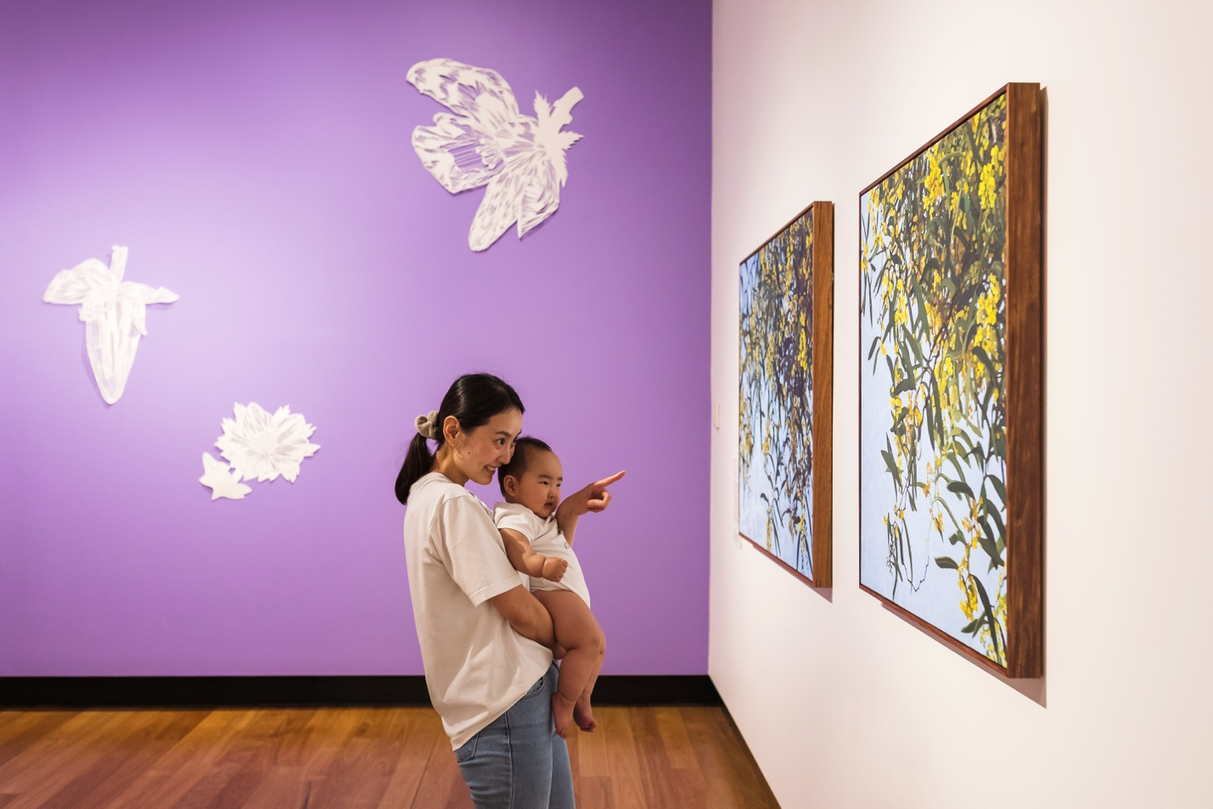

Milomirka Radovic
Rovine, Serbia b. 1942

Garland Harmony 2023
Acrylic yarn
Courtesy the artist

Milomirka (Millie) Radovic learned to spin, knit and crochet from her mother and grandmother in Serbia. She graduated from four years at the Technical School in Lescovac with a scholarship enabling her to study textile technology for a further four years in Ljubljana, Slovenia (Yugoslavia). She became a chartered engineer of textile technology, specialising in quality control and production of both natural and synthetic fibres, and led a laboratory and dyehouse. In 1972 she moved with her husband and two-year-old son to Brisbane, where she managed the physical and chemical laboratories at Morris Woollen Mills, Redbank, Ipswich until 1994.

Now in her 80s, living without a garden in Fortitude Valley, Millie fashions her own flower plots. Her imagination combines with her lifelong practical proficiency to allow her free experimentation with forms. Using premium acrylic yarn, which she favours for the range and consistency of its colours, and its ability to be washed and reshaped, she makes familiar forms of rosettes and daisies that explode into fantastical floral arrangements. Circular beds erupt with corals, cactuses and carnations; imaginary realms are evoked in cascading garlands of chrysanthemums, tumbling trumpets, and bunched clusters looking wattle-ish and fronds looking fern-ish. After her decades of working in industrial and commercial production of military uniforms and export products, Millie handmakes gardens where vines of fluted blooms fall in a cornucopia of colour.

Jaishree Srinivasan
South India b. 1954

Where to from here? 2023
Medium slip cast and hand built mid fire clay, terra sigillata slip, glaze and gold lustre
Museum of Brisbane Collection

Jaishree Srinivasan’s ceramic sculptures and installations are meticulous, often incorporating decorative motifs found in South Indian ritual practice. Her works explore identity, place and belonging through narratives and dialogues that she invites you to participate in.

Here, Jaishree has created an installation of over 800 ceramic ‘petals’ inspired by jasmine flowers. After moving to Brisbane from Canberra with her family, she recalls being overwhelmed by the heady perfume of jasmine during walks around the neighbourhood. The sweet scent triggered a rush of memories of growing up in Chennai, where jasmine holds a very special place. Not only is it used to decorate hair, but it is often gifted to female guests as a token of goodwill. Jasmine garlands adorn deities in temples and are used to honour dignitaries. It is the flower of choice for weddings and other celebrations. In Brisbane, Jaishree began cultivating sambac jasmine in her garden. For years, she watched her mother string the flowers into garlands to offer in her home shrine as part of daily ritual and to invoke well-being. Jaishree continues this multisensory tradition to honour her mother.

In her practice, Jaishree employs jasmine for its personal significance and as a symbol of transience. While the inner petals of her installation are smooth and white, the outer petals are rough and ‘burnt’. The transition from the inner to outer petals evokes the bloom and decay of jasmine, recalling the cyclical nature of life. It simultaneously symbolises the calluses we acquire throughout life, though the detached golden petals suggest there is always opportunity to better ourselves. These ideas are expressed in a concept referred to as samsāra in Hinduism.

Jaishree has positioned the petals in this installation to recall the geometric design of a kolam, a floor decoration traditionally drawn by South Indian women. By adapting an artform practised by women to embellish and nurture the home, Jaishree deliberates on the societal roles played by women, not only in India and Australia, but all over the globe.

Ashlee Becks

Mount Isa, Qld b. 1998

Flower Quilt 2022
Oil on canvas
Courtesy the artist

Ashlee Becks is a Brisbane-based painter who employs a technique called impasto, in which a palette knife is used to thickly layer paint onto a surface of choice. Texturally rich and deeply expressive compositions often result from this process. Ashlee’s practice is one of embodied mark-making, where the physicality and time required to create her paintings enables her to work through her emotions, from self-discovery to healing.

In this painting, Ashlee depicts a profusion of flowers, composed to resemble a patchwork quilt. She created the work while undertaking a three-month residency in Hobart. During this period, she stayed in Battery Point, a suburb populated with European-style cottages. Ashlee became enchanted by the cottage gardens, which featured flowers rarely found in Brisbane. She began painting the buds and blooms she observed, and produced this painting. Although not a self-portrait, this painting is largely autobiographical. It reflects, and is also part of, Ashlee’s journey of recovery as someone who has experienced mental illness. The painting is structured into 24 ‘quilt blocks’, each of which depicts a glut of flowers in varying states of growth and decay. Some of the blocks are overlaid with a poem written by the artist that suggests painting flowers helps her occupy her mind and combat intrusive thoughts. The blocks are contained within a white border decorated with thin parallel lines, reminiscent of satin stitching. At first glance, the ‘blanket of flowers’ evokes beauty and comfort. But there is an unease to the painting, achieved through the purposefully jumbled blocks and obscured poem. Ashlee describes the painting as reflecting her state of mind, where beauty and disarray fluctuate, emphasising recovery as non-linear.

Inspired by quilting, in this painting Ashlee pays homage to women’s work. She describes her practice as similar in that it is a ‘labour of love’ – the time and effort she puts in is considerable, but does not always bring reward. By leaning into what has traditionally been considered ‘domestic’ and ‘feminine’, Ashlee posits women’s work as being both intelligent and an act of self-care.

Monica Rohan
Beaudesert, Qld b. 1990

Sometimes, not always 2017
Oil on board
Private collection

Look down at the ground 2016
Oil on board
Private collection

Hoped you wouldn’t notice 2017
Oil on board
Private collection

Monica Rohan’s dream-like paintings feature enigmatic figures navigating swathes of fabric and cascades of flowers. Concealing their faces, they rarely touch the ground – they are either teetering or tumbling, climbing or reclining, hovering or hiding. Blending realism and fantasy, Monica’s alluring paintings express feelings that cannot be articulated in words.

Monica has always been drawn to Brisbane’s flowering trees – they abound throughout the parks and streets, are largely unkempt and proudly mark the changing seasons. She developed these paintings after photographing the many flowering trees around the city. Although her photographs informed her work, she used them as a guide, not a rule. In these paintings, the artist imagines climbing a mountain of poinciana, floating amongst a cloud of bougainvillea and falling into a shower of golden petals. Monica pictures herself enveloped by flowers, painting them at an enlarged scale to stretch across the entirety of her compositions. The patterns that emerge from the foliage are brought into focus, meticulously executed through a laborious yet meditative process. Although Monica began using herself as the model for her figures for practical reasons, by placing herself within these fantastical landscapes, she becomes the protagonist of her paintings.

While playful and whimsical, Monica’s works can also overwhelm. On one hand, her figures can be interpreted as innocent adventurers, exploring their surroundings. On the other, they can be interpreted as lonely travellers, about to be drowned in flowers. As claustrophobic as they are comforting, Monica’s works express her anxieties, which at times, run as rampant as Brisbane’s flowering trees. There is no set narrative for her paintings, encouraging you to decide for yourself whether the figures are safe or in danger, free or trapped.

Christopher Bassi
Brisbane b. 1990

Meriam and Yupungathi people
a passing storm 2023
Oil on board
Museum of Brisbane Collection

Christopher Bassi is an artist of Meriam, Yupungathi and British descent. Although he employs a representational style of painting, conceptually, his work stitches together thoughts and imagery from myriad places and experiences. Historically, representational painting was used by colonial artists to tell stories that they often embellished or exaggerated. Christopher appropriates this genre of painting to tackle questions of place, identity and history.
Christopher has long used subtropical and tropical flora to connect his home of Brisbane to his family in Far North Queensland and the Torres Strait. These places share a similar climate, with hot and humid summers, that encourages plants like frangipani to flourish. In this painting, Christopher depicts a cluster of frangipani flowers, strewn on the ground in the aftermath of a storm. The flowers symbolise Christopher’s experiences living between cultures, and reflect his understanding of place and belonging as concepts that are fluid and individual. In the painting, he captures a fleeting moment of serenity amidst the unpredictable, and at times severe, weather that characterises Far North Queensland. The flowers have been scattered on the ground, yet remain poised and intact – a testament to the resilience of nature in the face of adversity.

Although Christopher draws inspiration from his lived experiences, there remains a level of ambiguity to his paintings, allowing multiple meanings to be derived. The frangipani flowers, for example, could represent the stories of his people, whose lives are entwined with this abundant landscape. Christopher could also be emphasising the lifespan of the flowers to acknowledge the cyclical nature of life, where birth and death inevitably coexist. Christopher invites you to look beyond the edges of the painting to imagine a bigger narrative about place and identity.

Judith Sinnamon
Brisbane b. 1964

Zig-Zag Wattle with Eastern Yellow Robins 2023
Oil on linen
Museum of Brisbane Collection
Zig-Zag Wattle with Wattle Bird 2023
Oil on linen
Courtesy private collection and Edwina Corlette Gallery

Judith Sinnamon grew up in Red Hill and studied painting at Queensland College of Art’s Seven Hills campus in the mid-1980s. For two decades she and her family have lived near Maleny, on land that was rainforest before it was cleared in the 1920s for soldier settlement. Through years of hard physical work and commitment, Judith and her husband have regenerated the land which is now planted with flora endemic to the region. When she needs a break from painting, she swaps brushes for a machete and clears swathes of invasive lantana.

Judith’s commitment to Australian native flora is expressed in both her regenerative land practices and her paintings. While she painted exotics in earlier years and is also known for evocative portraits, Judith’s primary focus, now, is the flowers, plants and trees of South East Queensland. The Australian bush is often imagined as rough and untamed, yet Judith intentionally captures the beautiful delicacy of our flora – their vulnerability, their quirks, their humour – encouraging us to think about the inner life of plants, and to look more inquisitively at individual trunks, branches, foliage and blooms.

Judith revels in the spontaneous nature and fluidity of paint. She plays joyfully with swirls, and in the case of these paintings, dots are repeated in the wattle’s explosion of yellow. Her paintings are bathed in light, flowing across the canvas to articulate her selected subjects. Her compositions celebrate pattern, movement and shape, defined, in these works, by the negative space of the radiant, nuanced sky. As we are drawn into the detail, we notice what at first glance is hidden. Discovering the two yellow robins in one of the paintings and a wattle bird in the other, we are suddenly delighted by the marvels of nature.

Pamela See (Xue Mei-Ling)
Brisbane b. 1979

Banana
Strawberry
Quince
Citrus
Passionfruit
All works 2023
Paper
Museum of Brisbane Collection

Pamela See (Xue Mei-Ling) is a papercutter, scholar and writer who grew up in Mansfield and Logan City. Since the age of 20, when she completed her bachelor’s degree in visual art at Queensland College of Art, Griffith University, she has been making and studying art while teaching and writing. She gained a master’s degree in business at Queensland University of Technology (QUT) before returning to Griffith University to undertake a doctoral thesis on the applications of papercutting in the post-digital era. Having earned her PhD in 2020, she re-enrolled at QUT, where she obtained her master’s degree in education in 2022.

Most of the Chinese people Pamela met while young were first- or second-generation Australians, like her own family. It was some time before she realised that Chinese people had lived in Australia since the 1840s. Now, Pamela is a leader amongst the generation of Australian artists investigating and honouring their cultural inheritance, and examining their personal experience in broader historical contexts. Over the past decade she has researched the histories of Chinese people who have lived in Australia, and made many series of delicate, stunningly intricate artworks in response to what she has discovered. Working in the tradition of Foshan papercutters from her mother’s ancestral province of Guandong, she has cut portraits and images illustrating foods, fables, animals, floral emblems, tools and commodities relating to the early immigrants. Many of her artworks have been translated to mediums of glass, steel and acrylic. For Rearranged – working to a larger scale than she often uses for paper flora – Pamela has cut the shapes of flowers of crops grown by Chinese market gardeners in the Brisbane region.

